CHAPTER 22 SOUND AND MUSIC

The integration of sound, music, and video into Microsoft Windows has been a significant advancement in the evolution of the operating system. Initially, multimedia support was introduced as the Multimedia Extensions to Windows in 1991. However, with the release of Windows 3.1 in 1992, multimedia support became a fully integrated category of APIs.



Over the years, the availability of CD-ROM drives and sound boards, which were considered rare in the early 1990s, has become a standard feature in new PCs. Nowadays, it is widely recognized that multimedia capabilities enhance the graphical user interface of Windows and add a valuable dimension to the computing experience. These features have extended the traditional role of computers beyond number crunching and text processing.



The integration of sound, music, and video into Windows has transformed the way users interact with their computers. It has opened up new possibilities for entertainment, communication, and creativity. From playing audio files and videos to creating multimedia presentations, Windows provides a platform for users to engage with various forms of media.

With each new version of Windows, including Windows 10, Microsoft has continued to enhance and expand multimedia capabilities. Windows 10 offers a wide range of features and tools that make it easier for users to enjoy and create multimedia content.



Media Player: Windows 10 includes the built-in Windows Media Player, which allows users to play a variety of audio and video file formats. It provides basic playback controls, playlist management, and the ability to create and manage media libraries.

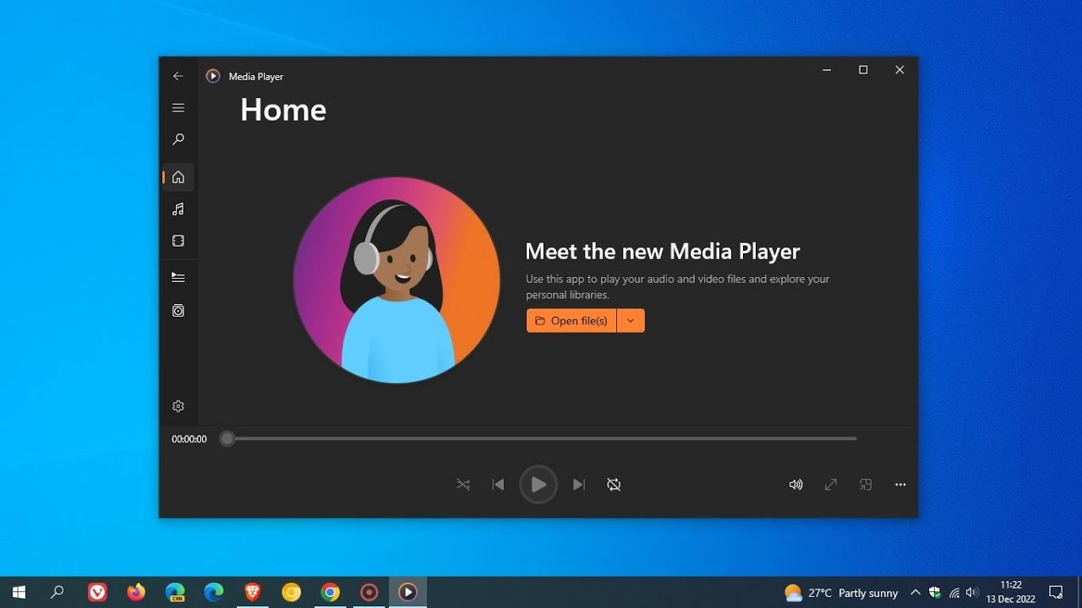

Groove Music: Windows 10 introduced the Groove Music app, which provides access to a vast library of songs and allows users to stream music from the Microsoft Store. It also supports local music playback and offers features like playlists, radio stations, and music recommendations.

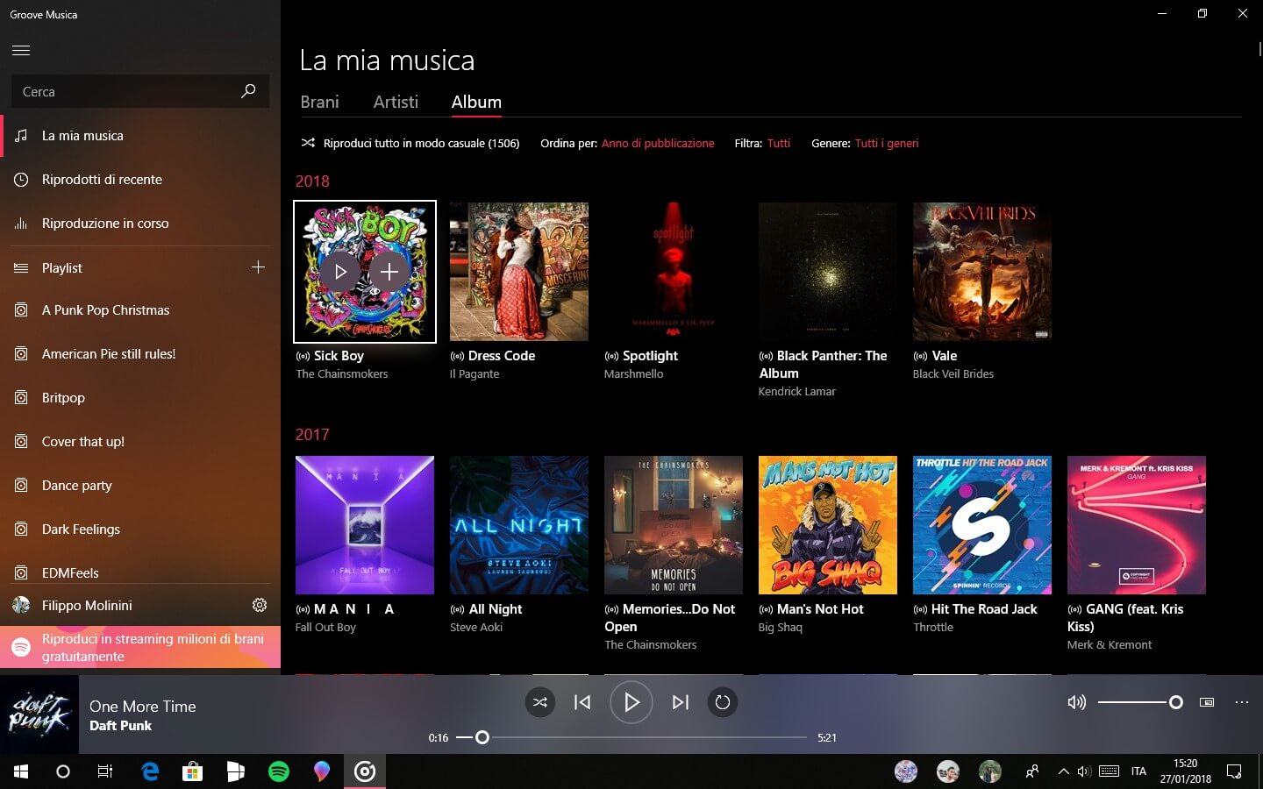

Movies & TV: The Movies & TV app in Windows 10 enables users to play movies and TV shows from their personal collection or purchase and rent content from the Microsoft Store. It supports a range of video formats and provides features such as playback controls, subtitles, and video casting.



Sound Settings: Windows 10 includes comprehensive sound settings that allow users to configure audio playback and recording devices, adjust volume levels, and apply audio enhancements. Users can also set default audio devices for different scenarios and customize sound effects.



Recording and Editing: Windows 10 provides built-in tools for recording and editing audio and video content. The Voice Recorder app allows users to record audio notes, interviews, or lectures, while the Photos app offers basic video editing capabilities, such as trimming, adding music, and applying visual effects.

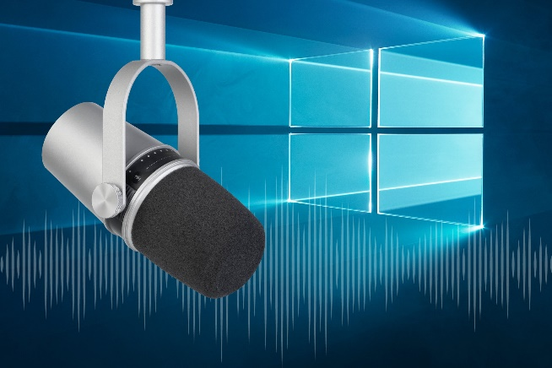 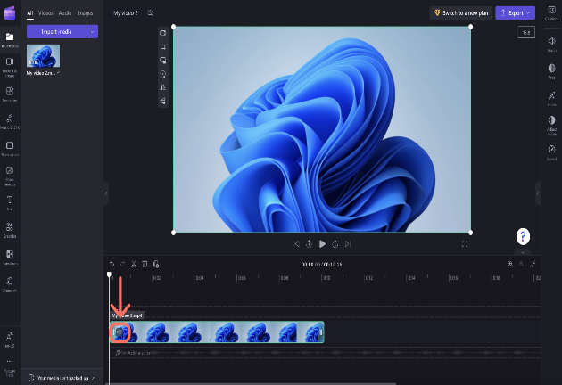

Gaming and Streaming: Windows 10 incorporates features specifically designed for gaming and streaming. The Xbox app allows users to record and capture gameplay, stream games to other devices, and communicate with fellow gamers. Additionally, the Game Bar provides quick access to gaming features, including audio settings and broadcasting options.

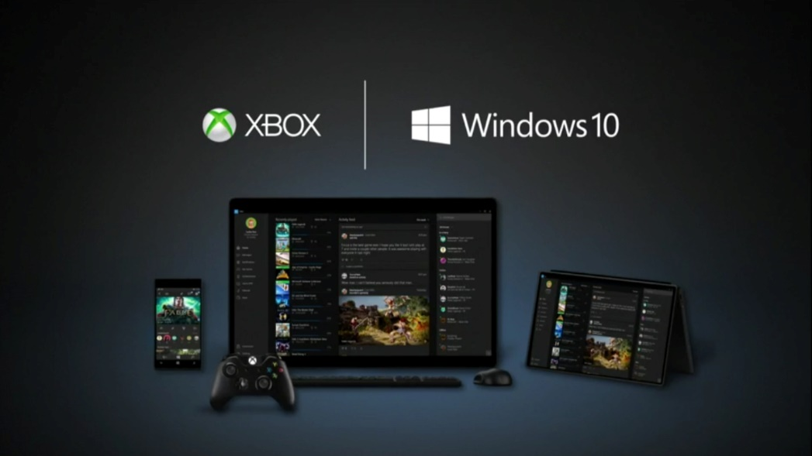

Virtual Reality and Mixed Reality: Windows 10 includes support for virtual reality (VR) and mixed reality (MR) experiences. The Windows Mixed Reality platform enables users to immerse themselves in virtual environments, play VR games, and enjoy 360-degree videos and photos.

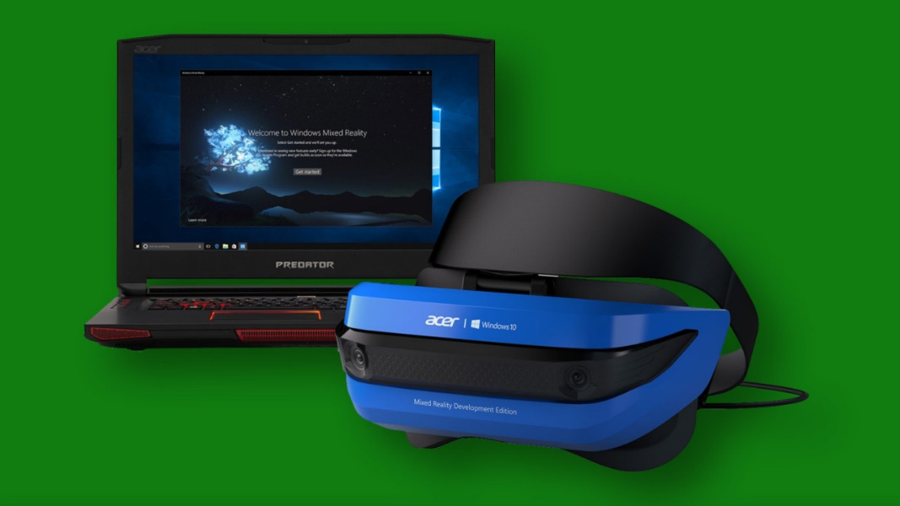

MULTIMEDIA CAPABILITIES

Multimedia capabilities are an essential and integrated part of the Windows operating system.

They encompass sound, music, and video, enhancing user experiences and extending the platform's capabilities.

Windows provides a device-independent multimedia API, which allows programmers to interact with various multimedia hardware devices through consistent function calls.

This device abstraction ensures compatibility and flexibility across different hardware configurations. Some of the key multimedia hardware devices supported by Windows include:

Waveform Audio Devices (Sound Cards): Sound cards convert analog audio signals from microphones and other input devices into digital samples for storage and processing (e.g., in .WAV files). They also convert digital waveforms back into analog sound for playback through speakers.



MIDI Devices: MIDI devices implement the Musical Instrument Digital Interface (MIDI) standard. They generate musical notes in response to MIDI messages and can interface with MIDI input devices such as musical keyboards and external synthesizers.



CD-ROM Drives (CD Audio): CD-ROM drives can play standard music CDs, allowing users to listen to audio tracks directly from the CD.

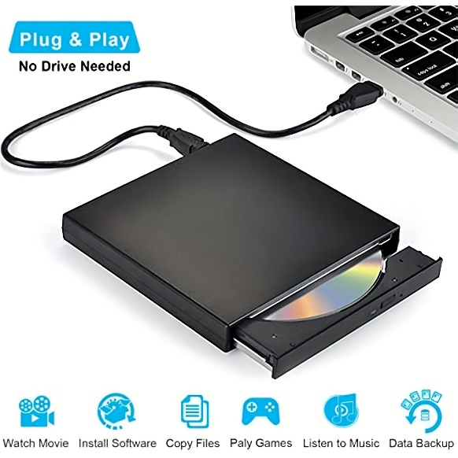

Video for Windows (AVI Video): Video for Windows is a software-based device in Windows that enables the playback of .AVI files (audio-video interleave). It provides support for playing video files and may also leverage video board hardware acceleration if available.



ActiveMovie Control: ActiveMovie Control expands video capabilities by providing support for additional movie formats, including QuickTime and MPEG. It can take advantage of video board hardware acceleration to enhance movie playback performance.

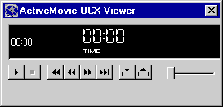

Laserdisc Players and VISCA Video Cassettes: Certain devices, such as laserdisc players and VISCA video cassettes, can be controlled via serial interfaces by PC software. This allows users to manage these devices and perform actions through their computer.

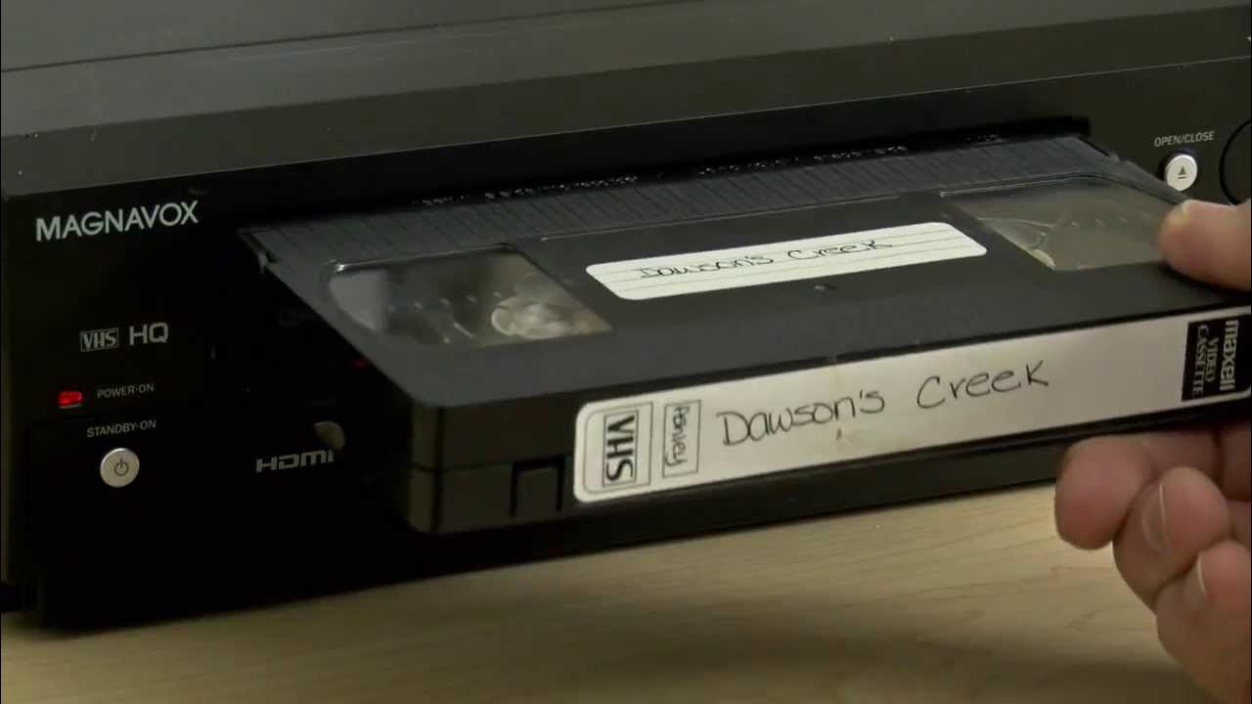

In addition to these hardware-specific features, Windows provides various core functionalities and concepts related to multimedia:

Device Abstraction: The Windows multimedia API abstracts the underlying hardware, providing a unified interface for programmers to access and control diverse multimedia devices. This allows developers to write multimedia applications that can work with different hardware configurations.

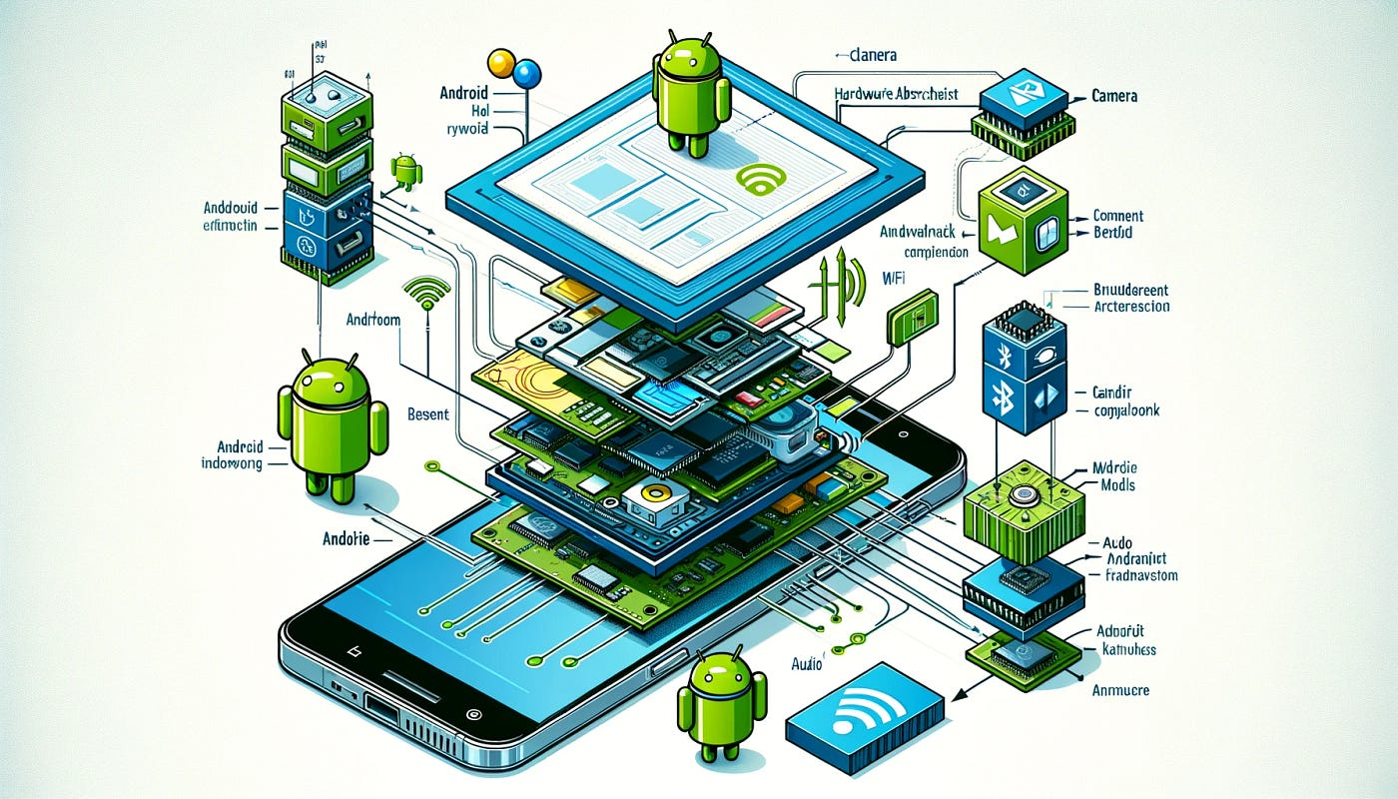

Hardware Mixing: Windows often includes a Volume Control application that allows users to blend output from multiple sources, such as waveform audio, MIDI, and CD audio. This enables users to control the relative volume levels of different audio streams.



Hardware Acceleration: Video boards can have dedicated hardware components that accelerate movie playback. This hardware acceleration improves performance and allows for smoother and more efficient video rendering.

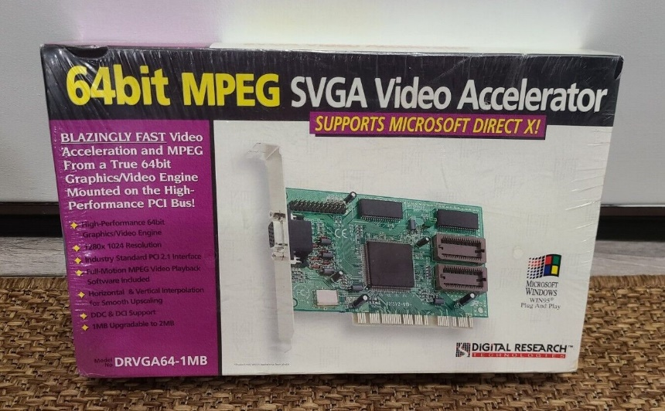

Serial Interface Control: Some multimedia devices, like laserdisc players and VISCA video cassettes, can be controlled via serial communication interfaces. This allows users to send commands and manage these devices directly from their computer.

 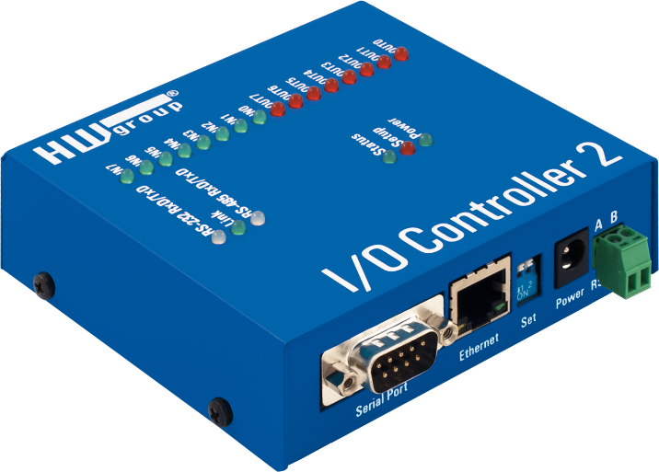

Overall, multimedia support in Windows has evolved significantly since its introduction as the Multimedia Extensions in 1991. With the widespread availability of CD-ROM drives and sound cards, multimedia capabilities have become standard in modern PCs. The integration of sound, music, and video into Windows has transformed the platform, going beyond traditional text and number processing and enabling immersive experiences for users.

Strategic API Design:

Dual-Layer Approach: Windows offers both low-level and high-level multimedia APIs, each serving distinct purposes and catering to different developer needs.

Low-Level Interfaces: Provide direct, granular control over hardware, enabling fine-tuning and optimization for demanding tasks or unique functionalities.

High-Level Interfaces: Simplify common operations, reducing development time and promoting code readability, often at the expense of some flexibility.

Low-Level Interfaces: Unleashing Hardware Potential:

Waveform Audio Mastery: waveIn and waveOut functions enable the recording and playback of digital audio signals, crucial for voice applications, music production software, and sound effects.

MIDI Orchestration: midiOut, midiIn, and midiStream functions control MIDI devices, essential for music creation software, interactive game audio, and sequencing hardware synthesizers.

Precision Timing: time functions establish high-resolution timers, ensuring accurate synchronization of multimedia events, particularly MIDI playback and real-time audio processing.

High-Level Interfaces: Streamlining Development:

MCI: The Versatile Orchestrator:

Offers a consistent interface for diverse multimedia devices, promoting code reusability and streamlining multi-device projects.

Its string-based form empowers rapid prototyping and scripting, enabling experimentation and customization.

Supports a comprehensive range of devices, encompassing audio, video, and optical media, fostering multifaceted multimedia experiences.

Beyond the Core: Expanding Possibilities:

*DirectX API: Powering Immersive Experiences:*

* While not extensively covered here, DirectX stands as a cornerstone for game development, multimedia applications, and graphics-intensive software.
* It provides unparalleled hardware acceleration, sophisticated 3D graphics rendering, advanced audio processing, and robust input device support.

*Convenient Sound Utilities:*

* MessageBeep: Offers a straightforward mechanism for auditory feedback, enhancing user interaction and signaling important events.
* PlaySound: Simplifies the incorporation of sound effects and music into applications, contributing to engaging user experiences.

Key Considerations for API Selection:

* Project Requirements: The choice of API hinges on the specific needs of the application, balancing performance, ease of development, and hardware access requirements.
* Developer Expertise: Familiarity with low-level programming concepts is essential for effective use of low-level interfaces, while high-level interfaces often align with broader programming knowledge.
* Target Hardware: Understanding the capabilities of the intended multimedia hardware is crucial for optimal API selection and feature utilization.

TESTMCI PROGRAM



The TESTMCI program is a C application that allows users to interactively test and experiment with MCI (Media Control Interface) commands. MCI commands are used to control multimedia devices and perform operations such as playing audio or video files.

The program provides a simple graphical user interface (GUI) based on a modeless dialog box. The main window of the program contains an edit box where users can enter MCI commands. When the user presses Enter or clicks the OK button, the program retrieves the command from the edit box and passes it to the mciSendString function.

The mciSendString function is a key function provided by the MCI API. It takes a command string as input and executes the specified MCI command. In the TESTMCI program, the command string is obtained from the edit box, and the result of the command execution is stored in a string buffer.

After executing the command, the program displays the result in the "Return String" section of the window. This can include information such as status messages or data returned by the MCI command.

Additionally, the program retrieves the error code returned by the mciSendString function. If an error occurs during the execution of the command, the error code is used with the mciGetErrorString function to obtain a textual description of the error. The error description is then displayed in the "Error String" section of the window.

The program supports selecting multiple lines in the edit box. If multiple lines are selected, each line is treated as a separate MCI command and executed sequentially. The program processes each line individually and displays the corresponding result and error description for each command.

The program also includes a section for handling the MM_MCINOTIFY message. This message is sent by the MCI subsystem to notify the application of changes in the status of multimedia devices or completion of asynchronous operations. The program enables or disables various controls in response to this message.



Overall, the TESTMCI program provides a convenient way for developers or users to experiment with MCI commands and observe their effects. It allows for interactive testing and troubleshooting of multimedia operations using the MCI API.

UNDERSTANDING MCI COMMANDS IN TESTMCI PROGRAM:

The TESTMCI program demonstrates the use of Multimedia Command Strings through two essential functions: mciSendString and mciGetErrorText. Here's an in-depth breakdown of the program's functionality:

mciSendString Function:

* The primary multimedia function used in TESTMCI is mciSendString. This function is responsible for sending command strings to the MCI subsystem for execution.
* When you type a command into the main edit window and press Enter, the program passes the entered string as the first argument to mciSendString.
* If multiple lines are selected in the edit window, the program sends them sequentially to mciSendString.
* The second argument to mciSendString is the address of a string (szReturn) that receives information back from the function.
* The returned information is then displayed in the "Return String" section of the program's window.

mciGetErrorText Function:

* The error code returned from mciSendString is passed to the mciGetErrorText function to obtain a text error description.
* The obtained error description is displayed in the "Error String" section of TESTMCI's window.

CD Audio Control:

* The program showcases the control of a CD-ROM drive to play audio CDs using MCI commands.
* Commands like open cdaudio, play cdaudio, pause cdaudio, and stop cdaudio are utilized to control audio playback.
* The "Return String" section displays information returned by the system in response to these commands.

Understanding Time Formats:

* The program allows users to interact with CD Audio by querying information like the total length of the CD, the number of tracks, and the length of individual tracks.
* Commands like status cdaudio length and status cdaudio number of tracks provide this information.
* The time format for CD Audio is explained, with examples like status cdaudio time format returning "msf" (minutes-seconds-frames).

Setting and Manipulating Time:

* The program demonstrates how to set and manipulate time formats, such as changing the time format to "tmsf" (tracks-minutes-seconds-frames).
* Users can play specific tracks or set the playback range using commands like play cdaudio from with specified time values.

Additional Features:

* The program handles error conditions gracefully, displaying appropriate messages in case of failures.
* It provides a practical and interactive way to explore MCI commands for CD Audio control.

Use of wait and notify Options:

* The explanation of the wait and notify options adds valuable insights into managing the behavior of MCI commands.
* The wait option ensures that mciSendString doesn't return control until the specified operation is completed. However, caution is advised to prevent unintended consequences.
* The break command is introduced as a safety mechanism when using wait, allowing the user to interrupt a potentially lengthy operation.

Combining wait and notify Options:

* The passage mentions that you can use the wait and notify options together, although it suggests that there's hardly a reason for doing so. This highlights the flexibility of MCI commands.

Handling MM_MCINOTIFY Messages:

* The notify option, when used, allows the program to receive an MM_MCINOTIFY message after the completion of the specified MCI operation.
* The TESTMCI program displays the result of this message in the MM_MCINOTIFY group box, enhancing user interaction and feedback.

Scripting MCI Commands:

* The passage introduces the concept of constructing MCI "scripts" by selecting and executing a series of MCI commands.
* This scripting capability allows users to automate a sequence of operations, providing a practical way to manage multimedia tasks efficiently.

CD Player Mimicry:

* The suggestion of constructing a simple application that mimics a CD player is intriguing. It highlights the potential for creating user-friendly interfaces for controlling CD playback, displaying track information, and leveraging the Windows timer for periodic updates.

Synchronization of On-Screen Graphics with CD:

* The idea of synchronizing on-screen graphics with CD audio opens up creative possibilities, such as music instruction or custom graphical music videos.
* This feature could enhance the user experience and extend the application of multimedia commands beyond basic playback control.

WAVEFORM AUDIO IN WINDOWS: AN IN-DEPTH EXPLORATION

Waveform audio stands as a cornerstone of multimedia features in the Windows operating system, offering a robust set of capabilities for capturing, processing, and playing back sounds. At its core, waveform audio transforms analog sound vibrations into digital data, allowing for efficient storage and retrieval in files with the .WAV extension.

Understanding the Physics and Perception of Sound:

Before delving into the intricacies of the waveform audio API, it's crucial to grasp the fundamental principles of sound. Sound, fundamentally, is a manifestation of vibration. In the context of human perception, sound is experienced as variations in air pressure acting on the eardrums. A microphone serves as the gateway to translating these vibrational patterns into electrical currents.



In traditional analog mediums like audio tapes and phonograph records, the storage of sound involves encoding vibrations into magnetic pulses or physical grooves. As these electrical currents are further processed, they give rise to waveforms that graphically depict the fluctuations of vibrations over time. The sine wave, a natural representation of vibration, emerges as a fundamental waveform, showcasing one complete cycle in Figure 5−7 of this book.

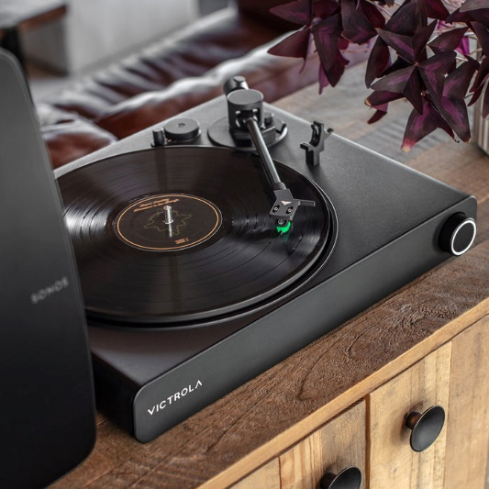

Parameters of Sound:

The sine wave introduces two critical parameters – amplitude and frequency. Amplitude, denoting the peak value of a wave over a single cycle, corresponds to our perception of loudness. On the other hand, frequency, determining the number of cycles per second, translates to our perception of pitch. The human auditory system exhibits sensitivity to sine waves across a spectrum, from low-pitched sounds at 20 Hz to high-pitched ones at 20,000 Hz. However, this sensitivity diminishes with age, particularly in the higher frequency range.

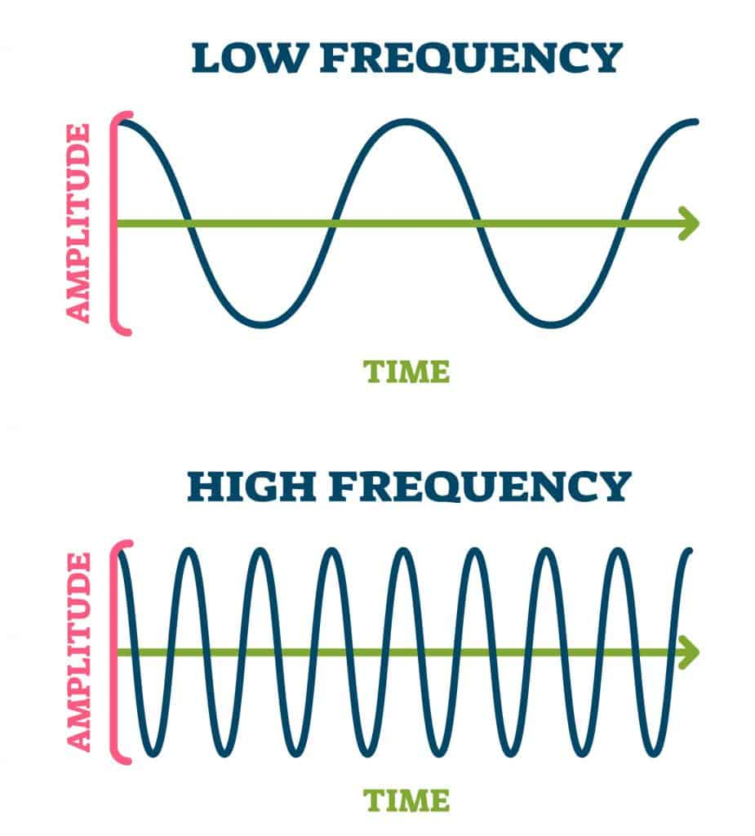

Waveform Audio API:

Armed with an understanding of sound's physical representation, the waveform audio API in Windows becomes a powerful tool. This API facilitates the capture of sounds through microphones, converting them into numerical data. These digitized waveforms can then be stored in memory or on disk in the widely recognized .WAV file format. Subsequently, the stored sounds can be played back, enabling diverse applications in multimedia development.

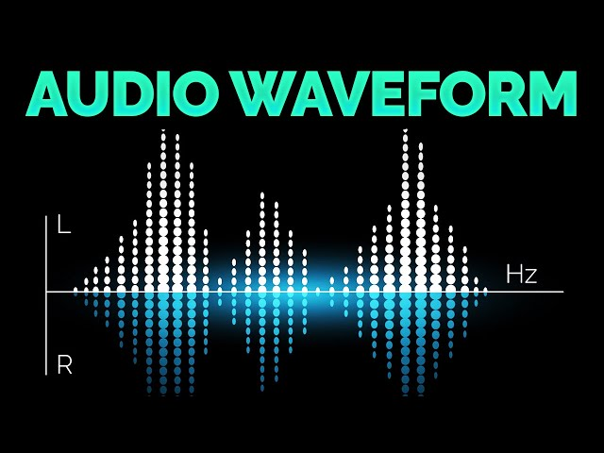

Applications and Implications:

The significance of waveform audio extends beyond its technical implementations. It forms the backbone of various audio applications, from basic sound recording to sophisticated multimedia projects. Understanding the physics of sound and the digital representation of waveforms lays the groundwork for harnessing the full potential of Windows' waveform audio capabilities.

 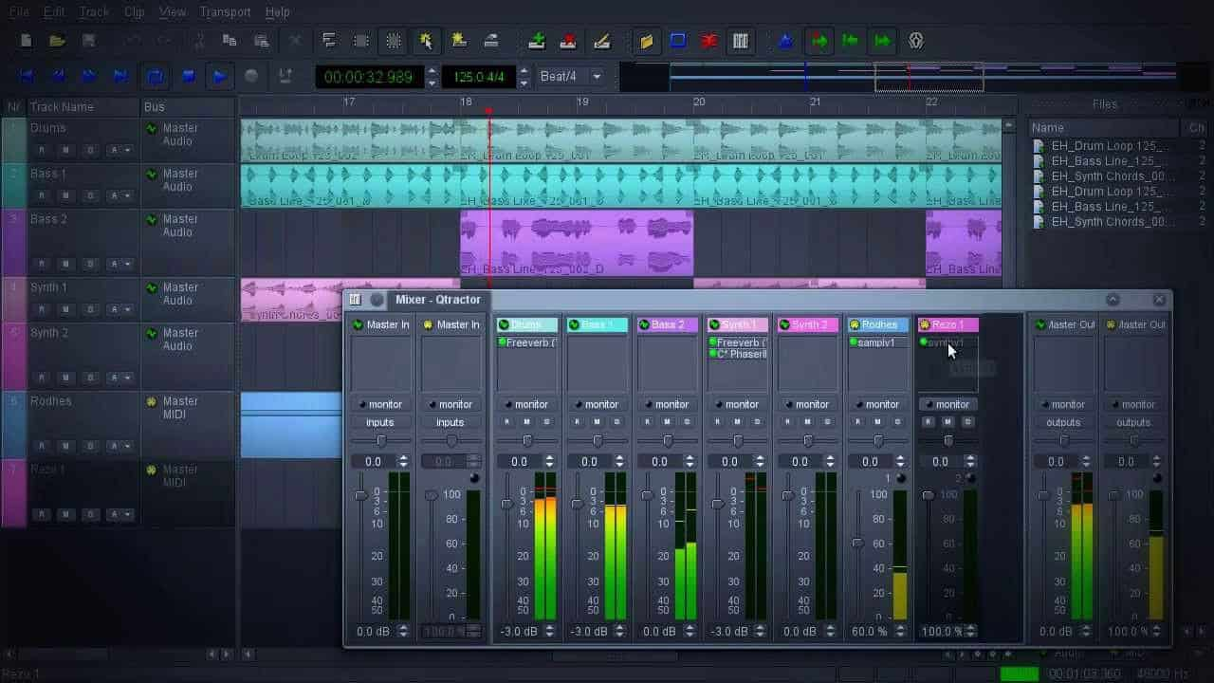

The Logarithmic Nature of Human Frequency Perception:

The human perception of frequency is inherently logarithmic, not linear. In practical terms, this means that the perceived difference between 20 Hz and 40 Hz is akin to the difference between 40 Hz and 80 Hz. This logarithmic sensitivity defines the musical concept of an octave, where frequency doubles. The human ear can discern sounds across approximately 10 octaves. To put this in perspective, the range of a piano spans a little over 7 octaves, from a low of 27.5 Hz to a high of 4186 Hz.

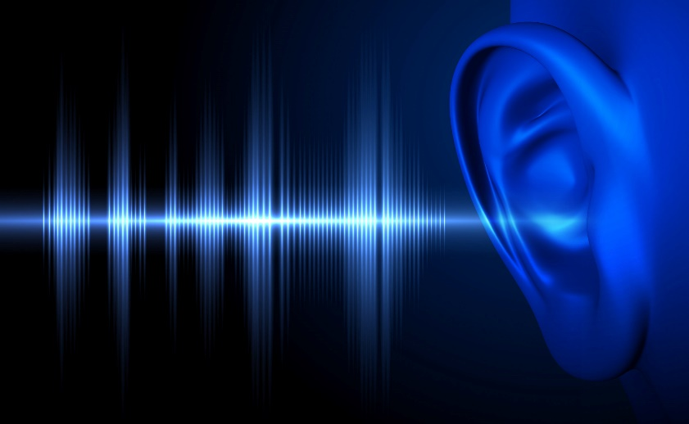

Complexity of Sound and Fourier Series:

While sine waves represent a natural form of vibration, they rarely occur in nature in pure forms, and, moreover, they often produce uninteresting sounds. Most sounds are much more complex. The concept of a Fourier series, attributed to Jean Baptiste Joseph Fourier, comes into play here. Any periodic waveform, one that repeats itself, can be deconstructed into multiple sine waves. These sine waves, known as overtones, have frequencies that are integer multiples of the fundamental frequency, also called the first harmonic. The second harmonic is the first overtone, and so forth.



Timbre and Harmonics:

The unique sound quality of each periodic waveform, influenced by the relative intensities of its sine wave harmonics, is termed "timbre." This characteristic is what differentiates, for example, a trumpet from a piano. Each instrument has a distinct pattern of harmonic intensities that contributes to its overall timbre.

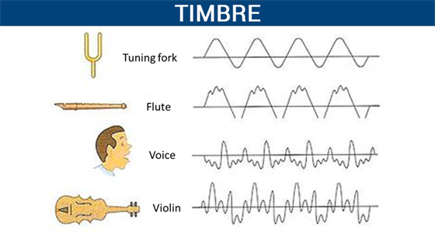

Different instruments and their timbres.

Timbre is mainly determined by the harmonic content of a sound and the dynamic characteristics of the sound. A sound must have one fundamental frequency and seven or more additional harmonics to have timbre.

The harmonic series is the set of frequencies f, 2f, 3f, 4f, etc.. The second harmonic always has exactly half the wavelength (and twice the frequency) of the fundamental.

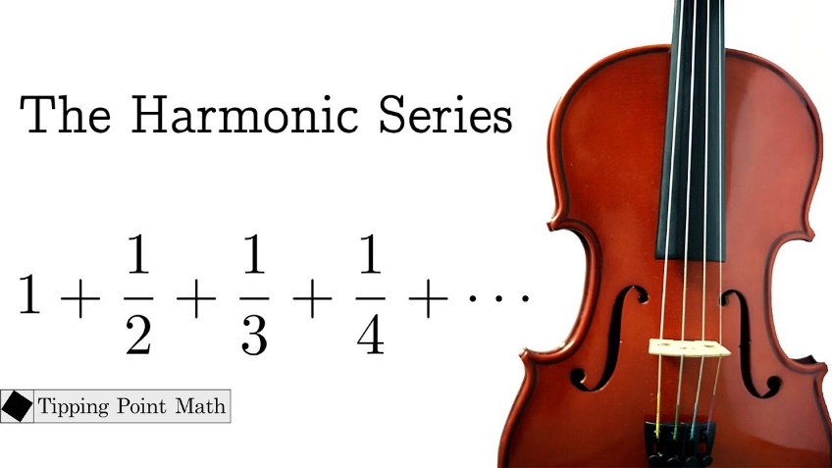

Real-World Complexity and Synthesis Challenges:

Historically, there was a belief that synthesizing musical instruments electronically simply required breaking down sounds into harmonics and reconstructing them using multiple sine waves. However, the reality is more intricate.

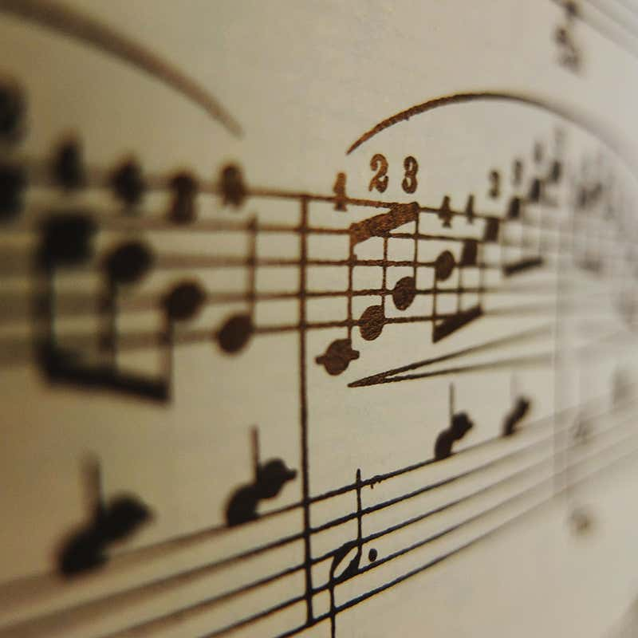

Real-world sounds from musical instruments are never strictly periodic. Harmonic intensities vary across the instrument's range, and these intensities change dynamically as each note is played. The initial phase of a note, known as the attack, can be particularly complex and is crucial to our perception of timbre.

Digital Storage and Sound Representation:

With advancements in digital storage capabilities, it has become feasible to store sounds directly in digital form without the need for intricate deconstruction. This has revolutionized the way we handle and reproduce complex sounds, enabling a more direct and efficient representation of the rich tapestry of real-world audio.



SOUND'S JOURNEY INTO THE DIGITAL REALM: PULSE CODE MODULATION

The Challenge of Digital Sound Representation: To understand PCM, we must first grasp the fundamental difference between analog sound waves and the digital language of computers. Sound, as we experience it, exists as continuous fluctuations in air pressure, forming smooth, wave-like patterns.

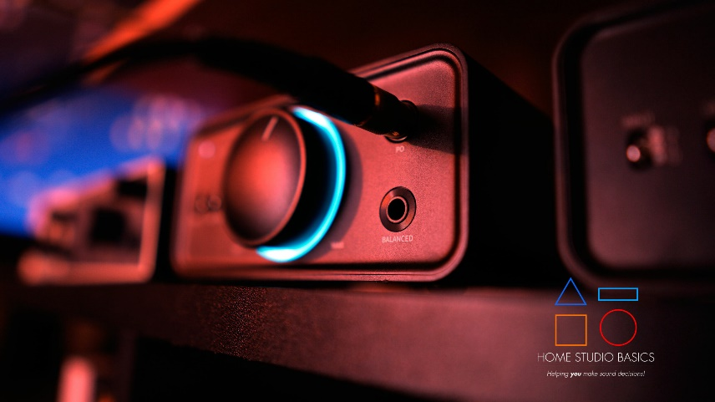

Computers, on the other hand, operate in a world of discrete numbers, requiring a translation process to bridge this divide. PCM stands as a cornerstone of this translation, enabling the accurate representation of sound within digital systems.

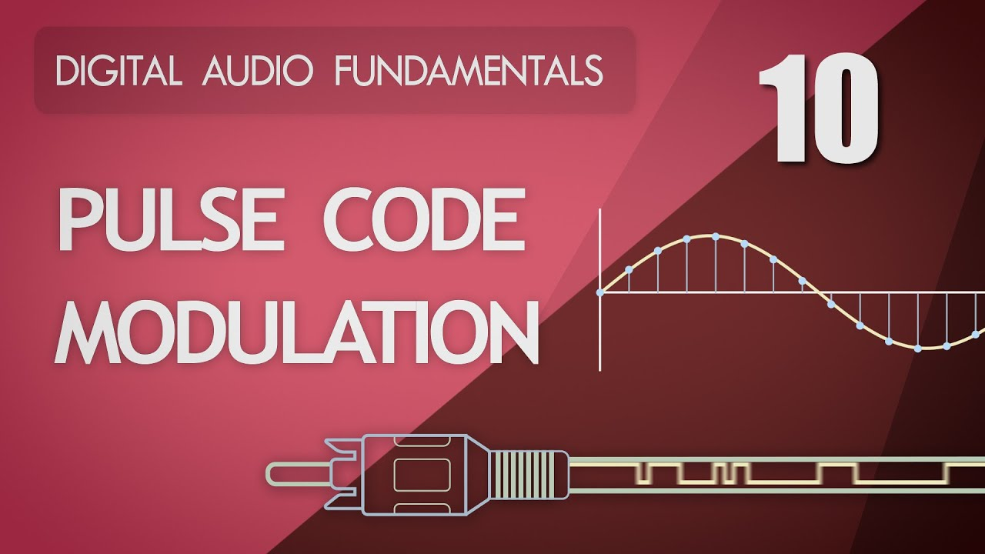

Capturing Sound's Essence in Snapshots and Numbers:

Sampling: Capturing Sound's Silhouette: Imagine a sound wave as a vast, undulating landscape. PCM's initial step involves meticulously measuring the wave's height (amplitude) at regular intervals, akin to taking snapshots of the terrain at specific points along its journey. This process, known as sampling, typically occurs thousands of times per second, determining the level of detail captured in the digital representation.

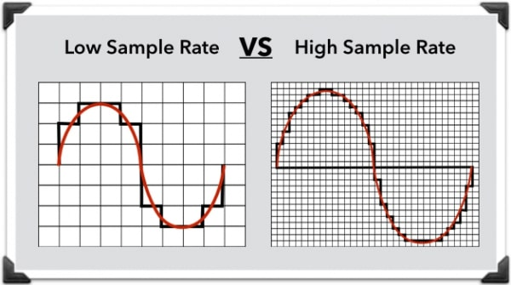

Quantization: Assigning Numerical Elevations: Each amplitude measurement, serving as a snapshot of the sound wave's shape, is then assigned a numerical value. This step, called quantization, resembles assigning elevations on a map. The precision of these values is governed by the sample size, measured in bits. Like the scale of a map, a larger sample size allows for finer detail, while a smaller sample size offers a broader, less granular representation. Specialized hardware, known as analog-to-digital converters (ADCs), expertly handles this delicate translation from wave to numbers.

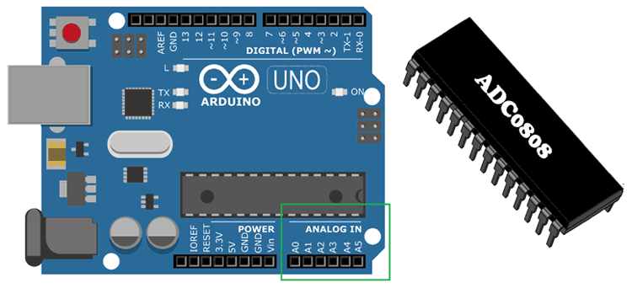

Reconstructing Sound's Symphony from Digital Data:

Reversing the Journey: Digital-to-Analog Conversion: To recreate sound from its digital form, PCM reverses the process. Digital-to-analog converters (DACs) act as cartographers, converting numerical values back into corresponding electrical wave amplitudes, carefully tracing the contours of the original sound wave.

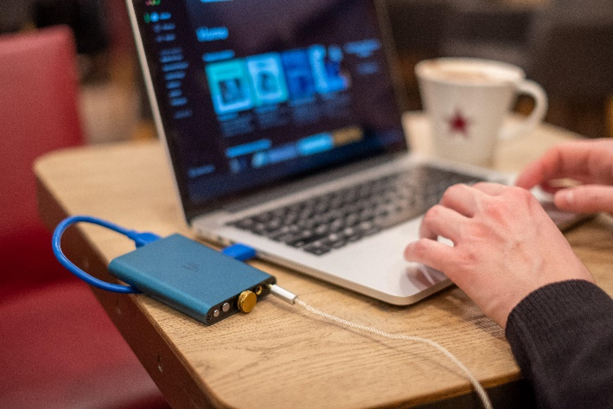 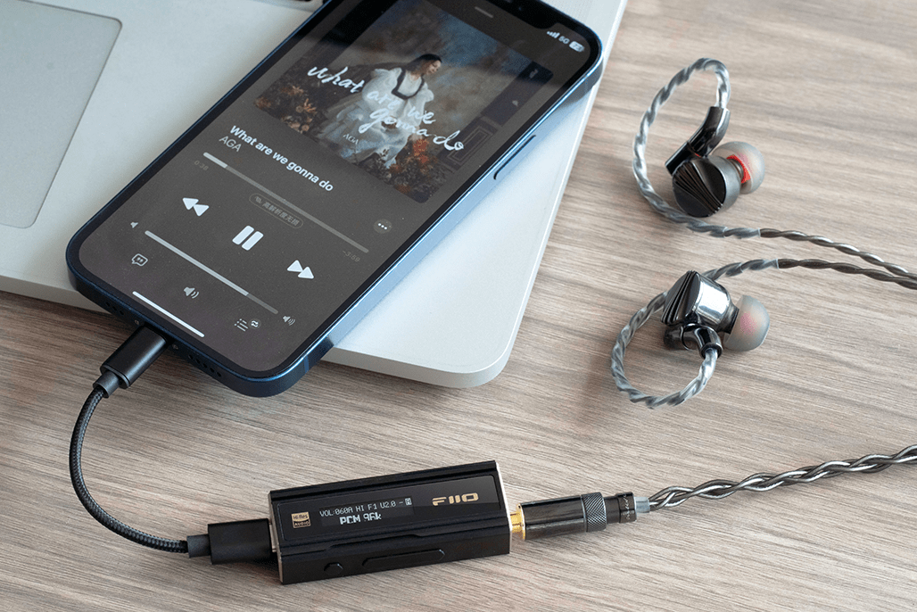

Smoothing Out Digital Edges: Similar to how a sculptor might refine a clay model, low-pass filters play a crucial role in PCM's reconstruction process. These filters, often likened to fine sandpaper, smooth out any sharp edges or abrupt transitions that might arise due to the inherent approximation of digital representation. This delicate refinement ensures a more natural, pleasing sound output.

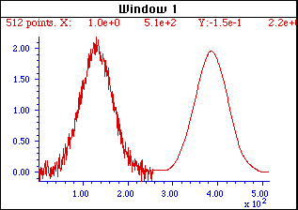

Balancing Fidelity and Efficiency: The Art of Sampling and Quantization:

Sampling Rate and Sample Size, Digital Audio's Guiding Parameters: Two key parameters fundamentally govern PCM's accuracy in replicating sound: sampling rate and sample size. Sampling rate dictates how often amplitude measurements are taken, while sample size determines the precision with which these measurements are stored.

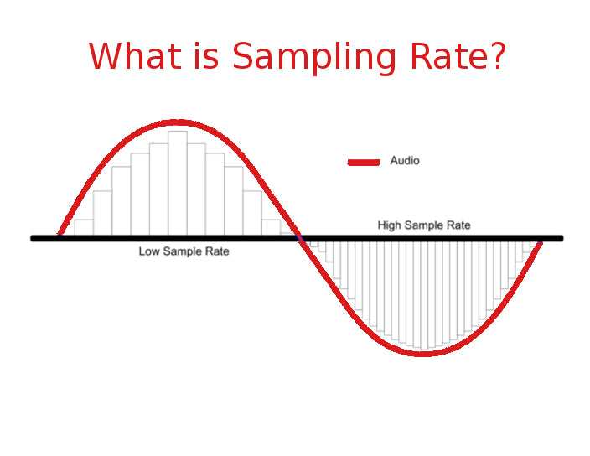

Finding Harmony, The Delicate Dance of Detail and Efficiency: Higher sampling rates and larger sample sizes capture more detail, potentially leading to more faithful sound reproduction. However, this increased detail comes at a cost, as it demands more data storage and processing resources. Thus, finding the optimal balance between fidelity and efficiency is crucial in PCM applications. Striking this balance ensures high-quality sound without placing excessive demands on storage and processing capabilities.

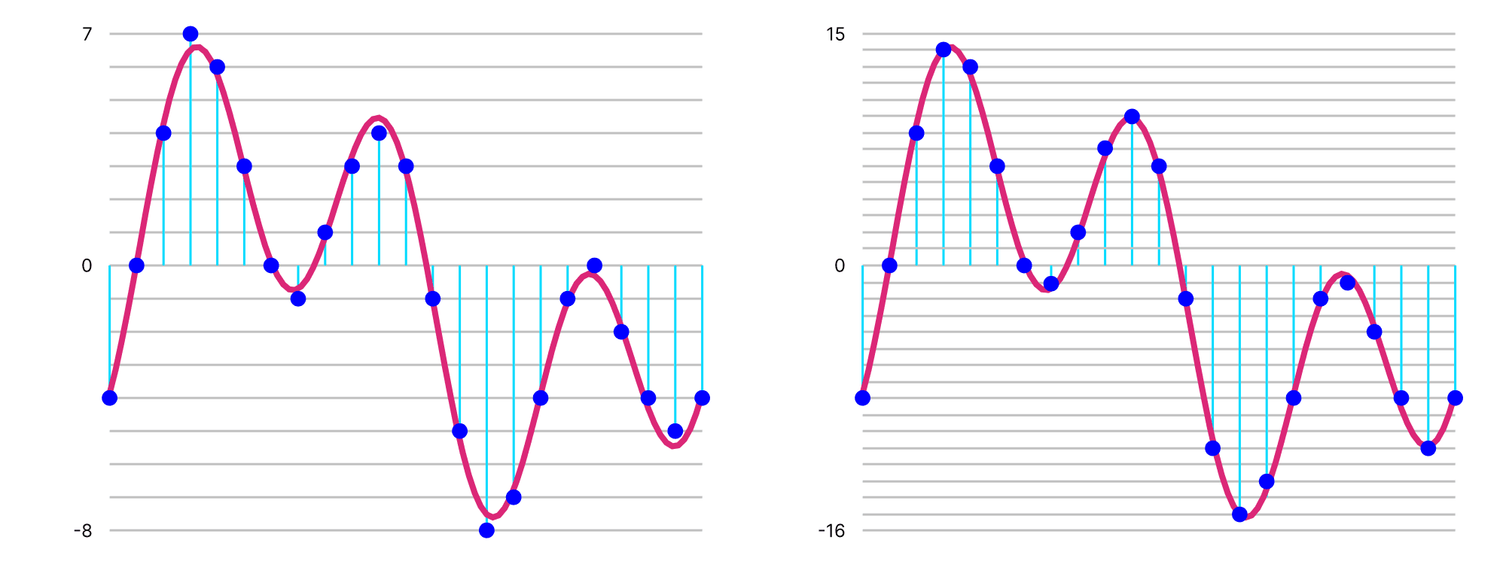

Sample Rate:

Expert Explanation: The sample rate is the number of snapshots or measurements taken per second from an analog signal to convert it into a digital format. It determines how frequently the amplitude of a sound wave is recorded.

Teen-Friendly Explanation: Imagine you're taking pictures of your favorite band at a concert. The sample rate is like how often you snap a photo. The more photos you take per second, the more accurate your representation of the band's performance.

Sample Size:

Expert Explanation: The sample size is the number of bits used to store each snapshot or measurement of the amplitude during the analog-to-digital conversion. It influences the level of detail and precision in representing the original sound.

Teen-Friendly Explanation: Think of the sample size as the quality of each photo you take. A larger sample size is like taking pictures with more pixels, providing a clearer and more detailed image of the music.

In a nutshell, sample rate is how often you capture moments of the sound, and sample size is how much detail each captured moment holds. It's like taking a lot of detailed pictures quickly to create a digital version of your favorite song.

SAMPLE RATE IN DEPTH

Sampling Rate: Capturing Sound's Delicate Details

Setting the Sound Stage: Sampling rate, measured in samples per second (Hz), is the cornerstone of digital audio, defining the frequency range that can be accurately captured and reproduced. It dictates how often snapshots of the sound wave's amplitude are taken, forming the foundation for its digital representation.



Nyquist's Crucial Rule: Doubling for Clarity: To faithfully reproduce sound, the sampling rate must be at least twice the highest frequency present in the original audio signal. This concept, known as the Nyquist frequency, ensures that enough information is captured to avoid distortion and create a faithful representation.

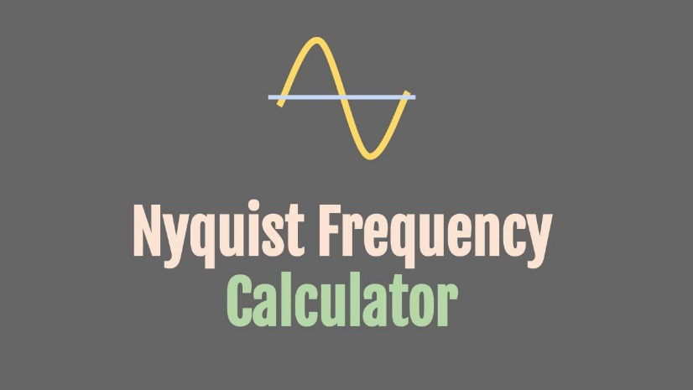

Aliasing: The Perils of Insufficient Sampling

Creating Phantom Frequencies: When the sampling rate falls below the Nyquist frequency, a phenomenon called aliasing occurs. This results in lower-frequency artifacts, or "aliases," appearing in the digital audio, often sounding like unintended, distorted echoes of the original sound.

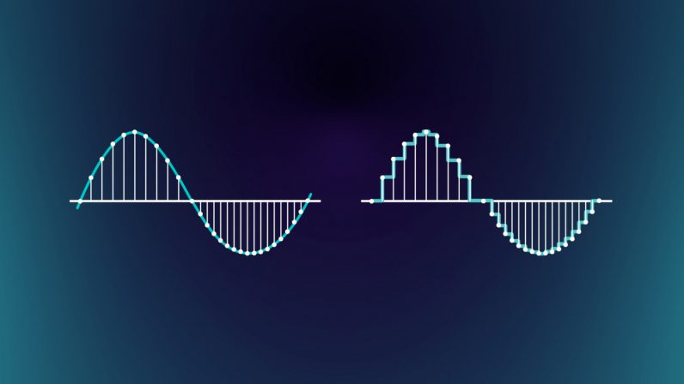

Guarding the Gates with Filters: To prevent aliasing, low-pass filters are strategically employed on both the input and output sides of the audio system. These filters act as gatekeepers, blocking frequencies above half the sampling rate, ensuring a clean and accurate representation.



Common Sampling Rates: Balancing Quality and Efficiency

CD-Quality Sound: 44.1 kHz: This widely adopted standard for audio CDs stems from a balance of factors:

* Capturing the full audible range for humans (up to 20 kHz).
* Accounting for the roll-off effect of low-pass filters.
* Enabling synchronization with video frame rates.

Voice and Lower Fidelity: Lower Rates for Different Needs: Sampling rates of 22.05 kHz, 11.025 kHz, and 8 kHz are often used for applications where less frequency detail is required, such as voice recordings or smaller file sizes.

Fundamentals vs. Overtones: Capturing True Musical Essence

The Importance of Overtones:

While a piano's highest fundamental frequency might be 4186 Hz, its rich, complex sound relies heavily on overtones, which are higher-frequency harmonics that contribute to its timbre and fullness. Lower sampling rates that cut off these overtones can result in a thin, less vibrant sound.

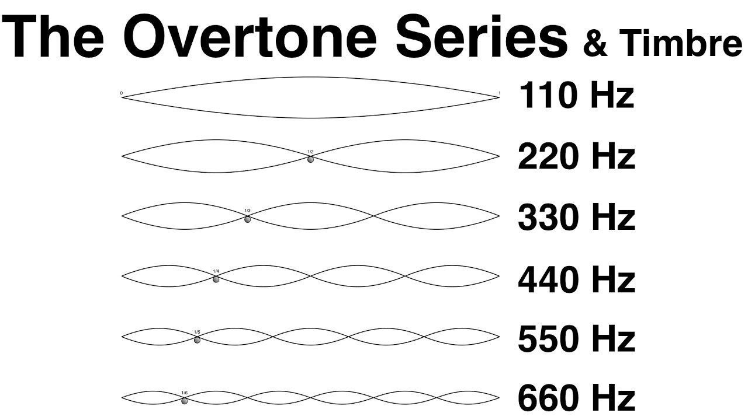

Expert Explanation:

Overtones are higher-frequency components that accompany the fundamental frequency of a sound. When a musical instrument, like a piano, produces a note, it's not just a single pure tone but a combination of various frequencies. The fundamental frequency is the lowest, defining pitch, while overtones are multiples of that frequency.

For instance, if the fundamental frequency is 100 Hz, the first overtone would be at 200 Hz, the second at 300 Hz, and so on. Overtones give each instrument its unique sound, known as timbre. In the case of a piano, overtones contribute to the richness and complexity of the music we hear.

When sampling sound, especially music, it's crucial to capture not only the fundamental frequency but also these overtones. They play a significant role in creating the true essence and character of the sound. Lower sampling rates might miss these higher-frequency components, resulting in a less authentic representation of the instrument.

Teen-Friendly Explanation:

Okay, let's break down overtones! Imagine your favorite song as a recipe. The main ingredient is the fundamental frequency, like the main spice in your dish. Now, overtones are like extra flavors that make the dish (or music) super tasty.

So, when a guitar string vibrates, it doesn't just make one sound; it's like a mix of different notes, kind of like a secret recipe. The main note is the fundamental frequency, and the extra notes are the overtones. They give each instrument its special taste, making a guitar sound different from a piano, even if they play the same note.

Now, if we don't catch these extra flavors when we record music (sampling), it's like having a bland dish without all the yummy spices. So, when we talk about sampling rates, we want to make sure we capture not just the main taste but all those delicious overtones to keep the music sounding rich and authentic!

Key Takeaways:

* Sampling rate is a crucial factor in digital audio quality.
* The Nyquist frequency sets a minimum threshold for accurate representation.
* Aliasing can occur when sampling rates are too low.
* Low-pass filters help prevent aliasing.
* Different sampling rates are used for various applications, balancing quality and efficiency.
* Overtones play a vital role in the richness of musical sounds.

SAMPLE SIZE: CAPTURING SOUND'S DYNAMIC RANGE

Measuring Sound's Nuances: Sample size, measured in bits, determines the dynamic range of a digital audio system. It dictates the precision with which amplitude measurements are stored, defining the range from the softest to the loudest sounds that can be accurately represented.

Creating a Digital Palette: Each additional bit doubles the number of possible amplitude levels, expanding the dynamic range. Imagine each bit as a brushstroke, adding finer detail to the audio painting.

Decibels: Quantifying Sound's Intensity:

Logarithmic Perception: Human hearing perceives sound intensity logarithmically, meaning we're more sensitive to changes in softer sounds than louder ones. The decibel (dB) scale reflects this, measuring sound intensity relative to a reference level.

Bels and Decibels: Honoring Bell's Legacy: The bel, named after Alexander Graham Bell, represents a tenfold increase in sound intensity. The decibel, one-tenth of a bel, signifies a barely perceptible change in intensity (about 1.26 times).

Calculating Dynamic Range:

The dynamic range in decibels between two sounds is calculated using the formula:



The dynamic range of a sound system, measured in decibels (dB), depends on the sample size, which represents the number of bits used to store the amplitude information of each sample. A larger sample size allows for a greater difference between the softest and loudest sounds, resulting in a higher dynamic range.

The formula to calculate the dynamic range for a given sample size is:



To figure out how much space we need for uncompressed audio, here's a simple formula:



For example, an hour of CD-quality sound (44,100 samples per second, 16 bits per sample, stereo) needs about 635 megabytes of storage, roughly what a CD can hold. So, the more bits and channels, the more space we need to keep all those musical details intact!

Common Sample Sizes and Their Impact:

8-bit Audio: Offers a dynamic range of about 48 dB, suitable for basic applications like voice recordings or sound effects.

16-bit Audio: Widely used in CDs and many digital audio systems, providing a dynamic range of approximately 96 dB, capturing a vast range of sounds from subtle whispers to powerful crescendos.

24-bit Audio: Often found in professional audio production, offering an impressive dynamic range of about 144 dB, capturing even the most delicate nuances and ensuring ample headroom for further processing.

Storage and Data Representation:

Storing Samples: Windows supports both 8-bit (unsigned bytes) and 16-bit (signed integers) samples.

Silence in Data: Silence is represented by 0x80 values for 8-bit samples and a string of zeros for 16-bit samples.

Calculating Uncompressed Audio Storage:

Factors Affecting Storage: Duration (seconds), sampling rate (samples/second), sample size (bits/sample), and number of channels (mono/stereo) determine storage requirements.

Example: An hour of CD-quality stereo audio (44,100 samples/second, 16 bits/sample, 2 channels) requires about 635 megabytes of storage.

GENERATING SINE WAVES

PCM and Sampling Rate: Digital audio relies on Pulse Code Modulation (PCM), which involves sampling sound waves at a fixed rate (e.g., 11,025 Hz).

Sine Waves in Software: The sin function from the C library generates sine wave values, enabling software-based sine wave creation.

Phase Angle: The Key to Continuity: Maintaining a consistent phase angle between samples ensures smooth wave generation, avoiding discontinuities.

To generate a sine wave, you can follow the approach described in your text using the sin function and maintaining a phase angle variable. Here's a step-by-step guide to generating a sine wave in software:

* Determine the sample rate: The sample rate represents the number of samples per second. In your example, the sample rate is assumed to be 11,025 Hz.
* Determine the desired frequency: Decide on the frequency of the sine wave you want to generate. For example, let's say you want to generate a sine wave with a frequency of 1000 Hz.
* Calculate the number of samples per cycle: Divide the sample rate by the desired frequency. In this case, 11,025 Hz / 1000 Hz = 11 samples per cycle.
* Initialize the phase angle variable: Start with a phase angle of 0 degrees.
* Generate the waveform data: Iterate over the samples in the buffer and calculate the sine value for each sample based on the phase angle. Scale the sine value to the desired amplitude and store it in the buffer. Increment the phase angle based on the formula:



* If the phase angle exceeds 2π radians, subtract 2π radians.
* Repeat the waveform: If you need to generate a continuous waveform, repeat the samples for one cycle over and over again in subsequent buffers. Keep incrementing the phase angle without reinitializing it to zero.

SINWAVE.C PROGRAM

Sine Wave Generation:

In the sine wave generation aspect of the code, the mathematical foundation lies in the use of the sin function from the math.h library. This function generates a sine wave, a fundamental waveform in audio processing. The frequency of this sine wave is a crucial parameter, dictating the pitch or tone of the generated sound.

The frequency is stored in the variable iFreq, which serves as a dynamic parameter allowing users to adjust the pitch according to their preferences. This user-adjustable feature adds a layer of interactivity to the application, allowing users to explore different auditory experiences.

Audio Playback:

The program employs the Windows waveform audio API for audio playback. This API facilitates communication with the audio hardware, enabling the program to play the generated sine wave.

To ensure a smooth and uninterrupted audio experience, the program utilizes two buffers, namely pBuffer1 and pBuffer2. These buffers operate in tandem, each holding portions of the sine wave data. As one buffer is played, the program simultaneously fills the other, ensuring a continuous stream of audio. This approach prevents gaps or glitches in the playback, providing a seamless auditory output.

User Interface:

The user interface of the application is presented through a dialog box, a graphical window that encapsulates various controls for user interaction. Among these controls is a scroll bar with the identifier IDC_SCROLL.

This scroll bar serves as an intuitive tool for users to dynamically adjust the frequency of the generated sine wave. As users move the scroll bar, the associated frequency (iFreq) is updated in real-time, offering a responsive and interactive means of controlling the auditory output.

The "On/Off" button (identified by IDC_ONOFF) serves a pivotal role in initiating or halting the generation and playback of the sine wave.

This button allows users to toggle the audio output on and off, providing a straightforward control mechanism for the application's core functionality.

The state of this button, whether it indicates "On" or "Off," directly influences the audio playback status.

A text box (identified as IDC_TEXT) complements the scroll bar by displaying the current frequency of the sine wave. This visual representation offers users a clear indication of the numerical value associated with the audible pitch. Furthermore, users can manually input a frequency in this text box, providing an alternative means of controlling the auditory experience.

Initialization:

In the initialization phase, the program sets up crucial variables, including the waveform format (WAVEFORMATEX), buffers, and headers. The sample rate is fixed at 11,025 Hz, providing a standard rate for audio playback. Additionally, the default frequency, initially set to 440 Hz, establishes a baseline pitch for the sine wave generation. This phase ensures that essential components are appropriately configured, laying the foundation for the subsequent audio processing.

Dynamic Frequency Adjustment:

The application introduces dynamic frequency adjustment, empowering users to control the pitch of the generated sine wave. This adjustment can be performed through a scroll bar or manual input.

The program, in response to these changes, dynamically updates the frequency parameter, thereby influencing the ongoing audio playback. This dynamic adjustment feature enhances the user experience, allowing real-time exploration of various auditory tones.

Waveform Continuous Playback:

Upon pressing the "On" button, the program enters a phase of continuous waveform playback. This involves memory allocation for buffers and headers, opening the waveform audio device, preparing headers, and initiating the playback process.

The seamless and uninterrupted playback is achieved by cyclically filling and writing new buffers as the audio progresses. This approach ensures a continuous stream of sound without interruptions, providing a smooth auditory experience for the user.

Shutdown and Cleanup:

Pressing the "Off" button halts the audio playback by invoking waveOutReset, a function that stops the playback and resets the audio device. Additionally, this action involves freeing the memory allocated for buffers and headers, ensuring proper resource cleanup.

The program is designed to handle both user-initiated shutdowns through the "Off" button and system close commands (SC_CLOSE), guaranteeing a comprehensive cleanup process before termination.

Main Functionality:

* Adjustable Frequency: Users are granted control over the frequency of the generated sine wave, allowing them to tailor the auditory experience to their preferences.
* On/Off Playback: The "On/Off" button serves as a central control for initiating or stopping the continuous playback of the sine wave. This functionality provides users with direct control over the audio output.
* Real-time Adjustment: Frequency adjustments take immediate effect during playback, enabling users to dynamically explore different pitches in real-time. This real-time responsiveness enhances the interactive nature of the application, offering users a hands-on experience with audio manipulation.

In summary, the application encapsulates a comprehensive set of functionalities, combining initialization, dynamic frequency adjustment, continuous waveform playback, and efficient shutdown procedures to create an interactive and user-friendly audio generator.

*I skipped the simple parts of the program, by now creating windows, and such, shouldn’t be a challenge. But I need to explain these remaining parts…*

Constants and Variables:

The program defines constants like OUT_BUFFER_SIZE, SAMPLE_RATE, and PI at the beginning. These constants are used in the FillBuffer routine.

The iFreq argument in the FillBuffer routine represents the desired frequency in Hz. It is adjustable by the user.

Scaling of Sine Wave:

The sine wave is generated using the sin function from the math.h library.

The result of the sin function is scaled to range between 0 and 254 for each sample.

Frequency Adjustment:

The fAngle argument to the sin function is increased by 2 * pi * frequency / sample rate for each sample. This dynamic adjustment allows for changes in frequency over time.

User Interface:

The SINEWAVE window contains three controls: a horizontal scroll bar for selecting frequency, a static text field indicating the selected frequency, and a push button labeled "Turn On."

When the "Turn On" button is pressed, a sine wave is played through the speakers. The button text changes to "Turn Off." Pressing the button again turns off the sound.

Initialization and Scroll Bar:

During the WM_INITDIALOG message, the scroll bar is initialized with a minimum frequency of 20 Hz, a maximum frequency of 5000 Hz, and an initial frequency of 440 Hz.

Frequency Adjustment Handling:

The DlgProc function handles WM_HSCROLL messages, adjusting the frequency based on user interactions with the scroll bar. Page Left and Page Right cause a decrease or increase in frequency by one octave.

Memory Allocation and Waveform Audio Device:

Upon receiving a WM_COMMAND message from the button, the program allocates memory for WAVEHDR structures and two buffers (pBuffer1 and pBuffer2) to hold waveform data.

The waveform audio device is opened for output using waveOutOpen. It allows specifying device ID, waveform format, callback information, and flags.

Device Selection:

The device ID can be specified as WAVE_MAPPER, allowing the system to choose the preferred device as indicated in the Audio tab of the Multimedia applet in the Control Panel.

Callback Function and Flags:

The fourth argument to waveOutOpen can be either a window handle or a pointer to a callback function. The dwFlags argument indicates the type of the fourth argument (window or function).

Flags like CALLBACK_WINDOW or CALLBACK_FUNCTION specify the nature of the callback.

Waveform Format:

The third argument to waveOutOpen is a pointer to a WAVEFORMATEX structure, which is not detailed in the provided notes. It likely contains information about the audio format.

Waveform Format Structure (WAVEFORMATEX):

The WAVEFORMATEX structure is explained, containing fields such as wFormatTag, nChannels, nSamplesPerSec, nAvgBytesPerSec, nBlockAlign, wBitsPerSample, and cbSize.

This structure is used to specify essential parameters like sample rate, sample size, and number of channels. For PCM, it simplifies configuration.

Configuration for PCM:

For PCM, the nBlockAlign field is set to the product of nChannels and wBitsPerSample divided by 8, representing the total bytes per sample.

The nAvgBytesPerSec field is set to the product of nSamplesPerSec and nBlockAlign.

Waveform Audio Device Initialization:

SINEWAVE initializes the WAVEFORMATEX structure and opens the waveform audio device using waveOutOpen.

The function returns MMSYSERR_NOERROR if successful. Otherwise, the program cleans up and displays an error message.

Wave Header Structure (WAVEHDR):

The WAVEHDR structure is introduced, representing a buffer of waveform audio data.

Fields include lpData (pointer to data buffer), dwBufferLength (length of data buffer), dwBytesRecorded (used for recording), dwUser (for program use), dwFlags (flags), dwLoops (number of repetitions), lpNext (reserved), and reserved (reserved).

Initialization of WAVEHDR Structures:

SINEWAVE initializes the fields of two WAVEHDR structures, setting lpData to the buffer address, dwBufferLength to the buffer size, and dwLoops to 1. Other fields are set to 0 or NULL.

Waveform Data Preparation:

The program calls waveOutPrepareHeader for the two headers to prevent the structure and buffer from being swapped to disk. This ensures proper initialization before playback.

MM_WOM_OPEN Message:

The waveOutOpen function posts a MM_WOM_OPEN message to the program's message queue, with the wParam parameter set to the waveform output handle.

In response, SINEWAVE calls FillBuffer twice to fill the buffer with sine wave data and then passes the two WAVEHDR structures to waveOutWrite to start sound playback.

Repetitive Sound Playback:

If you want to play a repeated loop of sound, you can specify that using the dwFlags and dwLoops fields in the WAVEHDR structure.

MM_WOM_DONE Message Handling:

When the waveform hardware finishes playing the data submitted through waveOutWrite, an MM_WOM_DONE message is posted to the program's message queue.

SINEWAVE processes this message by calculating new values for the buffer and resubmitting it through another call to waveOutWrite.

The use of two WAVEHDR structures and double-buffering prevents gaps in the sound, ensuring a continuous and smooth playback experience.

Waveform Hardware Shutdown:

When the user clicks the "Turn Off" button, the program sets the bShutOff variable to TRUE and calls waveOutReset.

waveOutReset stops sound processing and generates an MM_WOM_DONE message.

When bShutOff is TRUE, SINEWAVE processes MM_WOM_DONE by calling waveOutClose, which, in turn, generates an MM_WOM_CLOSE message.

MM_WOM_CLOSE Message Processing:

Processing of MM_WOM_CLOSE involves cleanup operations.

SINEWAVE calls waveOutUnprepareHeader for the two WAVEHDR structures, frees allocated memory blocks, and sets the text of the button back to "Turn On."

Handling System Close Command (WM_SYSCOMMAND):

When the user selects "Close" from the system menu, the program processes the WM_SYSCOMMAND message with wParam set to SC_CLOSE.

If waveform audio is still playing, waveOutReset is called. Regardless, EndDialog is eventually called to close the dialog box and end the program.



RECORD.C PROGRAM

Initialization and Memory Allocation:

In the program's initialization phase, constants are defined, and essential headers, including windows.h and the program-specific resource.h, are included. These headers provide necessary declarations and definitions for Windows programming. Following this, the WinMain function is introduced, which serves as the entry point for the program.

Inside WinMain, the program allocates memory for two critical components: wave headers and the save buffer. The wave headers (pWaveHdr1 and pWaveHdr2) are structures used in handling audio data, while the save buffer (pSaveBuffer) is employed to store the recorded audio data. This allocation of memory is a crucial step in preparing the program to work with audio input and output.

The conditional check for running on Windows NT adds a layer of platform-specific behavior. If the program is executing on Windows NT, it proceeds to display the main dialog box. This decision-making based on the operating system ensures that the program operates appropriately on different Windows environments.

ReverseMemory Function:

The ReverseMemory function is a utility function designed to reverse the order of bytes within a given memory buffer. This function takes a pointer to a memory buffer (pBuffer) and its length (iLength) as parameters. The reversal is accomplished by iterating over the first half of the buffer and swapping each byte with its corresponding byte from the second half.

This function is introduced to facilitate the playback of audio data in reverse. When playing in reverse, the program can use ReverseMemory to invert the order of bytes in the save buffer, effectively reversing the audio sequence. This reversal capability adds a dynamic and interactive element to the program, allowing users to explore different playback options.

Dialog Procedure (DlgProc):

The dialog procedure, DlgProc, serves as the central component for handling messages in the program. It efficiently manages various messages, orchestrating actions in response to user interactions and system events. Let's delve into the specific functionality related to recording setup within the context of the WM_COMMAND message.

Recording Setup:

Within the WM_COMMAND message handling section, the program responds to the user's action of pressing the "Record Begin" button (IDC_RECORD_BEG). This button signifies the initiation of the recording process. The corresponding actions taken by the program involve a series of steps aimed at preparing the system for audio input:

Buffer Memory Allocation:

The program allocates memory for input buffers, essential for temporarily storing incoming audio data. pBuffer1 and pBuffer2 are allocated memory blocks of size INP_BUFFER_SIZE, ensuring sufficient space to handle the incoming audio stream.



These buffers play a crucial role in efficiently handling audio data during the recording process.

Waveform Audio Input Initialization:

The program opens the waveform audio device for input (waveInOpen). It specifies the audio format (WAVEFORMATEX) and provides information about the callback window (hwnd) to receive notifications. If the opening process encounters an error, appropriate actions are taken, such as freeing allocated memory and displaying an error message.

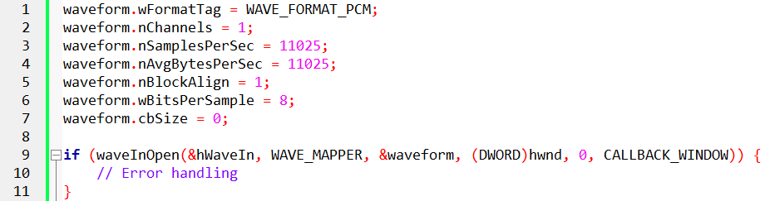

Wave Headers Setup:

Wave headers (pWaveHdr1 and pWaveHdr2) are structures that provide information about audio data. These structures are initialized with relevant details, including buffer pointers, sizes, and loop configurations. The waveInPrepareHeader function prepares these headers for use during the recording process.

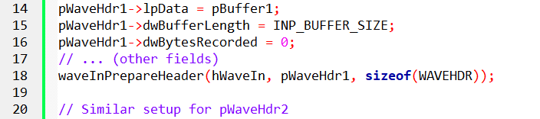

Recording Start:

Finally, the program starts the recording process by adding the initialized wave headers to the input buffer queue (waveInAddBuffer) and initiating the audio input (waveInStart).



These actions collectively set up the recording environment, ensuring that the program is ready to capture and process incoming audio data. The allocation of memory, initialization of audio input parameters, and setup of wave headers are integral to the effective handling of the recording functionality.

Recording Data Processing:

Upon receiving the MM_WIM_DATA message, the program executes crucial actions related to processing recorded data. This message signifies the availability of new audio data for the program to handle. The program responds with the following steps:

Memory Reallocation for Save Buffer:

The program reallocates memory for the save buffer (pSaveBuffer) to accommodate the incoming recorded data. The realloc function is employed to adjust the size of the save buffer, ensuring it can hold the additional data.

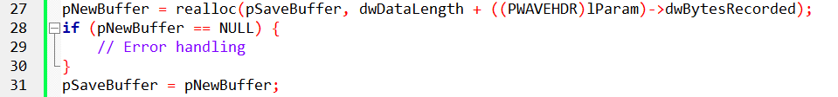

Data Copying:

The recorded data from the current buffer (lParam) is copied into the save buffer at the appropriate position. This ensures that the save buffer accumulates the complete recorded audio data.



Buffer Handling and Continuation:

If the program is in the process of ending (bEnding is true), it closes the input waveform audio device (waveInClose). Otherwise, it adds a new buffer to the input buffer queue to facilitate continuous recording.

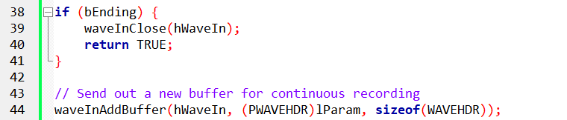

Message Processing Completion:

The function concludes by returning TRUE, indicating successful processing of the MM_WIM_DATA message.

Playing Setup:

Under the WM_COMMAND message, when the "Play Begin" button (IDC_PLAY_BEG) is pressed, the program takes specific actions to set up and commence the playback process:

Waveform Audio Output Initialization:

The program opens the waveform audio device for output (waveOutOpen). It specifies the audio format (WAVEFORMATEX) and provides information about the callback window (hwnd) to receive notifications. If the opening process encounters an error, appropriate actions are taken.

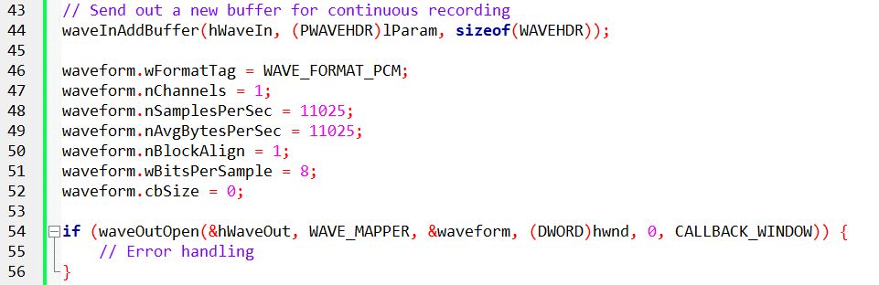

Wave Headers Setup for Playback:

Wave headers (pWaveHdr1) are initialized with relevant details, including buffer pointers, sizes, and loop configurations. The waveOutPrepareHeader function prepares these headers for use during the playback process.

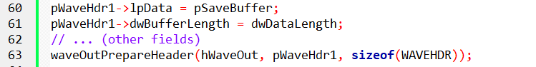

Playback Initiation:

The program initiates the playback process by writing the prepared header to the output buffer (waveOutWrite). The playback is now in progress.



These actions collectively prepare the system for audio output, initializing the waveform audio device and commencing the playback of recorded audio data. The playback setup ensures that the audio data stored in the save buffer is played through the audio output device.

Playback Data Processing:

The program handles the MM_WOM_DONE message, which is triggered when the playback of a buffer is completed. This message initiates the following actions:

Header Unpreparation and Output Closing:

The program unprepares the wave header (pWaveHdr1) and closes the waveform audio output device (waveOutClose) after the completion of buffer playback.

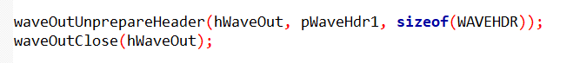

Cleanup:

Additional cleanup operations, such as resetting variables and managing the state of the program, are performed to ensure proper termination of the playback process.

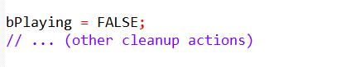

Reverse Playback Handling:

If the program was in reverse playback mode (bReverse is true), it reverses the order of bytes in the save buffer to prepare for future reverse playback.

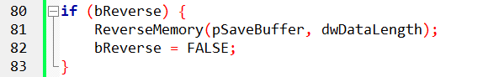

Termination Check:

If the program is in the process of terminating (bTerminating is true), it sends a close command to the main window (WM_SYSCOMMAND, SC_CLOSE).



This section of the program manages the aftermath of buffer playback, ensuring that the audio output is handled appropriately, and resources are released.

User Interaction:

The dialog procedure handles various aspects of user interaction, including enabling or disabling buttons based on the program's state. Additionally, it manages system commands, such as closing the program, under the WM_SYSCOMMAND message.

The state-dependent enabling or disabling of buttons ensures that users interact with the program in a way that aligns with its current functionality. The handling of system commands ensures a smooth and controlled termination of the program.

MORE EXPLANATIONS FOR CLARITY

Recording Sound Data Handling:

The program, during recording, continuously receives sound data through the waveInAddBuffer function and processes it using the MM_WIM_DATA message.

Recording continues until the user presses the End button (IDC_RECORD_END) or the program runs out of memory for the save buffer.

The program efficiently reallocates the save buffer using the realloc function, accommodating the growing sound data.

In case of a reallocation failure, the program gracefully handles it by calling waveInClose to stop recording.

End of Recording:

When the user presses the End button (IDC_RECORD_END), the program sets the bEnding flag to TRUE and calls waveInReset to stop recording.

The waveInReset function generates an MM_WIM_DATA message containing a partially filled buffer, and RECORD1 responds to this message, closing the waveform input device by calling waveInClose.

The waveInClose message generates an MM_WIM_CLOSE message, and RECORD1 responds by freeing the 16K input buffers and enabling/disabling appropriate push buttons.

Playback Setup and Execution:

When the user selects the Play button (IDC_PLAY_BEG), the program initializes the fields of a WAVEFORMATEX structure, calls waveOutOpen, and generates an MM_WOM_OPEN message.

During this message, the program enables/disables the appropriate push buttons, initializes the fields of the WAVEHDR structure with the save buffer, prepares it using waveOutPrepareHeader, and starts playing it with waveOutWrite.

The program processes the MM_WOM_DONE message when playback is completed, unprepares the header, and calls waveOutClose.

The waveOutClose function generates an MM_WOM_CLOSE message, and RECORD1 responds by enabling/disabling appropriate buttons.

Additional Playback Controls:

The program includes buttons for Pause, Resume, Reverse, Repeat, and Speedup during playback, each generating specific WM_COMMAND messages.

The Pause button, when pressed, calls waveOutPause to halt the sound and changes its text to "Resume." Pressing Resume resumes playback using waveOutRestart.

Reverse button reverses the order of bytes in the save buffer, enhancing the playback experience.

Repeat button utilizes the API's provision for repeating a sound by setting the dwLoops and dwFlags fields in the WAVEHDR structure.

Speedup button plays the sound twice as fast by adjusting the nSamplesPerSec and nAvgBytesPerSec fields in the WAVEFORMATEX structure.

Handling Memory Allocation and Deallocation:

The program allocates and deallocates memory for various buffers and structures during the WM_INITDIALOG, MM_WIM_OPEN, MM_WIM_DATA, MM_WIM_CLOSE, MM_WOM_OPEN, and MM_WOM_CLOSE messages.

It effectively uses realloc to adjust the size of the save buffer during recording, ensuring efficient memory usage.

MCI: A STREAMLINED APPROACH TO WAVEFORM AUDIO

While the low-level waveform audio interface offers extensive control, it can introduce complexity in terms of memory management and message handling. The Media Control Interface (MCI) emerges as a high-level alternative, providing a more streamlined approach to waveform audio tasks within Windows applications.

Key Differences and Trade-offs:

File-Based Operation: MCI operates on waveform files, recording audio data to files and playing it back from them. This contrasts with the low-level interface's direct manipulation of audio hardware.

Versatility vs. Ease of Use: The low-level interface grants greater flexibility for special effects and real-time processing, while MCI often simplifies common recording and playback scenarios.

Two Forms of MCI:

Message-Based MCI:

* Employs messages and data structures for communication with multimedia devices.
* Offers a structured approach for programmatic control.

Text-Based MCI:

* Utilizes ASCII text strings for device control.
* Designed for scripting languages but adaptable for interactive use.
* Demonstrated in the TESTMCI program.

RECORD2: A Message-Based MCI Example

* Employs message-based MCI to implement a digital audio recorder and player.
* Shares a dialog box template with RECORD1 (a low-level interface example).
* Omits special effects buttons due to MCI's file-based nature.

Considerations for Choosing an Interface:

* Special Effects: If real-time audio manipulation or special effects are crucial, the low-level interface might be necessary.
* Ease of Use: For standard recording and playback without extensive audio processing, MCI often provides a simpler development experience.
* File Handling: MCI's file-based nature can simplify file management tasks for storage and retrieval of audio data.

RECORD2.C Overview:

The RECORD2.C file encapsulates the source code for a Waveform Audio Recorder program devised by Charles Petzold in 1998.

Unlike its predecessor, RECORD1, this program streamlines sound recording and playback tasks through the utilization of the Media Control Interface (MCI).

RECORD2 primarily centers around file-based recording and playback, eschewing the incorporation of special audio effects.

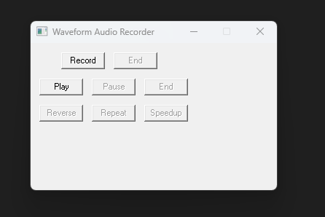

WinMain Function:

The WinMain function acts as the pivotal entry point for the application.

It endeavors to initiate the primary dialog box, defined within the DlgProc function, through the DialogBox function.

In the event that the function returns -1, indicative of an error, a message box is triggered to inform the user that the program necessitates Windows NT for proper execution.

This initial function, therefore, orchestrates the commencement of the application, attempting to establish the user interface through the designated dialog box.

The reliance on the DialogBox function underlines the event-driven nature of the graphical user interface, where user interactions with the dialog box components trigger corresponding actions within the program.

Furthermore, the Windows NT requirement is communicated to the user through a message box, enhancing the program's accessibility and providing transparency regarding its system dependencies.

ShowError Function:

The ShowError function plays a crucial role in enhancing user experience by providing clear and informative error messages in the case of MCI-related errors.

This function serves as a mechanism to bridge the gap between potentially cryptic error codes and user comprehension.

When MCI operations encounter errors, the ShowError function comes into play, leveraging the mciGetErrorString function to convert error codes into human-readable error messages.

This conversion enhances the program's user-friendliness by presenting users with intelligible information about the nature of the encountered issue.

The subsequent display of the error message within a message box, adorned with an exclamation icon, not only draws attention to the issue but also aids in rapid identification and resolution.

DlgProc Function:

The DlgProc function stands as the backbone of the program, acting as the dialog box procedure responsible for managing various messages to dictate the program's behavior.

Through the use of static variables, the function keeps track of essential states, including whether the program is currently recording, playing, or paused, as well as the filename designated for saving the recorded audio.

This meticulous state management is integral to orchestrating seamless transitions between different phases of the program's execution.

The function efficiently processes messages associated with specific buttons on the dialog box, such as record begin, record end, play begin, play pause, and play end.

Each button press triggers a series of actions, influencing the flow of the program. For instance, when the "Record Begin" button is pressed, the function initiates the recording process, updating button states and focusing on the appropriate UI elements.

Similarly, the handling of errors, as facilitated by the ShowError function, contributes to a robust and user-friendly application, ensuring that users are informed about issues promptly and comprehensibly.

The comprehensive nature of DlgProc reflects the intricate interplay between user interactions and program responses in the realm of audio recording and playback.

Recording:

Upon pressing the "Record Begin" button, the program undertakes several key actions to initiate the recording process.

Firstly, any existing waveform files are deleted, ensuring a clean slate for the upcoming recording.

Subsequently, the program leverages the Media Control Interface (MCI) to open the waveform audio device, a crucial step in preparing for recording.

This initialization phase involves configuring the necessary parameters for audio recording.

Once the setup is complete, the program commences the recording process, capturing audio input and updating the button states to reflect the ongoing operation.

This seamless integration of file management and MCI functionalities showcases the program's efficiency in handling recording tasks.

Stopping Recording:

Pressing the "Record End" button signifies the end of the recording session.

The program responds by stopping the recording process, saving the recorded audio file, and closing the waveform device.

These steps ensure the proper termination of the recording session and the preservation of the recorded audio.

Additionally, the program adjusts button states to reflect the conclusion of the recording operation, providing a clear and intuitive user interface.

Playback:

The "Play Begin" button triggers the playback functionality in the program.

Leveraging MCI, the program opens the recorded waveform file and initiates the playback process.

This phase showcases the program's versatility, seamlessly transitioning from recording to playback.

Button states are updated accordingly, reflecting the transition from the recording phase to the playback phase.

Pausing and Resuming Playback:

The "Play Pause" button introduces a dynamic element to the playback experience, allowing users to toggle between pausing and resuming playback.

This interactivity is facilitated by adjusting the button text to reflect the current state—whether it's in a paused or playing state.

Such functionality enhances user control and engagement during the playback phase.

Stopping Playback:

Pressing the "Play End" button serves as the mechanism to halt and close the playback operation.

Similar to the recording counterpart, this action ensures the proper termination of playback, and button states are updated to communicate the completion of the playback session.

MM_MCINOTIFY Handling:

The program is equipped to handle MCI notifications, specifically focusing on MCI_NOTIFY_SUCCESSFUL.

In the context of playback or recording, when this notification is received, the corresponding end actions are triggered.

This meticulous handling ensures that the program responds appropriately to the completion of these operations.

WM_SYSCOMMAND Handling:

The handling of system commands, specifically the close button (SC_CLOSE), is crucial for ensuring a clean exit from the program.

If recording or playback is in progress when the close button is pressed, the program simulates a button press to either stop recording or stop playback, ensuring proper cleanup before closing the dialog box.

This thoughtful approach enhances the user experience and prevents potential issues associated with abrupt program termination.

RECORD2 PROGRAM MORE EXPLANATION FOR CLARITY

In RECORD2, the central MCI function employed is mciSendCommand(wDeviceID, message, dwFlags, dwParam).

This function plays a pivotal role in communicating with the MCI device, utilizing various MCI command messages.

The first argument, wDeviceID, acts as a numeric identifier for the device, functioning similarly to a handle. Obtained during the device's opening, it is used consistently in subsequent mciSendCommand calls.

The second argument, message, represents MCI command messages, each prefixed with MCI. RECORD2 utilizes seven of these commands: MCI_OPEN, MCI_RECORD, MCI_STOP, MCI_SAVE, MCI_PLAY, MCI_PAUSE, and MCI_CLOSE.

These commands govern different aspects of the MCI device's behavior during recording, playback, and control operations.

The dwFlags argument in mciSendCommand generally comprises bit flag constants, combined with the bitwise OR operator, indicating various options. These options are specific to particular command messages or common across all messages.

The dwParam argument typically involves a long pointer to a data structure associated with the specific command message. These structures convey options to the device and obtain information from it. Many MCI messages have unique data structures associated with them.

The success or failure of the mciSendCommand function is indicated by its return value. A return value of zero signifies success, while an error code indicates an unsuccessful operation. To inform the user of errors, the mciGetErrorString function can be utilized, providing a text string describing the encountered error.

When the user initiates recording by pressing the "Record Begin" button, RECORD2's window procedure receives a WM_COMMAND message with wParam equal to IDC_RECORD_BEG.

Subsequently, RECORD2 opens the device by configuring an MCI_OPEN_PARMS structure and invoking mciSendCommand with the MCI_OPEN command message. The lpstrDeviceType field is set to "waveaudio" to indicate the device type for recording, and the lpstrElementName field is set to a zero-length string.

During recording, sound data is temporarily stored on the hard disk in a temporary file and is later transferred to a standard waveform file. When playing back the recorded sound, MCI utilizes the sampling rate and sample size defined in the waveform file. The specifics of waveform file formats are anticipated to be discussed later in the chapter, offering a deeper understanding of the underlying mechanisms.

Handling Device Opening Errors:

When attempting to open a device, RECORD2 checks for errors. If the device opening fails, the program utilizes mciGetErrorString and MessageBox to communicate the nature of the problem to the user. On successful device opening, the wDeviceID field of the MCI_OPEN_PARMS structure stores the device ID, crucial for subsequent calls.

Initiating Recording:

To commence recording, RECORD2 uses mciSendCommand with the MCI_RECORD command message and the MCI_WAVE_RECORD_PARMS data structure. Optionally, users can set the dwFrom and dwTo fields to insert sound into an existing waveform file. The dwCallback field is set to the program's window handle, and the MCI_NOTIFY flag ensures a notification message is sent when recording concludes.

Stopping Recording:

Pressing the first "End" button triggers the WM_COMMAND message with wParam equal to IDC_RECORD_END. In response, the window procedure calls mciSendCommand three times: MCI_STOP halts recording, MCI_SAVE transfers sound data from the temporary file to the specified file ("record2.wav"), and MCI_CLOSE deletes temporary files or memory blocks and closes the device.

Initiating Playback:

For playback, the lpstrElementName of the MCI_OPEN_PARMS structure is set to "record2.wav." The MCI_OPEN_ELEMENT flag indicates a valid filename, and the program uses the MCI_OPEN command message to open the waveform audio device, recognizing the .WAV extension.

Controlling Playback:

Playing involves an mciSendCommand call with the MCI_PLAY command message and an MCI_PLAY_PARMS structure. While any part of the file can be played, RECORD2 chooses to play it all. The "Pause" button generates a WM_COMMAND message with wParam equal to IDC_PLAY_PAUSE, prompting the program to pause or resume playback.

Ending Playback:

Pressing the second "End" button generates a WM_COMMAND message with wParam equal to IDC_PLAY_END. The window procedure responds with two mciSendCommand calls: MCI_STOP to halt playback and MCI_CLOSE to close the device.

MCI Notification Message:

The MCI notification message plays a crucial role in determining when a file has completed during playback. When a recording or playback operation is successful, the corresponding MCI_NOTIFY_SUCCESSFUL notification triggers actions in the window procedure. This ensures proper handling and synchronization, allowing the program to respond appropriately to the completion of recording or playback operations.

MCI_NOTIFY_ABORTED:

When the MCI_STOP or MCI_PAUSE command is sent via mciSendCommand, the program receives an MM_MCINOTIFY message with wParam set to MCI_NOTIFY_ABORTED. This happens when the user clicks the Pause button or either of the two End buttons. The program already handles these cases appropriately, so no further action is needed upon receiving this notification.

MCI_NOTIFY_SUCCESSFUL during playback:

When the sound file finishes playing, an MM_MCINOTIFY message is received with wParam set to MCI_NOTIFY_SUCCESSFUL. In response, the program simulates the user pressing the "End" button by sending itself a WM_COMMAND message with wParam set to IDC_PLAY_END. This triggers the program to stop playback and close the device, ensuring proper handling of the completion event.

MCI_NOTIFY_SUCCESSFUL during recording:

If the temporary sound file runs out of disk space while recording, an MM_MCINOTIFY message arrives with wParam set to MCI_NOTIFY_SUCCESSFUL. Despite the term "successful," it indicates an unexpected condition—exhaustion of storage space for the temporary file.

In this case, the program sends itself a WM_COMMAND message with wParam set to IDC_RECORD_END. The program then stops recording, saves the file, and closes the device, following the normal procedures despite the unexpected completion event.

MCI COMMAND STRING APPROACH

Purpose: MCI command strings offer a simplified text-based mechanism for controlling multimedia devices.

Syntax: They follow a structured format, specifying the device type, command, and optional parameters (e.g., "open waveaudio alias mySound").

Convenience: They often reduce code complexity compared to using MCI's message-based API.

mciExecute: A Custom Implementation:

* While not part of the standard Windows API, a custom mciExecute function is used in RECORD3 to streamline MCI command execution.
* Parameters: It accepts a single string argument containing the MCI command to be executed.
* Error Handling: It encapsulates error checking and feedback using mciGetErrorString and MessageBox.
* Return Value: It returns a Boolean value indicating success or failure.

RECORD3: Utilizing mciExecute for Audio Operations:

* Approach: RECORD3 leverages mciExecute for tasks like opening, recording, playing, pausing, and closing the waveform audio device.
* User Interface: It maintains the same dialog box interface as RECORD1 and RECORD2.
* Resource Files: It reuses the RECORD.RC resource script and RESOURCE.H header file for consistency.

Key Advantages of MCI Command Strings:

* Readability: Text-based commands can be more intuitive for developers familiar with command-line interfaces.
* Conciseness: They often require less code compared to message-based approaches.
* Compatibility: MCI command strings are generally supported across different Windows platforms.

Considerations:

* Flexibility: The message-based API can offer finer control over device interactions in certain scenarios.
* Error Handling: Custom mciExecute implementations should ensure robust error handling.
* Best Practices: Adhere to recommended coding conventions and error handling strategies for reliable applications.

RECORD3 PROGRAM STRING APPROACH

The provided program, RECORD3.C, is a simple waveform audio recorder application that utilizes the MCI (Media Control Interface) string approach for audio recording and playback. Let's break down its functionality:

The program's entry point is the WinMain function. It creates a dialog box using the DialogBox function, which is defined in a separate resource file. If the dialog box fails to be created, an error message is displayed.

The DlgProc function serves as the dialog box procedure. It handles various messages, including WM_COMMAND, WM_SYSCOMMAND, and others.

When the user clicks the "Record" button (IDC_RECORD_BEG), the program deletes any existing waveform file and opens a new waveform audio device using the MCI string command open new type waveaudio alias mysound. It then starts recording audio using the command record mysound. The corresponding buttons are enabled or disabled to reflect the recording state.

When the user clicks the "Stop" button (IDC_RECORD_END), the program stops the recording using the command stop mysound, saves the recorded audio to a file named "record3.wav" using the command save mysound record3.wav, and closes the audio device using the command close mysound. The buttons are updated accordingly.

When the user clicks the "Play" button (IDC_PLAY_BEG), the program opens the saved waveform audio file ("record3.wav") using the command open record3.wav alias mysound and starts playing the audio using the command play mysound. The buttons are again updated to reflect the playback state.

If the user clicks the "Pause/Resume" button (IDC_PLAY_PAUSE), the program toggles between pausing and resuming the playback using the commands pause mysound and play mysound. The button text is updated to reflect the current state.

When the user clicks the "Stop" button (IDC_PLAY_END), the program stops the playback using the command stop mysound and closes the audio device using the command close mysound. The buttons are updated accordingly.

The program handles the WM_SYSCOMMAND message to properly handle the close event (clicking the close button or Alt+F4). If recording or playback is in progress, it sends the corresponding stop command before closing the application.

In summary, the program provides a basic user interface to record and play waveform audio using the MCI string commands. It handles button clicks and updates the UI based on the current state of recording or playback.

*What do you mean when you say string approach mean? I don't get? Tell me more. What are some other examples of applications that utilize the MCI string approach for audio recording and playback? Can you explain how the MCI string approach differs from other methods of audio recording and playback? Are there any limitations or drawbacks to using the MCI string approach for audio recording and playback?*

When I mention the "MCI string approach," I am referring to the usage of MCI (Media Control Interface) commands in the form of strings to control audio devices and perform operations such as recording and playback. In this approach, commands are constructed as strings and sent to the MCI subsystem using functions like mciSendString to execute the desired actions.

Here are a few examples of applications that utilize the MCI string approach for audio recording and playback:

* Multimedia players: Many multimedia players, both standalone and embedded in other software, make use of the MCI string approach to control audio playback. They can play various audio formats by sending appropriate MCI commands.
* Sound recorders: Applications that allow users to record audio, like the provided example RECORD3.C, often use the MCI string approach to control the recording functionality. They send MCI commands to open the audio device, start recording, save the recorded audio, and perform other related actions.
* Voice chat and VoIP applications: Some voice chat and Voice over IP (VoIP) applications employ the MCI string approach to handle audio recording and playback. They use MCI commands to control the audio devices and handle real-time audio streaming.

The MCI string approach differs from other methods of audio recording and playback, such as using low-level APIs or dedicated libraries, in a few ways:

* Simplicity: The MCI string approach provides a simplified and high-level interface for controlling audio devices. It allows developers to perform common audio operations without dealing with low-level details.
* Portability: MCI is a standard interface supported by various Windows versions. Applications that use the MCI string approach can be written in a portable manner and run on different Windows platforms without significant modifications.
* Flexibility: The MCI string approach supports a wide range of audio devices and formats. It allows developers to control different audio features, handle multimedia synchronization, and perform operations like recording, playback, seeking, and volume control.

However, there are some limitations and drawbacks to using the MCI string approach:

* Limited control: The MCI string approach provides only a subset of the functionality available through low-level APIs. It may not expose all the advanced features or customization options provided by specific audio hardware or codec libraries.
* Performance considerations: The MCI string approach may not be the most efficient method for real-time audio processing or high-performance applications. For demanding scenarios, direct use of low-level APIs or specialized libraries can be more suitable.
* Platform dependency: While MCI is a Windows standard, it is specific to the Windows platform. Applications that utilize the MCI string approach may not be portable to non-Windows systems without significant modifications or the use of alternative interfaces.
* Lack of modern updates: MCI has been around for a long time and has not received significant updates in recent Windows versions. It may lack support for newer audio technologies or formats.

In summary, the MCI string approach offers simplicity, portability, and flexibility for audio recording and playback in Windows applications. However, it has limitations in terms of control, performance, platform dependency, and lack of modern updates. Developers need to consider these factors when choosing the appropriate method for their specific requirements.

MCI Interfaces in RECORD3:

In exploring the message-based and text-based interfaces to MCI, a close correspondence becomes evident. MCI seamlessly translates command strings into the corresponding command messages and data structures.

However, RECORD3 takes a different approach compared to RECORD2, notably due to the use of the mciExecute function.

Unlike RECORD2, RECORD3 does not utilize MM_MCINOTIFY messages, implying a distinctive interaction pattern.

The consequence of this choice is that RECORD3 lacks automatic awareness of when it finishes playing the waveform file.

As a result, the buttons do not dynamically change state, necessitating manual intervention by the user, who must press the "End" button for the program to recognize readiness for subsequent recording or playback operations.

Alias Keyword in MCI Open Command:

A notable feature in RECORD3's MCI open command is the use of the alias keyword. This allows all subsequent MCI commands to reference the device using the specified alias name. This approach enhances clarity and simplifies command structuring within the program.

Waveform Audio File Format:

Delving into the uncompressed (PCM) .WAV files reveals a specific format, as outlined in Figure 22-6.



Each section of the file is delineated by offsets and consists of various data components.

The "RIFF" chunk signifies the beginning of the file, followed by information such as the size of the waveform chunk, "WAVE" identifier, and details about the format chunk.

Key parameters in the format chunk include the audio format tag, number of channels, sample rate, average bytes per second, block alignment, and bits per sample.

The "data" chunk encapsulates the actual waveform data. Understanding this file format is crucial for working with .WAV files programmatically.

Drawbacks of MCI Execute Function in RECORD3:

While RECORD3 benefits from the simplicity of the mciExecute function, it faces a drawback in not being informed of the completion of waveform file playback.

The absence of MM_MCINOTIFY messages means that the program cannot dynamically update button states based on playback status.

This limitation requires users to manually signal completion by pressing the "End" button.

RIFF FORMAT AND WAVEFORM AUDIO FILE STRUCTURE:

The RIFF (Resource Interchange File Format) serves as an extensive format for multimedia data files, utilizing a tagged file structure composed of identifiable chunks.

Each chunk is denoted by a preceding 4-character ASCII name and a 4-byte chunk size, excluding the 8 bytes required for the chunk name and size. This format ensures a modular and extensible approach to organizing data within a file.

A waveform audio file, following the RIFF format, begins with the "RIFF" identifier, indicating its RIFF nature.

The subsequent 32-bit chunk size signifies the size of the remaining file, excluding the initial 8 bytes.

The actual chunk data starts with the "WAVE" identifier, designating it as a waveform audio chunk.

Following this, the "fmt " identifier (note the trailing blank for a 4-character string) signals a sub-chunk containing the format information of the waveform audio data.

The "fmt " sub-chunk is accompanied by the size of the format information, typically 16 bytes. This information corresponds to the first 16 bytes of the WAVEFORMATEX structure or, as originally defined, a PCMWAVEFORMAT structure incorporating a WAVEFORMAT structure. Key parameters in this structure include:

* nChannels: Indicates whether the audio is monaural (1 channel) or stereo (2 channels).
* nSamplesPerSec: Denotes the number of samples per second, with standard values like 11025, 22050, and 44100 samples per second.
* nAvgBytesPerSec: Represents the sample rate in samples per second multiplied by the number of channels and the size of each sample in bits, divided by 8 and rounded up.
* nBlockAlign: Signifies the number of channels times the sample size in bits, divided by 8 and rounded up.
* wBitsPerSample: Specifies the number of channels times the sample size in bits.

Following the format information, the sub-chunk concludes with the "data" identifier, succeeded by a 32-bit data size and the actual waveform data.

The data consists of consecutive samples, mirroring the format used in low-level waveform audio facilities.

For sample sizes of 8 bits or less, each sample is either 1 byte for monaural or 2 bytes for stereo.

If the sample size ranges from 9 to 16 bits, each sample is 2 bytes for monaural or 4 bytes for stereo. In stereo waveform data, each sample contains the left value followed by the right value.

Despite the necessary inclusion of "fmt " and "data" sub-chunks in a waveform audio file, additional sub-chunks, like "INFO," may coexist.

These sub-chunks can contain further information about the waveform audio file, emphasizing the flexibility and extensibility of the RIFF format.

One critical rule when dealing with tagged files is to ignore chunks that are not relevant or prepared for processing.

This ensures robust handling of files with varying structures, focusing only on the essential sub-chunks for waveform audio data.

Understanding the intricacies of the RIFF format provides valuable insights into how multimedia data, particularly audio, is organized within files. This knowledge is foundational for developers and enthusiasts working with audio file manipulation and processing.

EXPLORING ADDITIVE SYNTHESIS AND TIMBRE IN MUSICAL TONES:

Analyzing musical tones involves understanding fundamental elements such as pitch, volume, and the complex characteristic known as timbre.

Pitch refers to the frequency of a musical tone, spanning the human perceptual spectrum from 20 Hz to 20,000 Hz. For instance, the notes of a piano cover a frequency range from 27.5 Hz to 4186 Hz.

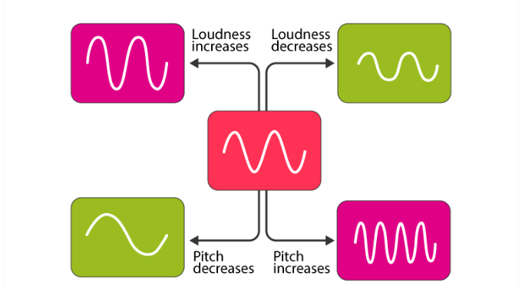

Volume or loudness, indicating the overall amplitude of the waveform generating the tone, is measured in decibels. While pitch and volume seem straightforward, the concept of timbre adds complexity.

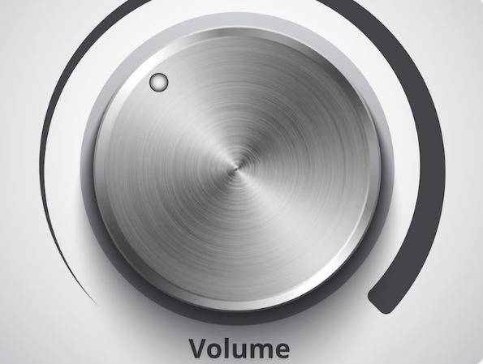

Timbre is the quality of sound that allows us to differentiate between instruments playing the same pitch at the same volume. It's the distinctive sonic fingerprint that separates a piano from a violin or a trumpet.

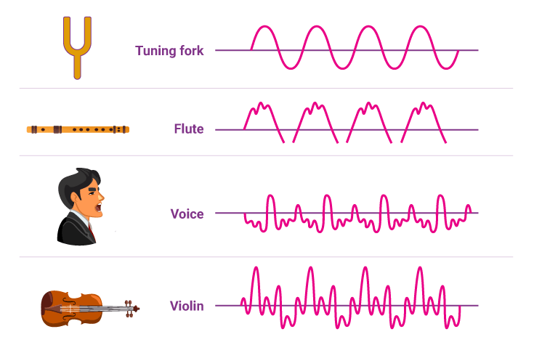

The mathematical insights of Fourier further illuminate the intricacies of sound. Fourier discovered that any periodic waveform, regardless of complexity, can be expressed as a sum of sine waves.



These sine waves have frequencies that are integral multiples of a fundamental frequency, with the fundamental representing the frequency of periodicity of the waveform.

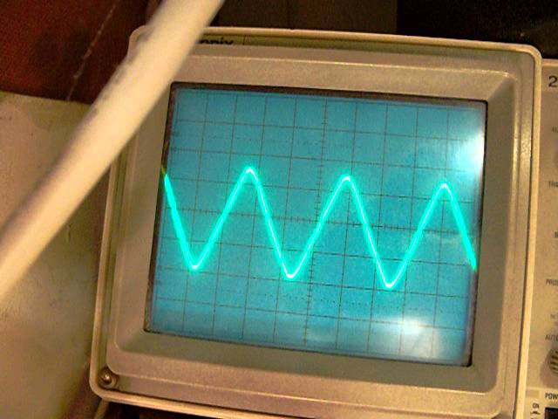

The overtones, or harmonics, are integral multiples of this fundamental frequency.

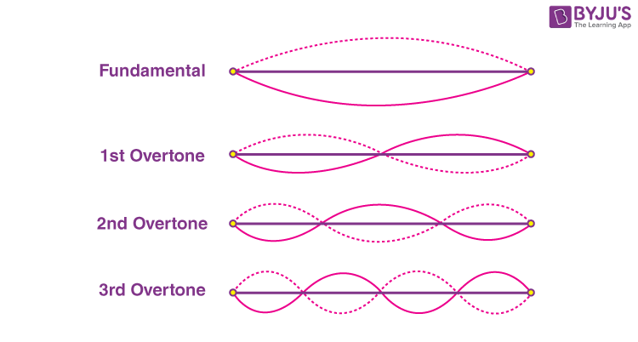

For instance, the first overtone (second harmonic) has a frequency twice the fundamental, the second overtone (third harmonic) has a frequency three times the fundamental, and so on.

The distribution of amplitudes among these harmonics determines the shape of the waveform.

In the case of a square wave, it can be decomposed into sine waves where even harmonics have zero amplitudes, and odd harmonics follow proportions like 1, 1/3, 1/5, and so forth.

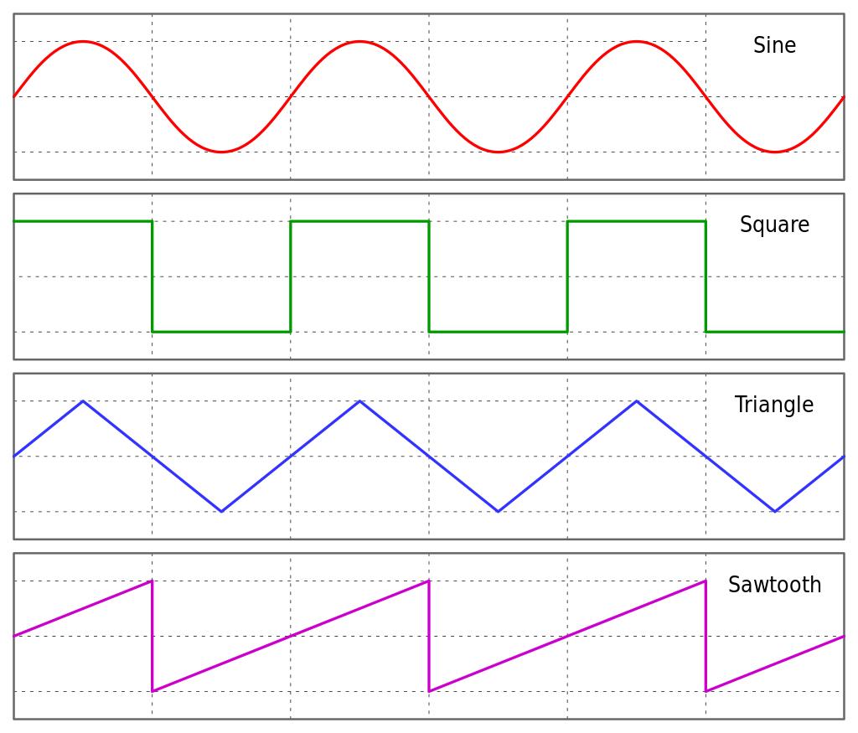

Conversely, a sawtooth wave includes all harmonics, with amplitudes following proportions like 1, 1/2, 1/3, 1/4, and so forth.

This additive synthesis approach reveals the underlying structure of complex waveforms, emphasizing the role of harmonics in shaping the tonal characteristics of different instruments.

The mathematical elegance of Fourier's findings provides a powerful tool for understanding and manipulating the rich tapestry of sound.

Experimenting with additive synthesis allows musicians and sound engineers to craft unique timbres and explore the intricate relationships between harmonics.

This exploration is not just a scientific endeavor but a creative one, offering avenues for innovation in music production and composition.

Hermann Helmholtz's Contribution and Evolution of Electronic Music Synthesis:

Hermann Helmholtz, a German scientist from the 19th century, played a pivotal role in shaping our understanding of timbre.

In his seminal work, "On the Sensations of Tone" (1885), Helmholtz proposed a theory suggesting that the ear and brain decompose complex tones into their constituent sine waves.

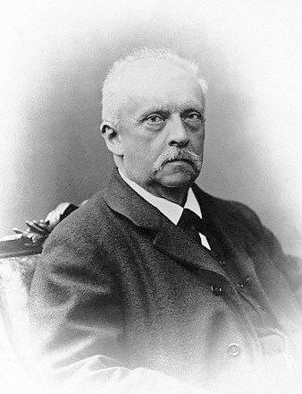

The perceived timbre is then derived from the relative intensities of these sine waves. However, the intricacies of timbre proved to be more nuanced than this initial proposition.

The landscape of electronic music synthesis underwent a transformative moment in 1968 with the release of Wendy Carlos's album "Switched on Bach."

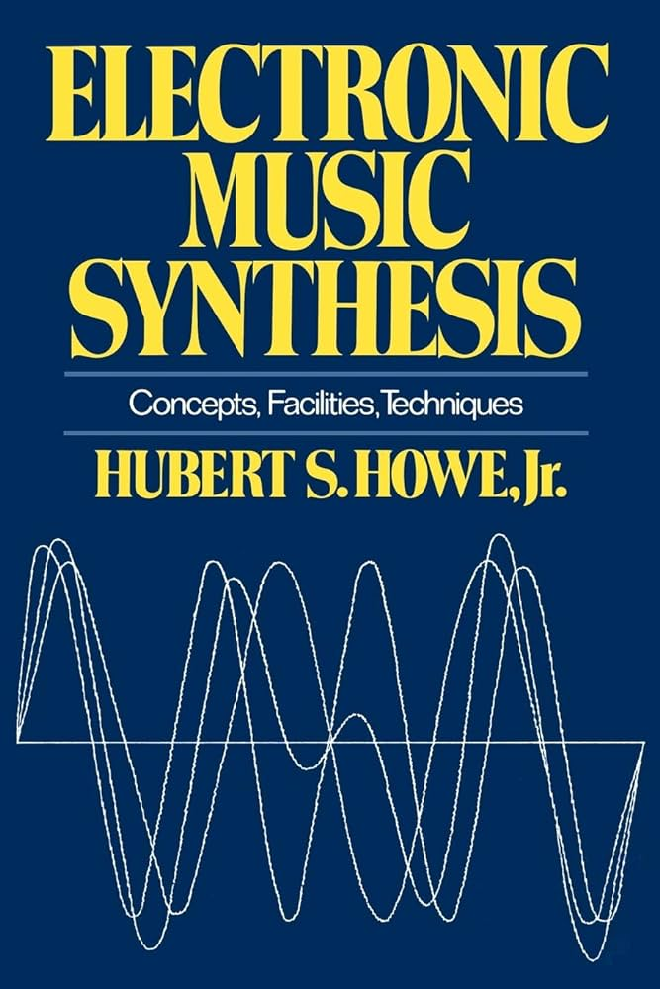

This marked the widespread introduction of analog synthesizers, such as the Moog, to the public. Analog synthesizers employ circuitry to generate diverse audio waveforms like square waves, triangle waves, and sawtooth waves.

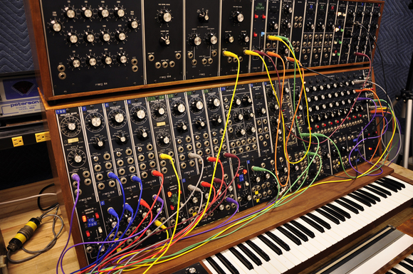

To emulate the characteristics of real musical instruments, these waveforms undergo modifications during a single note.

An essential aspect of shaping the sound in analog synthesizers is the use of an "envelope" to control the overall amplitude of the waveform.

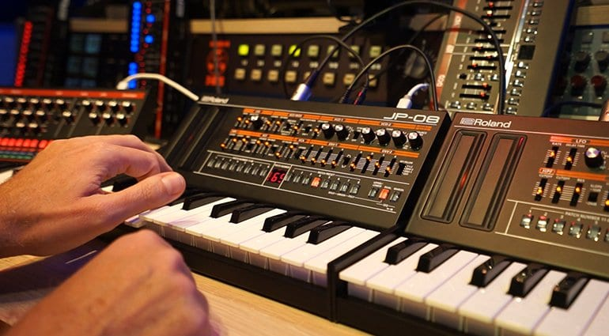

The envelope encompasses distinct phases: the attack, where the amplitude starts from zero and rises swiftly as the note begins; the sustain, where the amplitude remains constant during the note; and the release, where the amplitude falls to zero as the note concludes.

Filters are another integral element in analog synthesis. These filters attenuate certain harmonics, transforming simple waveforms into more complex and musically intriguing sounds.

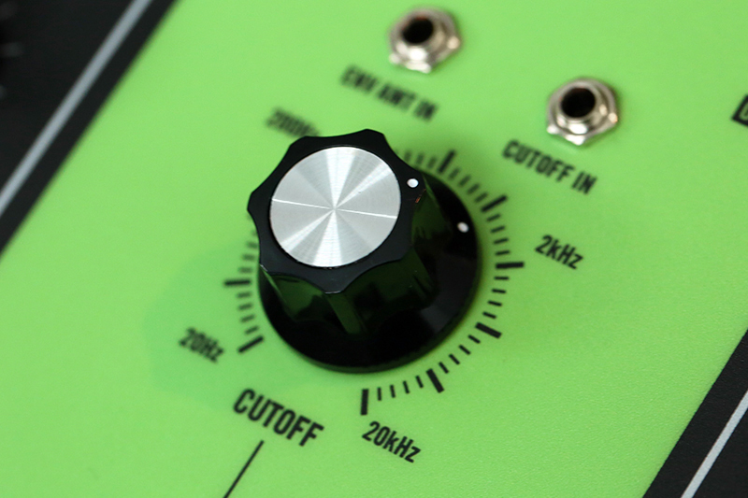

The cut-off frequencies of these filters can be dynamically adjusted by an envelope, influencing the harmonic content throughout the note duration. This approach, where harmonically rich waveforms are modified through filters, is known as "subtractive synthesis."

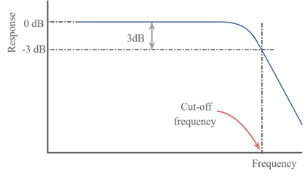

Despite the success of subtractive synthesis, the electronic music community saw potential in additive synthesis as the next frontier.

Additive synthesis involves starting with multiple sine wave generators tuned to integral multiples, with each sine wave representing a harmonic.

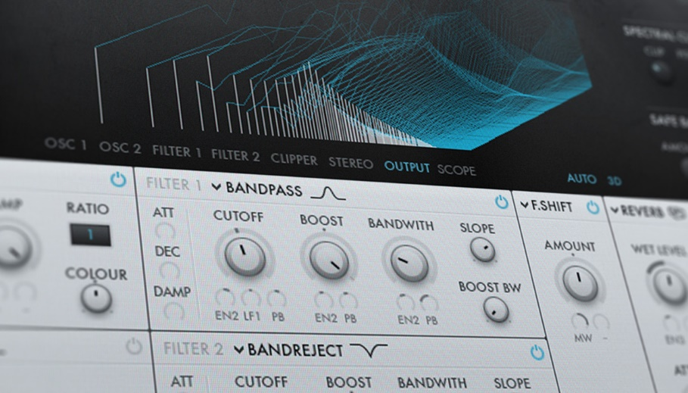

The amplitude of each harmonic can be independently controlled by an envelope.

However, implementing additive synthesis with analog circuitry presents challenges, as it would require a significant number of sine wave generators (between 8 and 24) for a single note, with precise tracking of their relative frequencies. Analog waveform generators are known for their instability and susceptibility to frequency drift.

Evolution of Additive Synthesis and the Complex Nature of Real Musical Tones:

The advent of digital synthesizers and computer-generated waveforms marked a significant milestone in the exploration of additive synthesis.

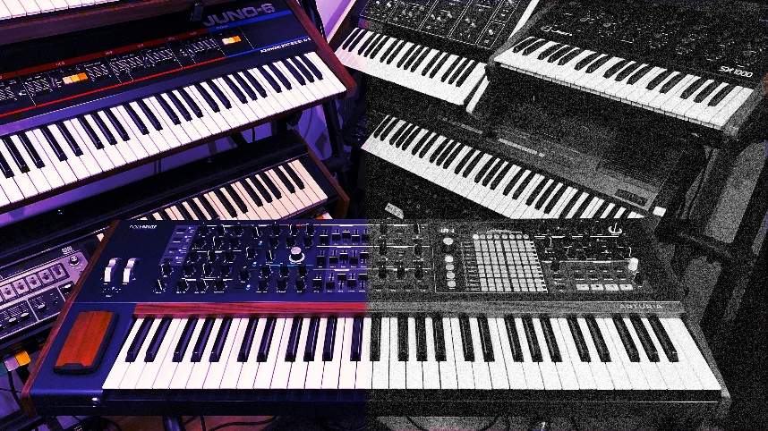

Unlike analog synthesizers with their susceptibility to frequency drift, digital synthesizers can generate waveforms digitally, enabling more precise control over harmonic components.

The fundamental concept involves recording a real musical tone, employing Fourier analysis to break it down into harmonics or partials, and digitally regenerating the sound using multiple sine waves.

However, as experimentation with Fourier analysis on real musical tones progressed, it became evident that the simplicity envisaged by Helmholtz did not fully capture the complexity of timbre.

Unlike ideal harmonic relationships, the partials of real musical tones are inharmonic, challenging the traditional notion of strict harmonicity. The term "partial" is more apt than "harmonic" for these components.

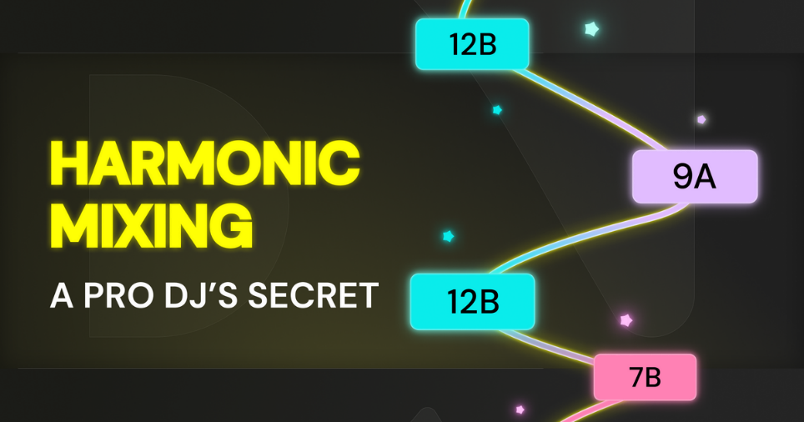

Inharmonicity plays a crucial role in making the tone sound authentic. Strict harmonicity tends to produce an "electronic" sound, while the inharmonic nature of real musical tones contributes to their richness and realism.

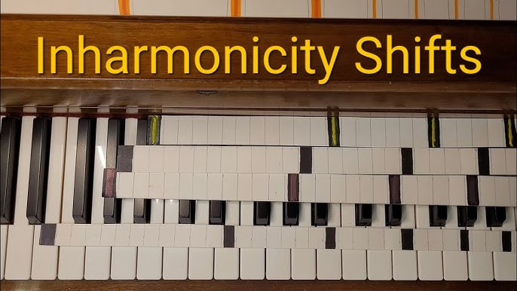

Each partial exhibits dynamic changes in both amplitude and frequency during a single note, with varying relationships among partials for different pitches and intensities from the same instrument.

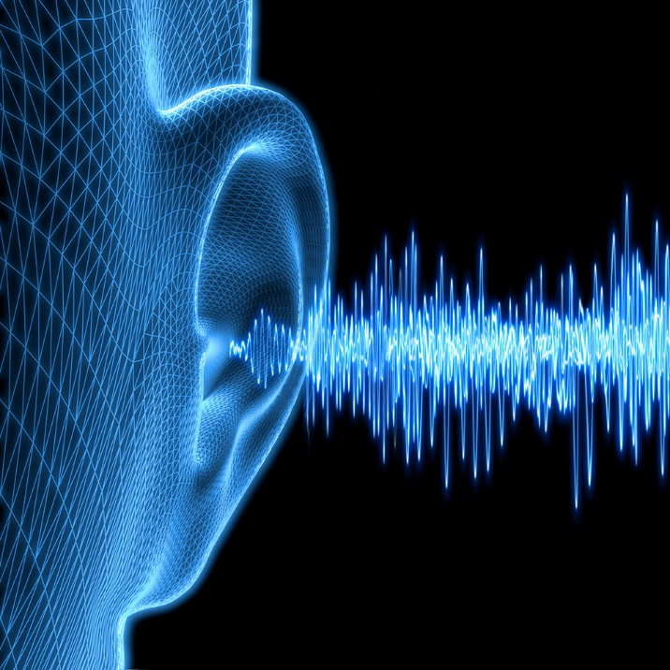

The most intricate part of a real musical tone occurs during the attack phase of the note, characterized by significant inharmonicity. This complex attack phase was identified as vital in human perception of timbre.

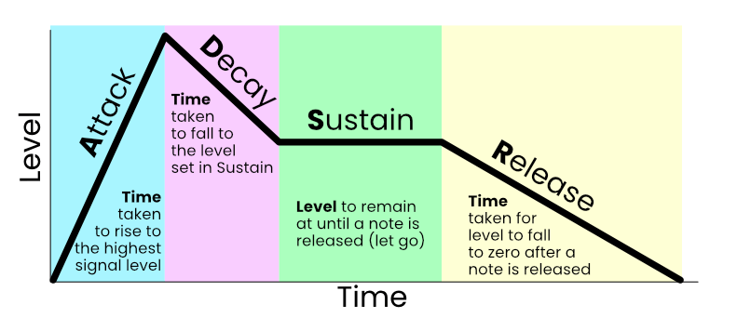

In summary, the sound of real musical instruments is far more intricate than initially envisioned. The idea of simplifying musical tones into a few basic envelopes for controlling partial amplitudes and frequencies proved impractical.

Early analyses published in the Computer Music Journal in the late 1970s, such as the "Lexicon of Analyzed Tones," provided numerical representations of amplitude and frequency graphs for partials of notes played on various instruments.

Partials are also known as components. The principal properties of the partials are their frequencies and amplitudes. The way the partials manifest in frequency, amplitude, and time is what our ears use to determine what kind of instrument made a particular sound.” With the support for waveforms in Windows, synthesizing these complex sounds became more feasible.

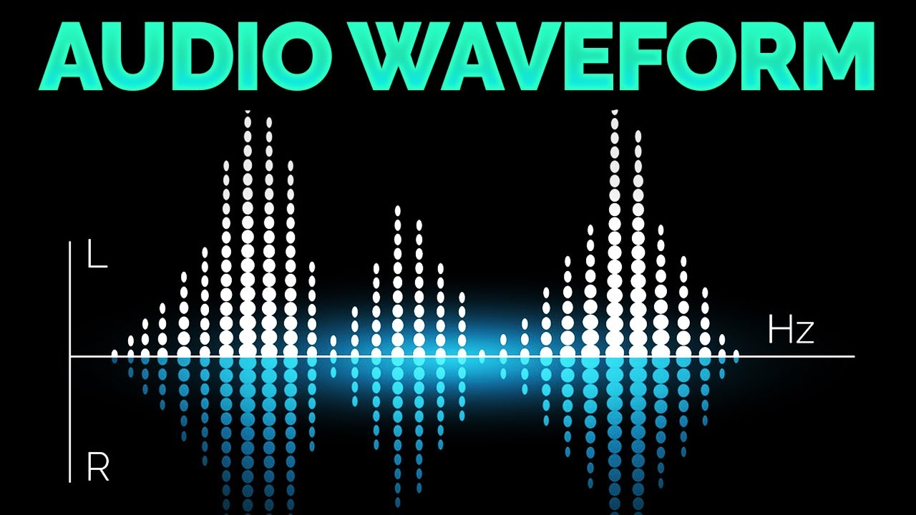

The ADDSYNTH ("additive synthesis") program, depicted in Figure 22-7, exemplifies this approach. By inputting numerical data representing frequency and amplitude envelopes for each partial, generating multiple sine wave samples, summing them up, and sending the samples to the waveform audio sound board, the program can reproduce sounds recorded over two decades ago.



This evolution in additive synthesis underscores the continuous exploration of sound synthesis techniques to capture the intricacies of real musical tones, offering new possibilities for creative expression in the realm of music production.

ADDSYNTH.C PROGRAM



Sine Wave Generation:

The SineGenerator function serves as the fundamental building block for the additive synthesis process. Its primary purpose is to generate a sine wave, the most basic form of a periodic waveform, based on a specified frequency. The frequency parameter determines the oscillation rate of the sine wave, corresponding to the pitch of the resulting sound.

Central to its operation is the concept of a phase angle. The function keeps track of this angle as it evolves over time. The phase angle is crucial for maintaining the continuity of the waveform, ensuring that successive samples are aligned in a seamless manner.

As the phase angle advances, the function calculates the sine values, producing a smooth and continuous oscillation. This capability is essential for creating harmonic components, which are the building blocks for more complex sounds.

Buffer Filling:

The FillBuffer function is responsible for the higher-level orchestration of additive synthesis. Its role extends beyond the generation of individual sine waves to the creation of a composite waveform. This composite waveform represents the culmination of multiple harmonic components, each contributing to the overall sound.

The function takes into account the amplitude and frequency envelopes for each harmonic. The amplitude envelope defines how the strength or volume of each harmonic evolves over time, while the frequency envelope governs how the pitch changes. By considering these envelopes, the function produces a dynamic and evolving sound characteristic.

As the function iterates through each harmonic, it calculates the contribution of each sine wave at a specific point in time, based on the current amplitude and frequency values. The individual contributions are then summed up to create the final composite waveform. This process mirrors the principles of additive synthesis, where complex sounds are synthesized by combining simpler sine wave components.

The resulting composite waveform is stored in a buffer, a temporary data structure that holds the audio samples. This buffer effectively captures the audio representation of the additive synthesis process, ready for further processing or playback.

Overall, the FillBuffer function encapsulates the essence of additive synthesis, allowing for the creation of diverse and expressive synthetic sounds.

Waveform File Creation:

The MakeWaveFile function is a pivotal component responsible for the creation of a waveform audio file in the WAV format. Leveraging the Windows API, this function manages essential file operations, ensuring the correct formatting of headers and the inclusion of waveform data. The resulting file is structured to adhere to the WAV format specifications, making it compatible with audio playback systems.

At its core, the function handles file creation using the CreateFile function from the Windows API. This function creates a new file or overwrites an existing one, providing a fresh canvas for the waveform audio data.

The subsequent steps involve calculating the sizes of various chunks within the WAV file, preparing the headers, and writing them to the file. The headers define critical information such as file type, audio format, sample rate, and bit depth.

Crucially, the function also fills the file with the actual waveform data, which has been previously generated through the additive synthesis process. The waveform data, stored in a buffer, represents the auditory output of the additive synthesis algorithm. By writing this data to the file, the function encapsulates the synthesized sound in a format compatible with audio playback systems.

User Interface (UI):

The program's user interface (UI) is designed as a straightforward Windows dialog-based interface, showcasing the utilization of the Windows API for graphical interaction. The UI serves as the interactive gateway for users to engage with the program's functionalities.

The main elements of the UI include individual buttons corresponding to different musical instruments, specifically the trumpet, oboe, and clarinet.

These buttons likely trigger the playback of the respective instrument's synthesized sound. Additionally, there is a text area within the UI dedicated to conveying the preparation status. This text area likely updates dynamically to inform the user about the current progress or status of the program.

The responsiveness of the UI to user interactions, such as button clicks, suggests an intuitive design aiming to provide a user-friendly experience.

The incorporation of buttons for each instrument indicates a modular approach, allowing users to selectively generate and play the synthesized sounds associated with different instruments.

In summary, the UI and its elements demonstrate the integration of the Windows API for creating a visually accessible and interactive platform. The UI serves as the control center through which users can initiate sound generation and playback processes, enhancing the overall usability of the program.

Instrument Specifics:

Within the program, each musical instrument—trumpet, oboe, and clarinet—is characterized by specific instrument structures (insTrum, insOboe, insClar). These structures likely encapsulate crucial parameters defining the unique sonic characteristics of each instrument.

Among these parameters, the amplitude and frequency envelopes play a pivotal role in shaping how the sound evolves over time. The envelopes are instrumental in providing a nuanced and realistic quality to the synthesized tones, mimicking the dynamic nature of real musical instruments.

The amplitude envelope is likely responsible for controlling the volume of the synthesized sound, determining how it swells, sustains, and fades. On the other hand, the frequency envelope governs the pitch modulation, contributing to the instrument's tonal variations. Together, these envelopes contribute to the authenticity and richness of the synthesized instrument sounds.

Testing and Playback:

The program incorporates a testing mechanism to validate the creation of sound files for each instrument. Upon successful creation, corresponding buttons on the user interface are enabled, reflecting the readiness of each instrument's sound for playback. The interactive nature of the UI allows users to engage with the program by pressing these buttons, initiating the synchronous playback of the generated sounds.

Playback functionality is likely facilitated by the PlaySound function, a Windows API function capable of playing sound files. The synchronous playback ensures that users can instantly experience the results of the additive synthesis process for each instrument.

Timer and Cursor Handling:

To manage asynchronous operations, the program employs a timer with the identifier ID_TIMER. Timers in Windows applications are often used to schedule periodic tasks or delays. In this context, the timer likely contributes to the orchestration of background tasks, ensuring smooth execution of operations without blocking the main user interface.

Cursor handling is another aspect managed by the program. The cursor, a graphical indicator of the user's interaction with the program, is dynamically managed to provide visual feedback during specific processing states. For instance, the cursor may change to indicate a wait state (IDC_WAIT) during resource-intensive tasks, offering a visual cue to the user about ongoing background processes.

Resource Files:

The ADDSYNTH.RC file serves as a repository for resource definitions related to the dialog-based user interface. It includes specifications for buttons, their associated IDs, positions, and captions. This file plays a vital role in defining the visual layout and behavior of the UI elements.

The RESOURCE.H file complements the resource definitions by providing symbolic constants for various UI controls. These constants enhance code readability and maintainability by associating meaningful names with control IDs, reducing reliance on numerical values.

*Let’s explain some structures in the program a bit more…*

Structures in ADDSYNTH.H:

ADDSYNTH.H defines three crucial structures: ENV, PRT, and INS. ENV represents amplitude and frequency envelope data, using number pairs for time and value. PRT stores the number of points and a pointer to the ENV array, acting as a container for partials. INS encapsulates the total tone time, partial count, and a pointer to the PRT array. These structures collectively manage envelope data, partial definitions, and instrument characteristics within the program.

Envelopes and Partial Definitions:

The ENV structure in ADDSYNTH.H holds time-value pairs representing amplitude or frequency. Straight-line connections link these pairs, defining the envelope's shape. Array lengths vary (6 to 14 values), determining the envelope's complexity. PRT, storing the number of points and a pointer to ENV, manages partial definitions. These structures collectively define how amplitude and frequency evolve over time, shaping the instrument's sound.

Calculation of Total Composite Maximum Amplitude:

The FillBuffer function calculates the total composite maximum amplitude by iterating through partials. It finds the maximum amplitude for each partial and aggregates them. This composite maximum amplitude is crucial for scaling samples to an 8-bit size, ensuring proper representation. Its significance lies in determining the overall volume and intensity of the synthesized sound, impacting the quality of the final output.

Sine Wave Generation and Phase Angle:

The SineGenerator function generates sine waves based on a given frequency, maintaining a phase angle for continuous waveform creation. It plays a pivotal role in additive synthesis by producing individual harmonic components. The phase angle's management is crucial for creating a coherent and seamless waveform. Understanding the digital sine wave generation process provides insights into how harmonics are generated and contribute to the overall sound.

Real-Time Calculations and Button Enablement:

ADDSYNTH acknowledges the computational demands of additive synthesis, indicating that real-time calculations may be impractical on current PCs. The program dynamically enables push buttons after completing initial calculations. A deeper exploration of the computational strategy would shed light on how the program optimizes additive synthesis calculations. Understanding the button-enablement mechanism adds insight into when users can interact with the UI based on the program's state.

Persistent Waveform File Checking:

The program checks for the existence of waveform files during subsequent runs to optimize efficiency. This file-checking mechanism ensures that, if waveform files already exist, the program skips unnecessary recalculations. A more detailed explanation of this mechanism would clarify how the program manages previously generated sound files, enhancing the user experience and program efficiency in subsequent executions.

WAKEUP ALARM CLOCK PROGRAM





Includes and Definitions:

The inclusion of necessary header files, such as windows.h and commctrl.h, provides essential functionality for the Windows operating system and common controls.

The program defines specific ID values for child windows, a timer ID, and constants associated with waveform generation. These definitions contribute to the overall structure and functionality of the program by providing unique identifiers and constants for various components.

Waveform Structure:

The WAVEFORM structure is a crucial component in the program, representing a simulated waveform "file." It consists of several fields that define the structure of the audio data. Let's delve deeper into each field:

* chRiff[4]: This array represents the RIFF identifier, indicating the file format. The "RIFF" identifier signifies a Resource Interchange File Format.
* dwRiffSize: This DWORD specifies the size of the RIFF chunk, indicating the total size of the file minus 8 bytes.
* chWave[4]: The "WAVE" identifier denotes the file as a waveform audio file within the RIFF structure.
* chFmt[4]: This field holds the "fmt " identifier, indicating the beginning of the format chunk.
* dwFmtSize: A DWORD representing the size of the format chunk, excluding the first 8 bytes.
* pwf: The PCMWAVEFORMAT structure contains information about the waveform format, including sample rate, number of channels, and bits per sample.
* chData[4]: This array holds the "data" identifier, marking the beginning of the data chunk.
* dwDataSize: A DWORD specifying the size of the data chunk, indicating the length of the waveform data.
* byData[0]: This flexible array member represents the actual waveform data. It is an array of structures containing amplitude values for each sample.

Understanding the structure of the WAVEFORM allows for a detailed comprehension of how the program organizes and represents audio data within its internal workings. Each field plays a specific role in defining the format and content of the simulated waveform file.

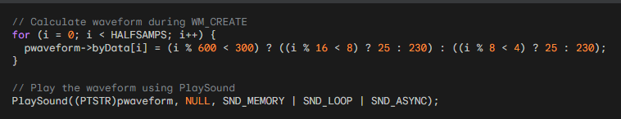

Window Procedure and Subclassing:

The main window procedure, WndProc, serves as the central hub for handling messages related to the program's functionality.

Messages such as WM_CREATE, WM_COMMAND, WM_NOTIFY, and WM_DESTROY are processed within this procedure.

An essential aspect of the program's design is the subclassing of three child windows: the date and time picker, the checkbox, and the push button.

Subclassing is achieved by assigning new window procedure addresses (SubProc) to these controls. This enables custom handling of messages for each specific control, allowing for tailored behavior.

Initialization and Child Windows:

In the WM_CREATE message, the program undergoes necessary initialization procedures.

It registers window class information, creates the main window, and performs common control initialization using InitCommonControlsEx.

Additionally, the program creates a waveform file with alternating square waves. Three child windows are set up: a date and time picker (hwndDTP), a checkbox (hwndCheck) for setting the alarm, and a push button (hwndPush) for turning off the alarm.

The date and time picker is initialized with the current time plus 9 hours, providing a default alarm time.

User Interaction Handling:

The WM_COMMAND message is crucial for handling various user interactions within the program. Specific actions are taken in response to control events.

When the user checks the "Set Alarm" checkbox, the program calculates the time difference between the selected time in the date and time picker and the current PC time.

A one-shot timer is set, and the alarm sound is played when the timer elapses. Unchecking the checkbox cancels the timer.

Clicking the "Turn Off" button stops the alarm sound, resets the interface by unchecking the checkbox, and enables user interaction with the date and time picker. This mechanism provides a user-friendly interface for setting and turning off alarms.

Date and Time Picker Handling:

The program utilizes the WM_NOTIFY message to manage notifications from the date and time picker control (hwndDTP).

Specifically, when the user changes the alarm time while the alarm is set (checked), the program takes action. It unchecks the "Set Alarm" button, indicating a change in the alarm setting, and ensures that any outstanding timer is terminated.

This mechanism prevents discrepancies between the displayed time and the one-shot timer when the user adjusts the alarm time.

Timer Handling:

The WM_TIMER message is responsible for handling the one-shot timer set by the program when the user checks the "Set Alarm" button.

Upon receiving the timer message, the program takes several actions. It first kills the timer, ensuring that the alarm sound is a one-time occurrence.

Subsequently, it initiates the annoying alarm sound by playing the waveform data. Simultaneously, UI elements are manipulated to reflect the transition from the alarm-triggered state to a responsive interface.

The date and time picker and checkbox are re-enabled, while the push button gains focus, preparing the program for user interaction.

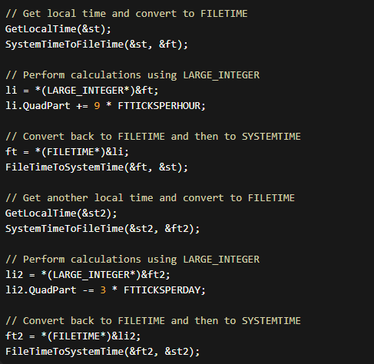

FILETIME Structure and Large Integer Operations:

The FILETIME structure, consisting of dwLowDateTime and dwHighDateTime, represents a 64-bit value indicating intervals from January 1, 1601.

The Microsoft C/C++ compiler introduces the __int64 type, allowing arithmetic operations on 64-bit integers. The union LARGE_INTEGER provides a flexible way to handle the large integer as two 32-bit quantities or a single 64-bit quantity. This methodology aligns with the Windows Base Services documentation on Large Integer Operations.

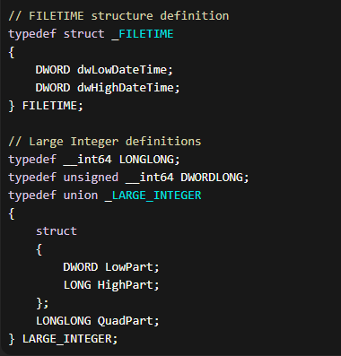

Cleanup and Window Destruction:

The WM_DESTROY message serves as the endpoint for the program's execution. This section ensures proper cleanup and resource management before the program exits.

It frees the memory allocated for the waveform data, stopping the alarm sound if it is still playing. Additionally, it checks if the "Set Alarm" checkbox is checked and, if so, kills any remaining timer to prevent unexpected alarm triggers. This meticulous cleanup guarantees the program concludes gracefully, leaving no residual effects.

DEEP DIVE INTO MIDI AND MUSIC: BEYOND THE BASICS

This passage provides a solid overview of MIDI (Musical Instrument Digital Interface), but let's delve deeper into its intricacies and explore its impact on the world of music.

Beyond Note On and Note Off:

While the explanation of basic Note On/Off messages is accurate, MIDI's capabilities extend far beyond. It transmits various types of data, including:

* Pitch Bend: Fine-tuning the pitch of a note for expressive playing.
* Aftertouch: Applying pressure to a key after striking it for dynamic control.
* Control Change: Modifying sound parameters like vibrato, filter cutoff, or volume.
* Program Change: Selecting different sounds on the synthesizer.
* Sysex (System Exclusive): Sending manufacturer-specific commands for advanced functionality.

These messages enable advanced musical expression, allowing MIDI controllers to mimic the nuances of acoustic instruments and create unique sonic textures.

The Rise of Sequencers and Computer Integration:

While stand-alone sequencers have diminished in popularity, their role in shaping music cannot be overstated.

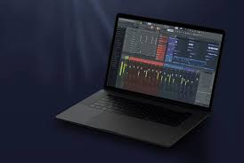

They offered early musicians the ability to record and edit sequences, paving the way for complex arrangements and groundbreaking electronic genres. The integration of MIDI with computers further revolutionized music production.

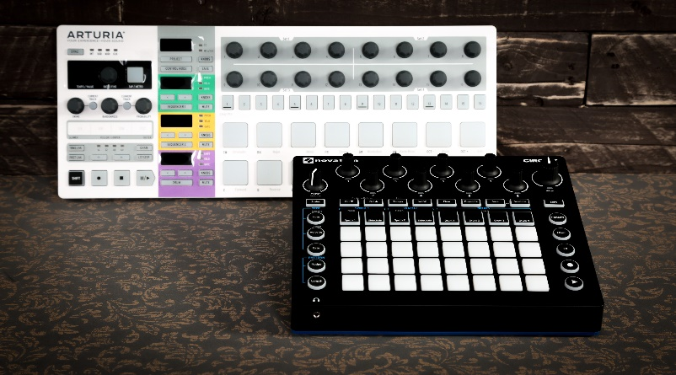

Software sequencers like Pro Tools and FL Studio became essential tools for composing, editing, and mixing music, providing unparalleled flexibility and accessibility.

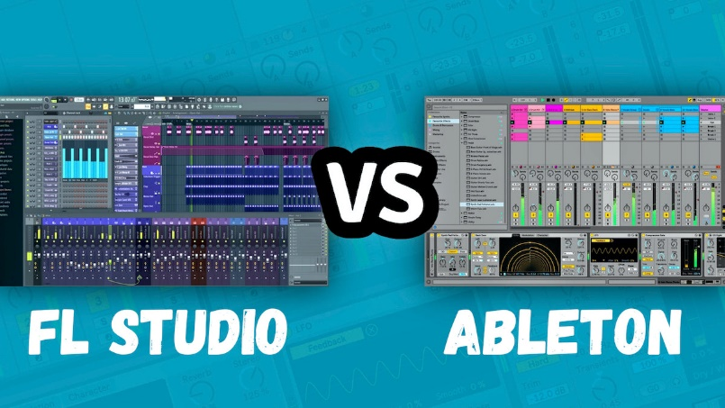

Beyond Controllers and Synthesizers:

The MIDI ecosystem extends beyond keyboards and synthesizers. Drums, guitars, wind instruments, and even vocals can be equipped with MIDI capabilities, allowing seamless integration into digital setups.

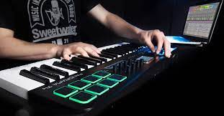

Moreover, MIDI interfaces connect controllers and instruments to computers, opening up a world of virtual instruments and sound libraries.

The Impact of MIDI:

MIDI's influence on music is undeniable. It:

Democratized music creation: Made producing music more accessible and affordable, fostering a vibrant amateur and independent music scene.



Birthed new genres: Electronic music as we know it wouldn't exist without MIDI, giving rise to techno, house, and countless other styles.

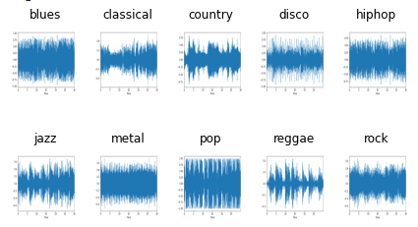

Revolutionized live performance: Musicians can control multiple instruments and complex soundscapes with a single MIDI controller, enhancing stage shows.



Preserved musical heritage: MIDI files act as digital sheet music, ensuring the longevity of compositions and facilitating collaboration.



Looking Ahead:

MIDI continues to evolve with new specifications and capabilities. Wireless MIDI connections simplify setups, and integration with artificial intelligence opens up exciting possibilities for interactive music creation. As technology advances, MIDI's role in shaping the future of music remains significant.

This deep dive paints a more comprehensive picture of MIDI, showcasing its power and versatility. It goes beyond the technical details to highlight its cultural impact and lasting legacy in the world of music.

SWITCHING SOUNDS WITH PROGRAM CHANGES: NAVIGATING THE SONIC LANDSCAPE OF SYNTHESIZERS

Understanding Program Changes:

Accessing Diverse Sounds: Synthesizers store a vast array of sounds, often called voices, instruments, or patches. To switch between these sounds, MIDI uses Program Change messages.

Sending the Message: The message is simple: C0 pp, where pp ranges from 0 to 127, selecting a specific program.

Common Controls: MIDI keyboards often feature numbered buttons to directly send these messages, allowing convenient sound selection.

The Program Number Challenge:

Lack of Standardization: MIDI itself doesn't dictate which program numbers correspond to specific instruments. This means the same program number on different synthesizers might trigger vastly different sounds.

Unexpected Surprises: Without knowing the synthesizer's sound mapping, Program Change messages can lead to unexpected results.

MIDI File Compatibility Issues: MIDI files containing Program Change messages might sound different on different devices, posing a challenge for portability.

Enter General MIDI (GM):

Standardization Effort: To address this issue, General MIDI (GM) was introduced to standardize program numbers across compliant devices.

Widespread Adoption: GM is widely supported by software and hardware, promoting consistency and predictability.

Ensuring Compatibility: When working with MIDI files, using GM-compliant sounds or mapping non-compliant synthesizers to GM standards ensures the intended sound playback.

Key Takeaways:

* Program Change messages are essential for exploring a synthesizer's sonic palette.
* Understanding program number variations is crucial for avoiding surprises and ensuring compatibility.
* General MIDI offers a standardized framework for predictable sound selection across devices.
* When working with MIDI files, consider GM compatibility for consistent playback.

UNVEILING THE ORCHESTRA WITHIN: A DEEP DIVE INTO MIDI CHANNELS

Imagine a single cable carrying the symphony of 16 distinct instruments—that's the magic of MIDI channels.

Orchestrating Communication:

Separate Channels, Unified Cable: This note highlights how MIDI channels allow for independent communication pathways within a single MIDI cable. Each channel can carry its own set of MIDI messages, enabling multiple devices to interact seamlessly. This organization ensures that different devices can communicate without interference or confusion.

Assigning Roles, Avoiding Collisions: Each MIDI device is assigned a unique channel to ensure that it responds only to messages intended for it. This assignment helps prevent sonic chaos by avoiding collisions between devices. By designating specific channels for each device, MIDI ensures that messages are received and interpreted correctly.

The Status Byte: A Cunning Conductor: The status byte, which is the first byte of each MIDI message, plays a crucial role in MIDI communication. It holds the channel information within its lower four bits, indicating the intended recipient of the message. The status byte acts as a conductor, directing the message to the correct device by specifying the appropriate channel.

16 Instruments, One Cable: MIDI cables have the capability to convey messages for up to 16 instruments simultaneously. Each instrument is assigned to a distinct channel, allowing for the transmission of messages related to different sounds or instruments over a single cable. This feature enables the creation of intricate and rich sonic tapestries by combining multiple MIDI devices.

Deconstructing MIDI Messages:

Note On: The Note On message is used to trigger the start of a musical note. It consists of three components:

* Status Byte: The Status Byte for the Note On message is represented by 9n, where "n" designates the MIDI channel (from 0 to 15). The channel allows multiple MIDI devices to communicate independently.
* Key Number: The Key Number, represented by "kk," specifies the pitch of the note being played. It corresponds to a specific musical pitch or key on a keyboard or other MIDI controller. The key number ranges from 0 to 127, with 60 typically representing middle C.
* Velocity: The Velocity byte, represented by "vv," determines the intensity or strength with which the note is played. It represents the force or speed at which a key is struck on a MIDI controller. The velocity value ranges from 0 to 127, with 0 representing the release of a note and 127 representing the maximum intensity.

Program Change: The Program Change message allows for selecting different sounds or patches on a MIDI device. It consists of two components:

* Status Byte: The Status Byte for the Program Change message is represented by Cn, where "n" identifies the MIDI channel (0 to 15) on which the change is applied.
* Program Number: The Program Number, represented by "pp," specifies the desired sound or patch to be selected. Each number corresponds to a different sound or instrument on the MIDI device's internal sound bank. For example, program number 0 might correspond to a piano sound, while program number 32 could represent a guitar sound.

Channel Multiplexing:

* MIDI allows for simultaneous conversations or communication between multiple MIDI devices or channels.
* This is achieved through the use of different MIDI channels, each capable of carrying its own set of MIDI messages.
* Each MIDI channel is independent and can transmit its own Note On, Note Off, Control Change, and other MIDI messages.
* This channel multiplexing capability allows for the simultaneous control and playback of multiple sounds or instruments.
* For example, one channel can be used for a piano sound, another for a bass guitar, and so on, allowing for complex and layered musical arrangements.

Overall, MIDI messages provide a standardized way of communicating musical information, such as note events, sound selection, and control parameters, between MIDI devices. By deconstructing and understanding these messages, musicians and producers can manipulate and shape the sounds produced by MIDI devices to create expressive and diverse musical compositions.

The conversation flow in MIDI begins with initial Program Change messages, which serve as the foundation for each channel. These messages assign a specific voice or instrument to each channel, similar to assigning instruments to musicians in an orchestra. This step establishes the sonic palette and sets the stage for the harmonious interplay that follows.

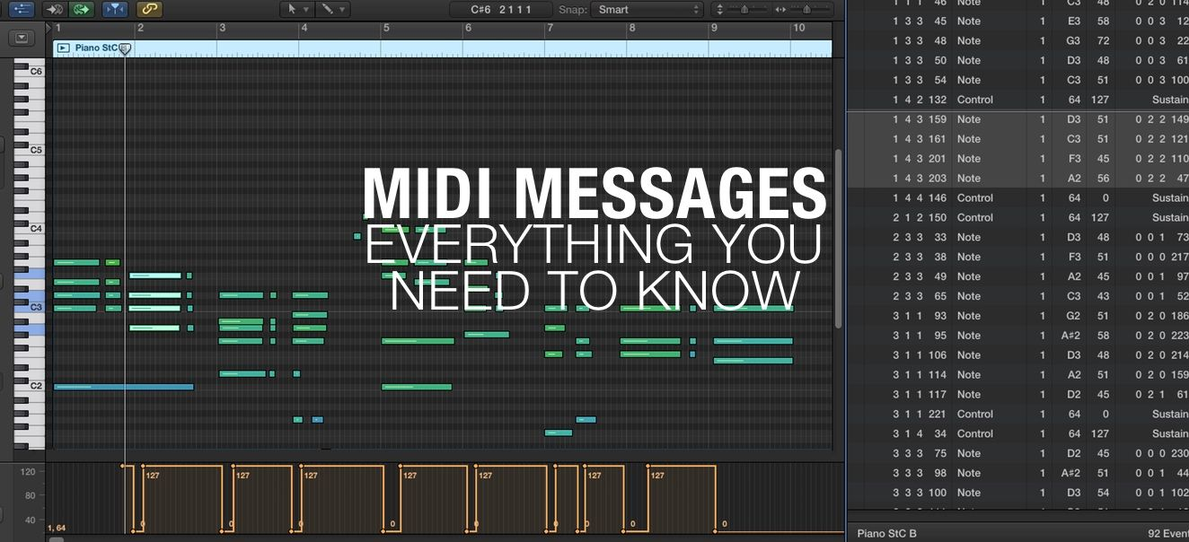

Once the Program Change messages have set the voices, a flurry of Note On and Note Off commands ensues. These commands trigger the start and end of individual notes on their designated channels. As different notes are played on various channels, a rich and harmonious interplay emerges, as if each voice in the composition is speaking its part in a musical conversation.

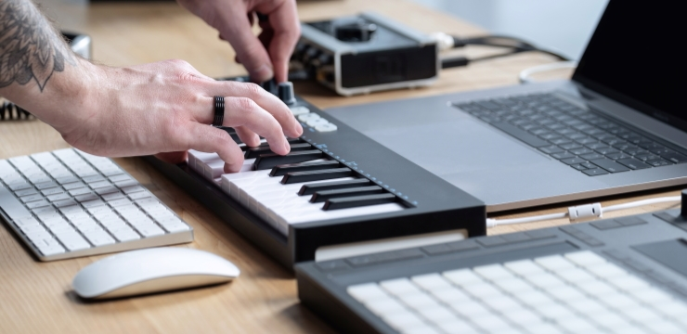

In addition to the initial voice assignments, MIDI allows for additional Program Change messages to be sent during a performance. These messages can dynamically switch sounds or instruments mid-performance, adding versatility and creating dynamic shifts in the music. This flexibility allows musicians to explore different sonic landscapes and adapt the composition in real-time, adding depth and variety to their performances.

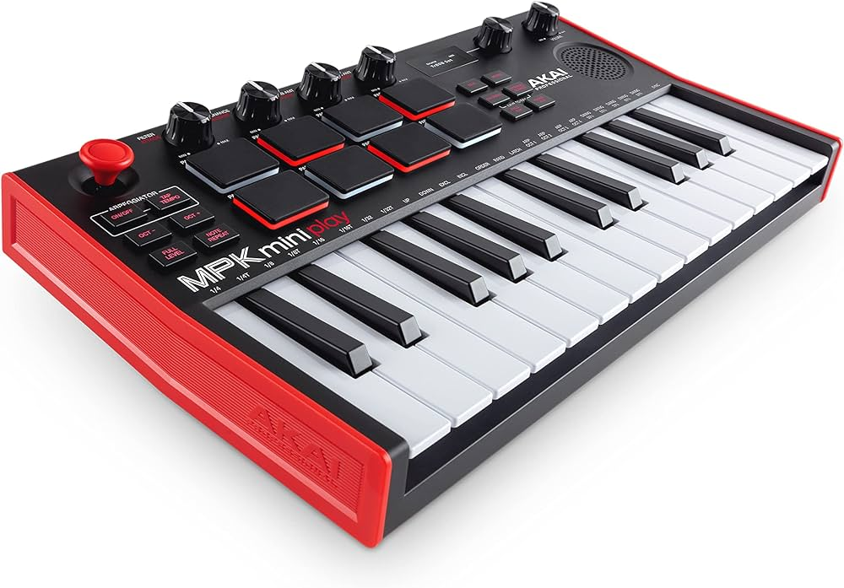

To ensure clarity and prevent cacophony, MIDI dedicates each channel to a single voice at any given moment. This means that each channel carries the musical information for a specific instrument or sound. By dedicating channels to individual voices, MIDI achieves a clear and organized musical expression, where each voice can be heard distinctly within the overall composition.

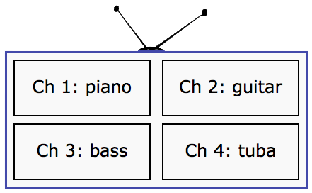

MIDI channels play a crucial role in harnessing the power of MIDI technology. They empower musicians to create intricate arrangements using multiple instruments, all controlled through a single cable.

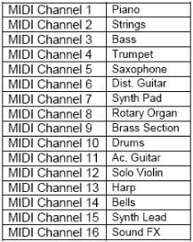

By assigning different voices to separate channels, musicians can layer sounds, blend different instruments, and create complex musical compositions.

Understanding the assignment of channels and the structure of MIDI messages is essential for effective MIDI control, as it enables seamless interaction between MIDI devices and facilitates the realization of musical ideas.

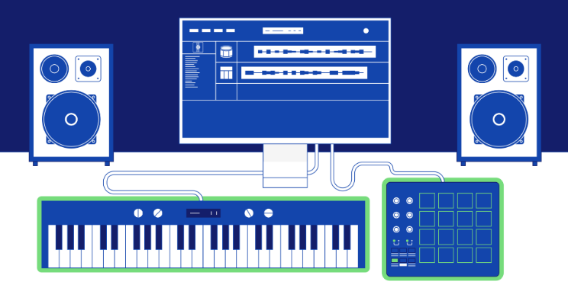

Proper channel configuration forms the foundation of a symphony in MIDI. By setting up channels correctly, musicians can unlock the full potential of MIDI technology and create layered, expressive, and immersive musical compositions.

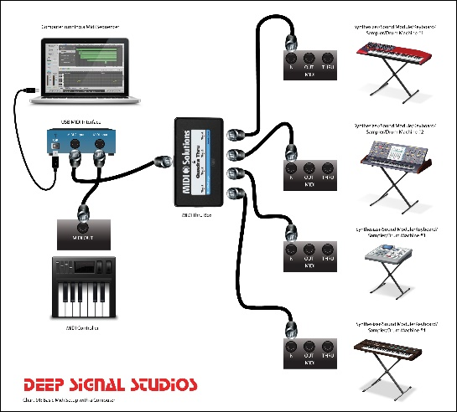

MIDI channels embody the essence of MIDI's versatility, allowing a simple cable to unleash a symphony of sounds. By mastering the mechanics of MIDI channels, musicians tap into a realm of limitless possibilities, where multiple voices blend and flow in perfect harmony, bringing their musical visions to life.

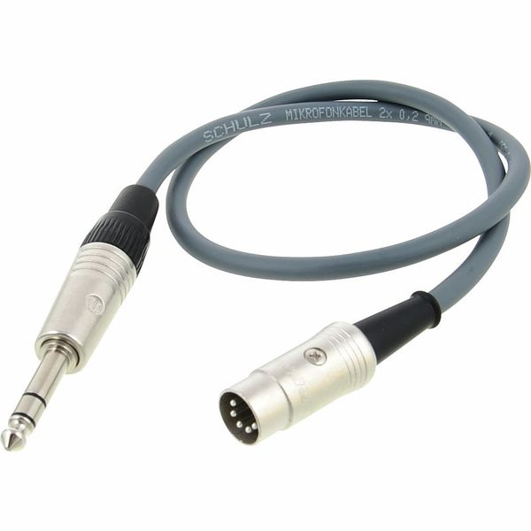

Assignment of channels and the structure of MIDI messages

MIDI channels are independent communication pathways within a MIDI system. Each channel is assigned a unique number from 0 to 15, allowing multiple devices to communicate simultaneously without interference. Assigning different voices or instruments to separate channels enables musicians to create intricate arrangements and layered compositions. It ensures that each voice has its dedicated channel, promoting clarity and preventing sonic chaos.

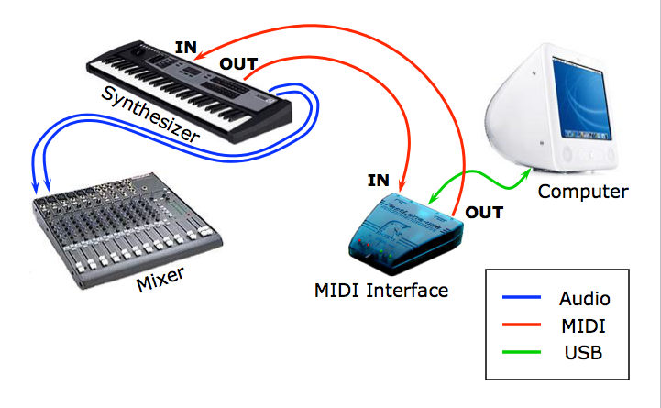

The structure of MIDI messages consists of various components. The status byte, which is the first byte of each MIDI message, carries information about the type of message and the intended recipient channel. It plays a vital role in directing the message to the correct device by specifying the appropriate channel. The following data bytes convey specific information related to the message type, such as pitch, velocity, program number, or control parameters.

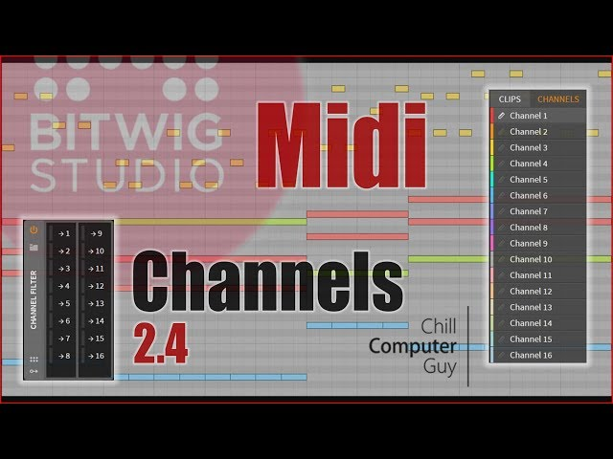

Understanding the structure of MIDI messages and the assignment of channels is crucial for effective MIDI control. It allows musicians to send and receive the right messages to control sounds, trigger notes, switch instruments, and modulate various parameters. With this understanding, seamless interaction between MIDI devices can be achieved, enabling musicians to create expressive performances and unlock the full potential of MIDI technology.

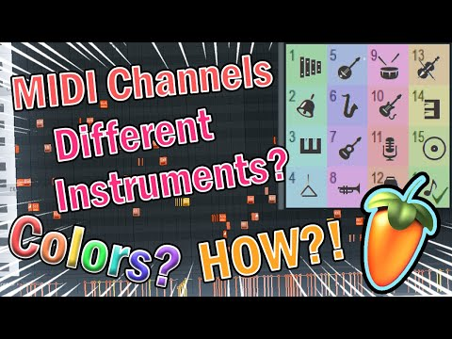

UNLEASHING THE MULTI-INSTRUMENTAL POWER OF MIDI CHANNELS: A DEEP DIVE

Transforming a Single Keyboard into a Duet:

Sending Program Change Messages:

* C0 01 sets channel 1 to program 2 (remember, 0-based encoding).
* C1 05 sets channel 2 to program 6.

Playing in Unison: Each key press triggers two Note On messages, one for each channel, playing both instruments simultaneously.

Splitting the Keyboard for Independent Control:

* Lower Keys, Channel 1: Notes played on the lower keys control channel 1, activating its assigned instrument.
* Upper Keys, Channel 2: Notes played on the upper keys control channel 2, playing its distinct sound.
* Result: A single keyboard becomes a versatile tool capable of performing two independent parts.

Splitting the keyboard for independent control is a technique that allows a single keyboard to perform two separate parts or voices by assigning different MIDI channels to specific sections of the keyboard.

In this technique, the lower keys of the keyboard are assigned to control channel 1, while the upper keys are assigned to control channel 2. Each channel is associated with its own instrument or sound.

When a musician plays notes on the lower keys, MIDI messages are sent on channel 1, activating the instrument assigned to that channel. This means that the lower notes trigger sounds or play notes associated with channel 1, creating a specific musical voice or part.

On the other hand, when the musician plays notes on the upper keys, MIDI messages are sent on channel 2, controlling the instrument or sound assigned to that channel. The upper notes produce a distinct sound or play a different musical part associated with channel 2.

By splitting the keyboard and assigning different channels to each section, the musician gains independent control over two voices or parts. They can play different melodies, harmonies, or rhythms with each hand, effectively transforming a single keyboard into a versatile tool capable of performing as if two separate instruments were playing simultaneously.

This technique is commonly used in live performances, studio recordings, and musical arrangements where a single musician wants to create a fuller and more dynamic sound. It allows for greater expressiveness and flexibility in playing and composing music, as the musician can explore different musical ideas and textures by controlling multiple voices independently.

Orchestrating a 16-Piece Band from a PC:

Orchestrating a 16-piece band from a PC involves utilizing MIDI sequencing software as the conductor, which assigns each instrument to a unique MIDI channel. This software serves as a virtual maestro, directing and coordinating the various instruments in the ensemble.

In this scenario, each MIDI channel is assigned to control a specific instrument or sound. For example, channel 1 might be assigned to a flute, channel 2 to a violin, channel 3 to a bass, and so on. By assigning each instrument to a distinct channel, a diverse range of sounds and timbres can be created, allowing for a rich and realistic ensemble experience.

What makes this orchestration even more remarkable is that it can be achieved using just a single MIDI cable. All the instrument data, including note information, dynamics, and other musical parameters, is transmitted through this single cable to a MIDI-compatible synthesizer or sound module.

The MIDI sequencing software running on the PC generates and sends the MIDI messages for each instrument on their respective channels. These messages are then received by the synthesizer, which interprets them and produces the corresponding sounds based on the assigned instrument or sound for each channel. This allows the PC to effectively control and coordinate the entire 16-piece band, creating a seamless and cohesive musical performance.

By leveraging the power of MIDI and MIDI sequencing software, musicians and composers can orchestrate complex musical arrangements and compositions directly from their PC. This approach offers a level of convenience and flexibility, as it eliminates the need for physical instruments and allows for easy editing, arranging, and recording of MIDI data. It also provides a cost-effective solution, as a single MIDI cable can transmit the performance data for the entire ensemble.

Key Takeaways:

MIDI Channels = Independent Instrument Pathways: MIDI channels serve as separate communication pathways within the MIDI system, enabling multiple instruments to coexist and communicate over a single cable.

Channel Assignment = Essential for Control: Assigning instruments or sounds to specific MIDI channels ensures that MIDI messages are directed precisely to their intended targets. This prevents sonic collisions and allows for individual control over each instrument.

Keyboard Versatility: MIDI channels offer keyboards the versatility to play multiple instruments independently. Through channel assignments, keyboards can trigger different sounds or play separate musical parts, either in unison or through split configurations, expanding the expressive possibilities of a single keyboard.

Sequencing Software = Virtual Orchestra: MIDI sequencing software acts as a virtual conductor, making use of MIDI channels to create complex arrangements for multi-instrument compositions. By assigning different instruments to specific channels, the software can orchestrate and control the entire ensemble, allowing for sophisticated musical productions and performances.

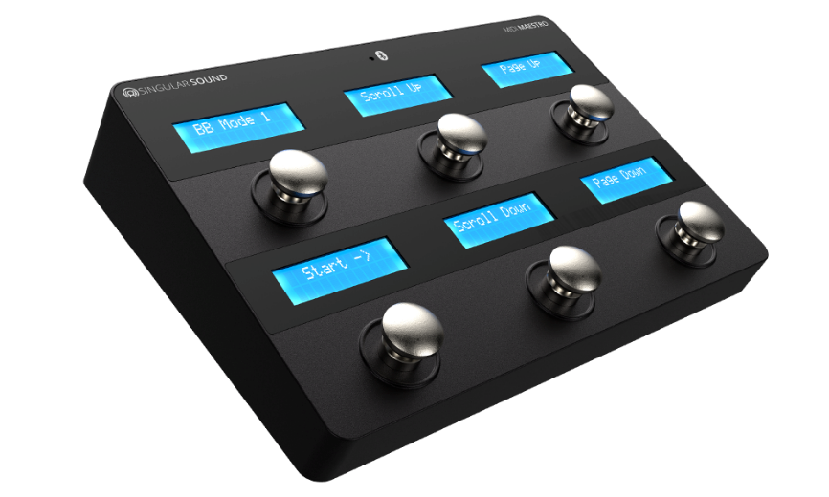

MIDI Messages:

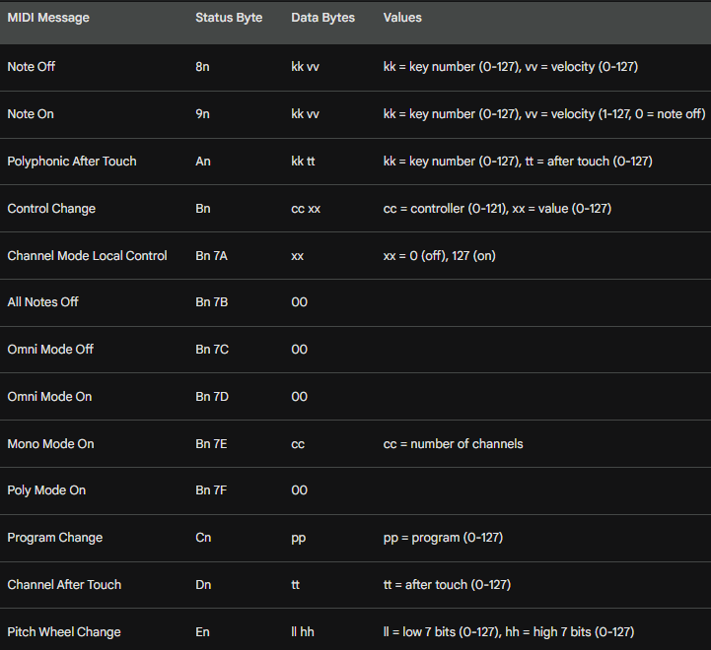

Decoding the MIDI Orchestra: A Grand Tour of Messages Beyond the Basics

Remember the symphony behind MIDI? Its language, beyond the basic melodies of Note On and Program Change, holds rich layers of expression and control.

Let's dive deeper into these messages, appreciating their nuanced roles in the musical performance.

Key Numbers: Beyond the Western Scale:

While key numbers often map to the familiar Western Music scale, their versatility shines through. Percussion instruments, for instance, assign each key to a unique sound, transforming the keyboard into a drum machine. Moreover, MIDI extends the range beyond a piano's grasp, venturing 21 notes down and 19 notes up, opening doors for sonic exploration unseen on an 88-key instrument.



Velocity: Sculpting the Sound:

The velocity, captured in a simple number, isn't just about volume. It's a sculptor's chisel, shaping the character of the sound. On piano-like voices, it influences both loudness and the harmonic richness, from a delicate murmur to a thunderous roar. But remember, different voices may react in unique ways, adding another layer of expressive potential.

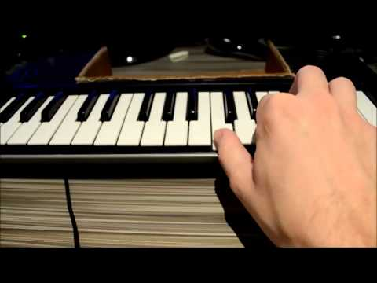

Aftertouch: A Dynamic Embrace:

Some keyboards offer the magic of aftertouch, allowing you to dynamically alter the sound by applying pressure to a pressed key. It's like whispering secrets to the notes, subtly changing their character. Two types of aftertouch messages exist: one influencing all playing notes in a channel, and the other, a more intimate conversation, affecting each key independently.

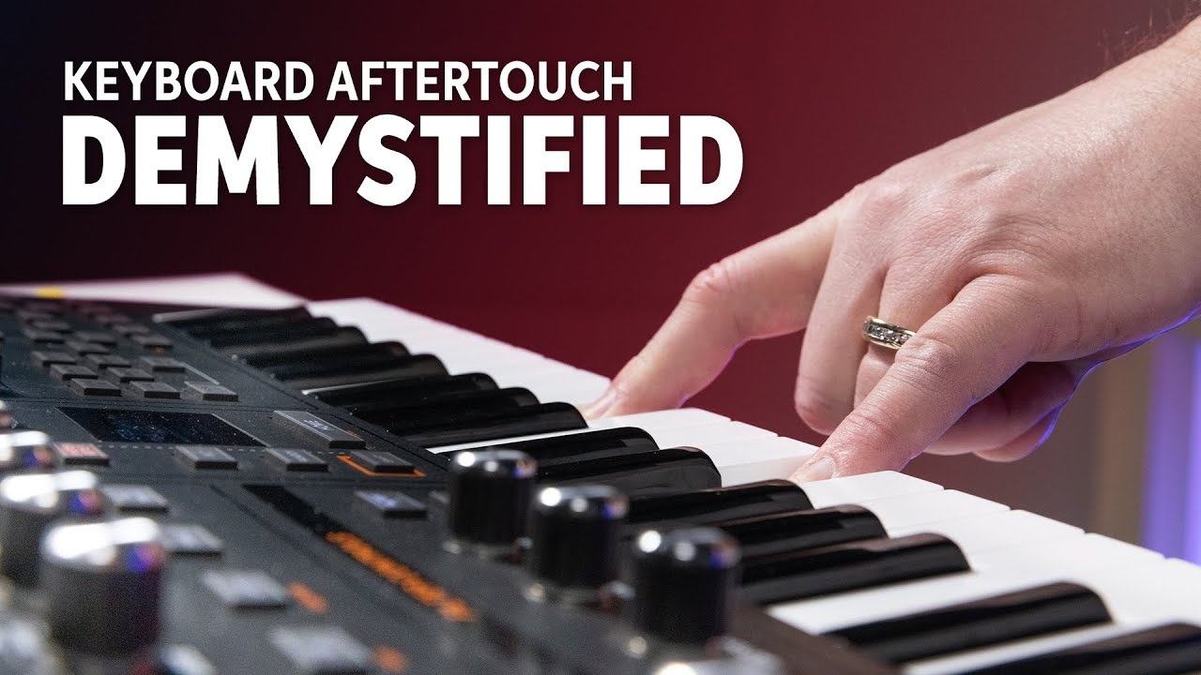

Controllers: Fine-Tuning the Canvas:

Knobs and switches on your keyboard aren't mere ornaments; they're gateways to sonic nuance. These controllers send out Control Change messages, identified by unique numbers. This allows you to tweak parameters like reverb, filter cutoff, or vibrato intensity, painting your sonic canvas with exquisite detail. Additionally, the same message type acts as a conductor for Channel Mode messages, dictating how a synthesizer handles multiple notes playing simultaneously in a channel.

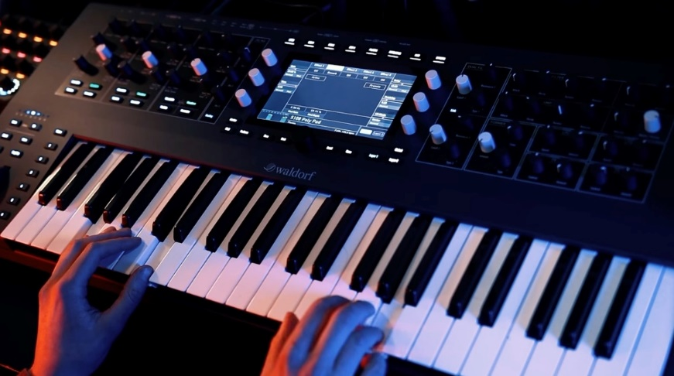

Pitch Wheel: Bending the Melody:

For those yearning for expressive melodic bends, the dedicated Pitch Wheel message offers a virtual joystick for your musical desires. With its high-resolution control, you can soar above the notes, adding a soulful vibrato or a dramatic glissando, bending the very fabric of your melody.

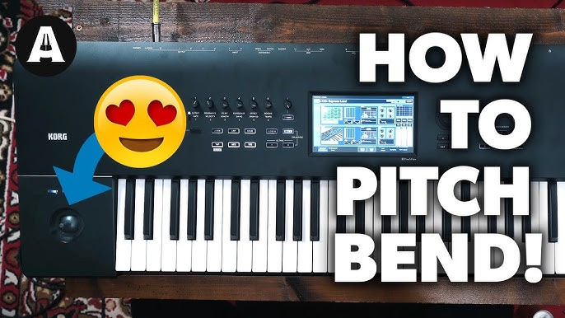

System Messages: The Conductor's Baton:

Messages starting with F0 through FF form a hidden orchestra within your MIDI setup. These system messages operate beyond individual channels, acting as the conductor's baton, coordinating the entire ensemble. They ensure smooth synchronization, trigger sequencers, reset hardware, and even retrieve vital information from connected devices.

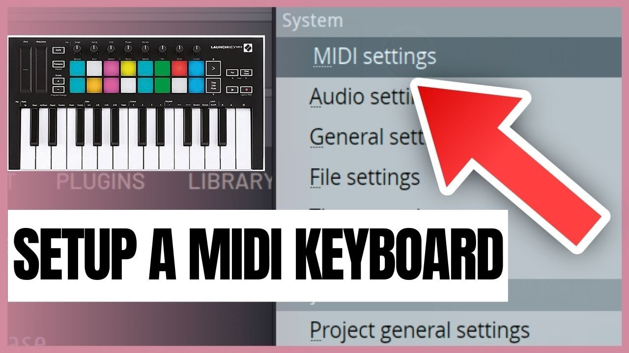

Active Sensing: Keeping the Pulse:

Imagine a constant rhythm keeping the MIDI orchestra in sync. Many controllers send out Active Sensing messages, acting like a steady heartbeat, signaling their presence and ensuring uninterrupted communication within the system.

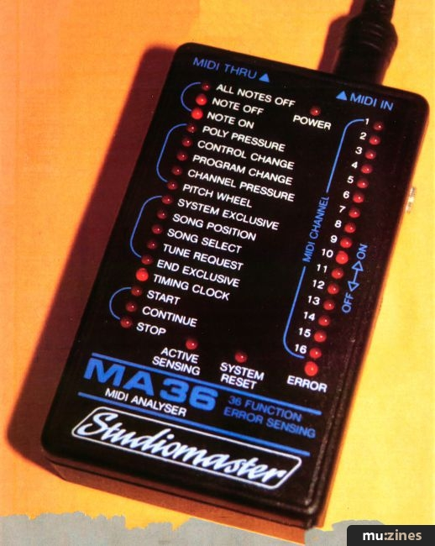

System Exclusive: Secret Handshakes:

For delving into the deepest corners of your synthesizer's sonic palette, System Exclusive messages offer a manufacturer-specific handshake. These messages carry chunks of data, like new voice definitions, in a format understood by its creator.

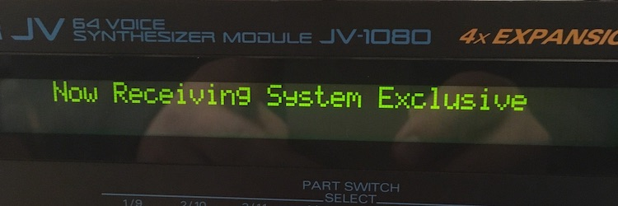

While staying device-independent might mean avoiding them, for adventurous musicians, they unlock a treasure trove of sonic possibilities, allowing you to craft custom voices and breathe new life into your synthesizer.

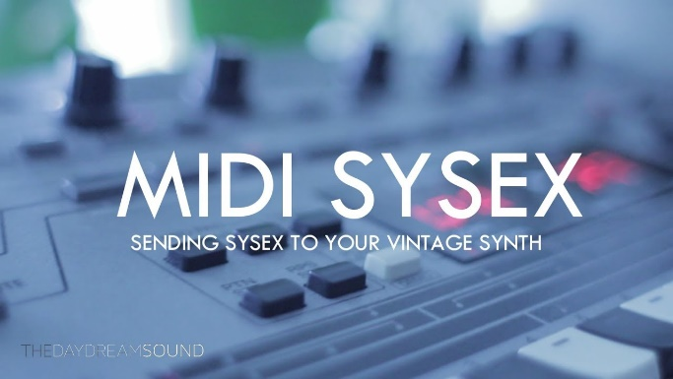 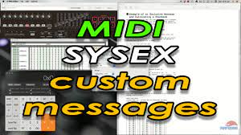

MIDI Files: Capturing the Performance:

Imagine bottling the essence of a musical performance. MIDI files do just that, capturing a collection of MIDI messages along with their timing information. These files then become musical blueprints, ready to be brought to life on other instruments or software, sharing the joy of your creation with the world.

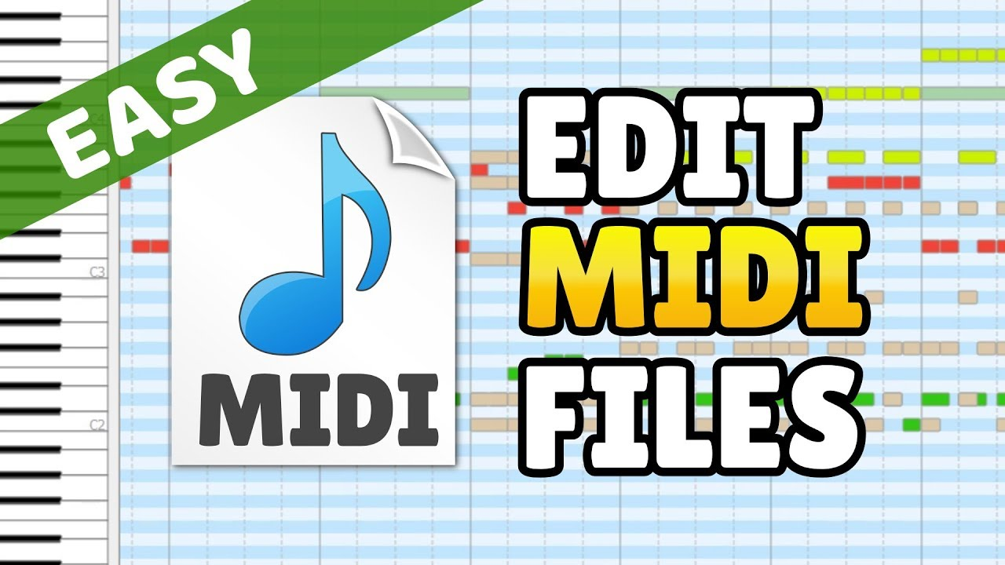

By venturing beyond the surface of Note On and Program Change, we gain a deeper understanding of MIDI's expressive power. These messages become tools in our hands, allowing us to sculpt sound, bend melodies, and orchestrate sonic landscapes. So, go forth, explore the nuances of MIDI messages, and let your music bloom in a rich tapestry of sound and emotion.

This journey through the hidden depths of MIDI messages expands your knowledge and empowers you to craft truly expressive and dynamic music. Remember, the orchestra is within your reach, waiting to be conducted by your understanding and creativity.

DELVING INTO MIDI SEQUENCING: ORCHESTRATING MUSIC WITH CODE

Communicating with MIDI Devices: A Low-Level Symphony

While MIDI files offer a way to capture and share musical performances, the true magic of MIDI lies in its ability to control instruments and create music in real-time.

This is where the low-level MIDI API enters the stage, providing a direct line of communication with MIDI devices.

Opening the Stage Door: midiOutOpen

To begin your MIDI journey, you'll first need to establish a connection with the desired MIDI output device, whether it's an internal synthesizer or an external instrument. Here's how you use the midiOutOpen function:

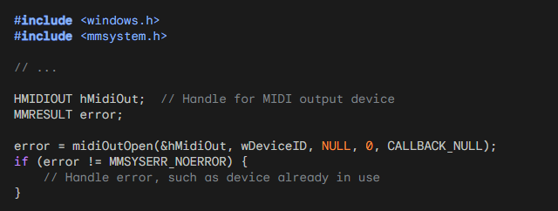

After calling midiOutOpen to open the MIDI output device, it is important to handle any potential errors that may occur. Error handling allows you to gracefully respond to issues that may arise, such as the MIDI device already being in use or being unavailable.

In the provided code snippet, the error variable is used to capture the return value of midiOutOpen.

If error is not equal to MMSYSERR_NOERROR, it indicates that an error has occurred during the attempt to open the MIDI output device.

Handling errors typically involves taking appropriate actions based on the specific error code returned. For example, you might display an error message to the user, log the error for debugging purposes, or implement a fallback strategy.

If the error code is MMSYSERR_ALLOCATED, it means that the MIDI output device is already in use by another application or process. In this case, you might want to inform the user that the device is unavailable and allow them to try again later or select a different device if available.

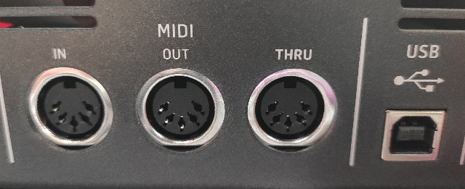

If the error code is MMSYSERR_BADDEVICEID, it indicates that the specified device ID is invalid. This could happen if the device ID provided in wDeviceID is out of range or does not correspond to a valid MIDI output device on the system. You can display an error message to the user informing them of the invalid device ID and allow them to select a different device.

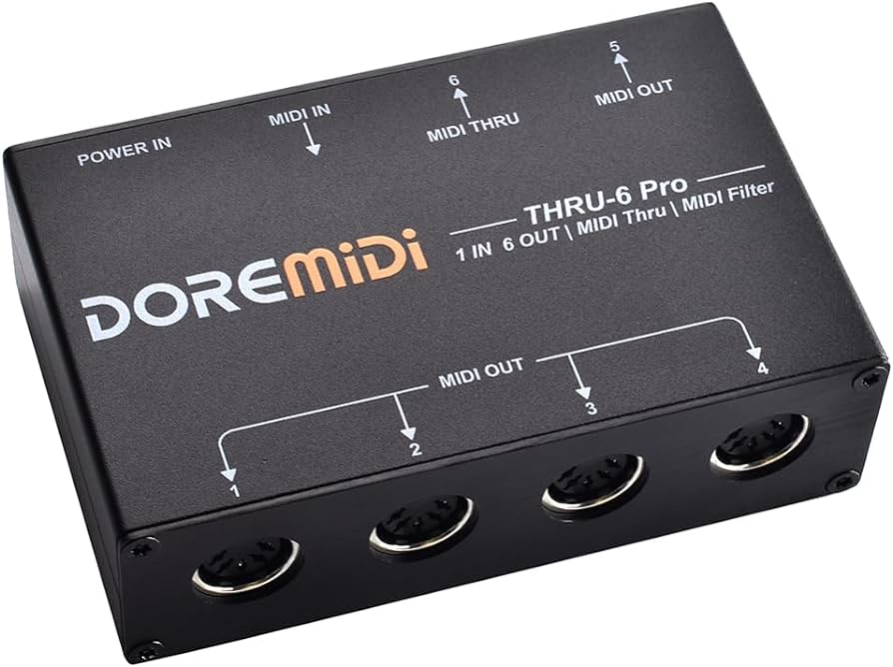

If the error code is MMSYSERR_NODRIVER, it suggests that there is no driver installed for the MIDI output device. You can inform the user that the MIDI device is not supported or that they need to install the appropriate driver for the device to work correctly.

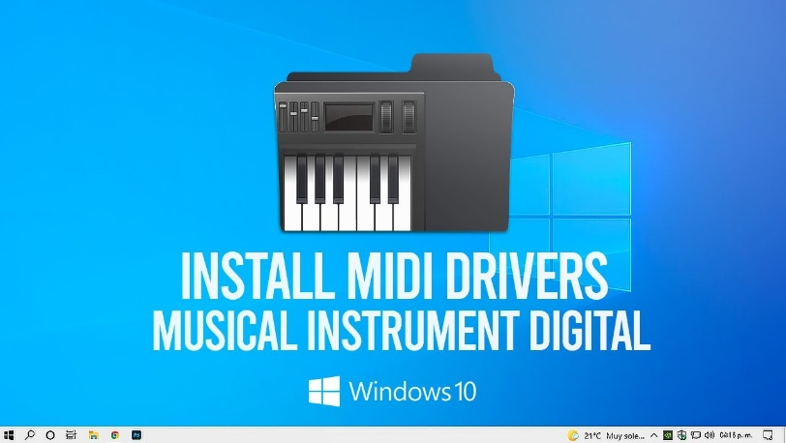

These are just a few examples of how you can handle errors when opening a MIDI output device. The specific actions you take will depend on the requirements of your application and the desired user experience. It's important to provide informative error messages and handle errors gracefully to ensure a smooth user experience when working with MIDI devices.

Sending Musical Messages: midiOutShortMsg

Once the stage is set, you can start sending MIDI messages to create music! Here's how you use the midiOutShortMsg function:

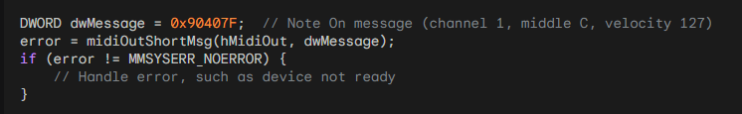

With the stage set and the MIDI output device open, you can start sending MIDI messages to create music. One way to do this is by using the midiOutShortMsg function. This function allows you to send a MIDI message in the form of a 32-bit DWORD to the MIDI output device.

In the provided code snippet, a DWORD variable named dwMessage is used to store the MIDI message. The message represents a "Note On" event on channel 1, with middle C as the note (0x40) and a velocity of 127 (0x7F). The status byte (0x90) indicates a Note On event on channel 1, and the most significant byte is set to 0.

After composing the MIDI message, you can call midiOutShortMsg to send it to the MIDI output device specified by the hMidiOut handle. If the function call returns an error code other than MMSYSERR_NOERROR, it indicates that there was an issue sending the MIDI message.

Handling errors when sending MIDI messages is essential to ensure the smooth operation of your application. Possible error scenarios include the MIDI device not being ready, the device becoming disconnected, or other system-level issues.

You should handle these errors appropriately, which may involve displaying an error message to the user, logging the error for further investigation, or taking any necessary recovery actions.

It's important to note that the provided code snippet demonstrates sending a "Note On" message, but MIDI offers a wide range of message types for various musical actions. For example, you can explore messages for actions such as changing programs/instruments, controlling pitch bend, altering control parameters, and more. Understanding and utilizing different MIDI messages will allow you to create dynamic and expressive musical experiences.

Once you have finished sending MIDI messages and no longer need the MIDI output device, it is important to close it using the midiOutClose function. This ensures that the resources associated with the device are properly released.

By embracing the low-level capabilities of MIDI and utilizing functions like midiOutShortMsg, you gain the power to compose and conduct your own MIDI symphonies.

You can send precise commands to MIDI devices, shaping and controlling the musical experience to your desired vision.

Whether you're creating simple melodies or orchestrating complex musical arrangements, MIDI provides a flexible and powerful foundation for your musical endeavors. Let the music flow and enjoy the creative possibilities that MIDI offers!

BACHTOCC.C PROGRAM STRUCTURE:

WinMain Function:

The WinMain function serves as the entry point for the Windows application.

It initializes the window class, creates the main window for MIDI playback, and enters the main message loop.

Parameters include hInstance (handle to the current instance of the application), hPrevInstance (historical instance, no longer used), szCmdLine (command-line parameters), and iCmdShow (initial window display state).

WndProc Function:

The WndProc function is the window procedure that processes messages for the main window.

It handles messages such as WM_CREATE for initialization, WM_TIMER for timing events, and WM_DESTROY for window destruction.

In the WM_CREATE case, it opens the MIDIMAPPER device and sends Program Change messages to set the instrument to "Church Organ."

The function also manages the polyphonic playback logic, note sequencing, and MIDI messages.

MidiOutMessage Function:

The MidiOutMessage function encapsulates the creation and sending of MIDI messages.

It takes parameters such as the MIDI output handle (hMidi), MIDI status, channel, data1, and data2.

It constructs a DWORD message using bitwise operations and sends the MIDI message using midiOutShortMsg.

MIDI FUNCTIONALITY:

MidiOutMessage Function:

This function is crucial for generating MIDI messages.

It takes the specified parameters and constructs a DWORD value representing a MIDI message using bitwise operations.

The resulting message is sent to the MIDI output device using the midiOutShortMsg function.

WM_CREATE Case in WndProc:

In the WM_CREATE case, the program initializes MIDI functionality.

It opens the MIDIMAPPER device using midiOutOpen, which establishes communication with the MIDI output device.

Program Change messages (0xC0) are then sent to set the instrument to "Church Organ" on both channel 0 and channel 12.

These components collectively form the program's structure and MIDI functionality. The program creates a window, sets up MIDI communication, and initiates playback of the first bar of Bach's Toccata in D Minor using polyphonic MIDI sequencing. The use of Program Change messages allows the selection of a specific instrument for playback, enhancing the musical experience.

NOTE SEQUENCING:

Static Array (noteseq):

The program incorporates a static array named noteseq to represent the note sequence of the first bar of Bach's Toccata in D Minor.

Each entry in noteseq holds information about the note duration (iDur) and two simultaneous notes (iNote[0] and iNote[1]).

This structured array serves as a musical score, defining when and which notes should be played during the polyphonic playback.

Duration and Simultaneous Notes:

* iDur represents the duration of the note in milliseconds, indicating how long a note should be held.
* iNote[0] and iNote[1] contain the MIDI note numbers of two simultaneous notes to create a polyphonic effect.
* The inclusion of simultaneous notes allows for the representation of chords or harmonies in the musical sequence.

POLYPHONIC PLAYBACK:

Two-Note Polyphony:

The program employs a polyphonic playback mechanism that supports a two-note polyphony.

This means that the musical sequence can include two simultaneous notes, enhancing the richness of the generated sound.

MIDI Messages for Playback:

The polyphonic playback is achieved through the generation of MIDI Note On and Note Off messages.

When a note is to be played (Note On), the program sends MIDI messages with the appropriate note numbers and velocity.

Conversely, when a note is to be stopped (Note Off), corresponding MIDI messages are sent with a velocity of 0, indicating the release of the note.

Timing with WM_TIMER Case:

The WM_TIMER case in the WndProc function is crucial for managing the timing of note playback.

It handles the progression through the noteseq array, triggering the Note On and Note Off messages at specific intervals based on the defined note durations.

The use of a timer ensures accurate timing, creating a seamless musical experience during playback.

Dynamic Note Sequencing:

The program dynamically advances through the noteseq array, playing the specified notes and maintaining the polyphonic structure.

As each note's duration expires, the program proceeds to the next set of notes in the sequence, creating a fluid and dynamic musical output.

In summary, the note sequencing and polyphonic playback mechanisms in the program work cohesively to interpret and translate the musical score (noteseq array) into a real-time, polyphonic MIDI performance. The use of simultaneous notes and accurate timing enhances the overall musicality of the generated sound during playback.

TIMER HANDLING:

SetTimer Function:

The SetTimer function is employed to establish a timer, which triggers the WM_TIMER case at regular intervals.

In this program, it ensures the advancement through the note sequence, facilitating polyphonic playback.

The timer is set with a specified interval, and the WM_TIMER case in the WndProc function handles the events triggered by this timer.

KillTimer Function:

The KillTimer function is used to stop the timer when the note sequence is complete.

After the timer is killed, the program proceeds to close the MIDI output and exit gracefully.

This mechanism ensures that the program concludes its musical playback and cleans up resources appropriately.

WINDOW PROCEDURE:

WndProc Function:

The WndProc function serves as the window procedure, handling various Windows messages to control program behavior.

Messages such as WM_CREATE, WM_TIMER, and WM_DESTROY are managed within this function.

WM_CREATE Case:

In the WM_CREATE case, the program initializes the MIDI output device.

It opens the MIDIMAPPER device, sends Program Change messages to set the instrument to "Church Organ," and establishes the initial state for MIDI playback.

Additionally, it sets the timer to initiate polyphonic note sequencing.

WM_TIMER Case:

The WM_TIMER case is crucial for managing the timing of note playback.

It handles the progression through the note sequence, triggering MIDI Note On and Note Off messages at specific intervals based on the defined note durations.

The dynamic nature of the WM_TIMER case ensures accurate timing for a seamless musical experience during playback.

WM_DESTROY Case:

In the WM_DESTROY case, the program resets and closes the MIDI output.

The midiOutReset function resets the MIDI output, and midiOutClose closes the MIDI output device.

Finally, the program posts a quit message to exit the application gracefully.

Window Creation:

The program creates a window with a specified title and dimensions using the CreateWindow function.

The window is set to play the Bach Toccata when it is created, initiating the MIDI playback.

Window Destruction:

Upon window destruction (handled in WM_DESTROY case), the program resets the MIDI output using midiOutReset and closes the MIDI output device with midiOutClose.

Proper cleanup ensures that resources are released, providing a smooth exit for the program.



In summary, the program seamlessly combines Windows GUI functionality with MIDI sequencing. It creates a window for MIDI playback, handles note sequencing with precise timing using timers, and ensures proper cleanup upon program termination. The integration of Windows messages and MIDI functionality results in a cohesive and responsive musical experience.

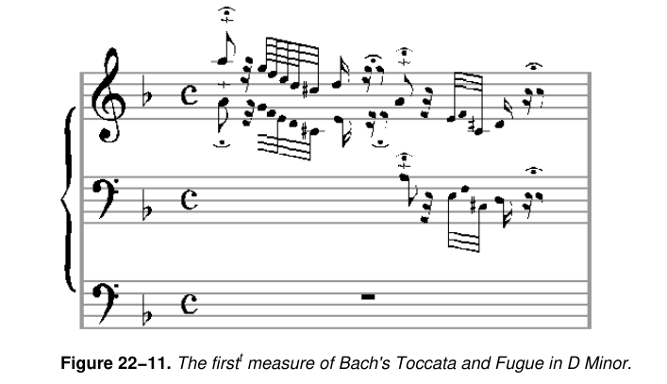

Limitations of Windows Timer:

* BACHTOCC demonstrates playing music using the Windows timer, but the approach has limitations.
* The Windows timer, based on the system clock, lacks the resolution required for accurate music reproduction.
* Asynchronous and timing issues may occur, affecting the quality of music playback.

Alternative Timer Functions:

* Windows provides supplementary timer functions with the prefix "time" for improved resolution (as low as 1 millisecond).
* These functions can be utilized for accurate timing when working with low-level MIDI output functions.

KBMIDI PROGRAM IN DEPTH

MIDI Communication:

1. midiOutOpen, midiOutShortMsg, and midiOutClose:

midiOutOpen: This function is used to open a connection to a MIDI output device. It requires parameters like the device identifier, callback function, and instance data. Handling the device identification and ensuring proper initialization is critical. Error checking is vital to address potential issues in device availability or opening.

midiOutShortMsg: Responsible for sending short MIDI messages to the specified MIDI output device. Understanding the structure of MIDI messages is essential, as this function is crucial for note on/off, control changes, and other real-time adjustments. Efficient management of MIDI channels, instruments, and control messages is imperative for accurate and expressive musical output.

midiOutClose: Closes the MIDI output device opened with midiOutOpen. Proper cleanup, resource release, and error handling are essential to ensure the graceful termination of the MIDI communication. Failing to close the device properly may lead to resource leaks and impact system stability.

2. Managing MIDI Channels, Instruments, and Control Messages:

MIDI Channels: MIDI communication involves 16 channels, each capable of carrying independent musical data. The program must manage channel assignments for different instruments and ensure that the right messages are sent to the correct channel.

Instruments (Voices): Assigning and handling different instruments or voices require a deep understanding of the General MIDI (GM) standard or any custom instrument mapping used by the program. This includes managing program change messages to switch between instruments dynamically.

Control Messages: Beyond note on/off messages, MIDI offers control messages for parameters like pitch bend, modulation, and expression. Proper handling of these messages is crucial for achieving nuanced and expressive musical output.

Window Procedure (WndProc):

1. Handling Keyboard Input:

Key Press/Release Events: WndProc must efficiently differentiate between key press and release events to trigger the corresponding actions. This involves tracking the state of each key and updating it dynamically.

Mapping Keyboard Input to MIDI Notes: The program likely includes a mapping mechanism to associate each key with a specific MIDI note. This mapping should consider factors like octaves and potentially handle different key layouts or configurations.

2. Menu Commands:

Dynamic Menu Creation: Depending on the available MIDI devices, the program dynamically creates menus. This involves querying the system for MIDI devices, obtaining their capabilities, and generating corresponding menu items. Error handling is crucial for situations where MIDI devices may not be available or accessible.

Menu Command Handling: WndProc processes menu commands triggered by user interactions. This includes actions like opening/closing MIDI devices, changing channels, and selecting instruments. Proper synchronization with MIDI communication functions ensures a seamless user experience.

3. Scrollbar Adjustments:

Horizontal and Vertical Scroll Bars: The program likely uses scroll bars to control parameters such as velocity and pitch bend. WndProc must respond to scroll bar messages, updating the associated parameters and reflecting these changes in real-time.

Visual Feedback: Inverting the color of keys when pressed provides visual feedback. Managing this visual representation involves handling WM_PAINT messages and updating the window's appearance dynamically.

In summary, both MIDI communication and the Window Procedure are intricate components requiring a deep understanding of real-time musical data processing, user interface interactions, and system-level resource management. The effective coordination of these elements is essential for creating a responsive and feature-rich MIDI synthesizer application.

MENU CREATION AND HANDLING:

1. Dynamic Menu Creation:

Enumerating MIDI Devices: The program likely uses MIDI API functions to enumerate available MIDI devices. This involves querying the system for MIDI input and output devices, obtaining device information, and dynamically creating menu items based on this information.

Device Capabilities: Each MIDI device may have unique capabilities. The program must extract and interpret these capabilities to provide meaningful menu options. For instance, displaying the available channels, instruments, or other device-specific settings in the menu.

Dynamic Menu Update: The program must dynamically update the menu whenever the number or configuration of MIDI devices changes. This includes scenarios where devices are added or removed during runtime.

2. Responding to Menu Commands:

Open/Close MIDI Devices: WndProc responds to menu commands related to opening and closing MIDI devices. Proper error handling is essential to address situations where a device cannot be opened or closed successfully, ensuring the stability of the MIDI communication.

Change Channels and Select Instruments: The program allows users to change MIDI channels and select instruments through menu commands. Coordination with MIDI communication functions is crucial to ensure that these changes are reflected in real-time, affecting the program's musical output.

KEYBOARD INPUT PROCESSING:

1. Mapping Keyboard Input to MIDI Notes and Octaves:

Key to Note Mapping: WndProc processes keyboard input, mapping each key to a corresponding MIDI note. This involves creating a mapping table that associates keys with specific note values, considering factors like the starting octave and potential octave adjustments.

Octave Adjustments: The program likely allows users to adjust the octave using modifiers like Shift and Ctrl. WndProc must interpret these modifier states and dynamically update the mapping, allowing users to play across multiple octaves with ease.

Visual Feedback: In addition to MIDI output, the program may provide visual feedback for pressed keys, enhancing the user experience. This involves updating the appearance of keys in the graphical user interface to reflect the current state of each key, providing a responsive and immersive interaction.

2. Managing Key States:

Key Press and Release Events: WndProc efficiently manages key press and release events, maintaining the state of each key. This involves handling the WM_KEYDOWN and WM_KEYUP messages, updating the internal key state, and triggering the corresponding MIDI note events.

Modifiers (Shift, Ctrl): Recognizing and interpreting modifier keys is crucial for implementing advanced features like octave adjustments. WndProc tracks the state of these modifiers, dynamically adjusting the mapping table to accommodate changes in octave settings during live play.

In summary, effective menu creation and keyboard input processing are integral to the overall functionality and user experience of a MIDI synthesizer program. These components require a combination of system-level interaction, real-time data processing, and dynamic user interface updates to deliver a seamless and expressive musical environment.

SCROLL BAR CONTROLS:

1. Incorporating Horizontal and Vertical Scroll Bars:

Parameter Control: The program uses scroll bars to allow users to control parameters like velocity and pitch bend. Horizontal and vertical scroll bars likely correspond to different parameters, providing a visual and interactive way for users to adjust these settings dynamically.

Mapping to MIDI Parameters: Each scroll bar's position is mapped to specific MIDI parameters. For example, the vertical scroll bar might control pitch bend, while the horizontal scroll bar adjusts velocity. Ensuring a smooth and intuitive mapping is crucial for user-friendly parameter manipulation.

2. Handling Scroll Bar Messages:

Message Processing: WndProc processes messages related to scroll bar interaction, such as SB_LINEUP, SB_LINEDOWN, SB_THUMBPOSITION, etc. These messages signify user actions like scrolling, dragging the thumb, or clicking on the scroll bar arrows.

Real-time Updates: The program must update MIDI parameters in real-time based on scroll bar interactions. This involves translating the scroll bar positions into meaningful changes in velocity and pitch bend, ensuring that the musical output reflects the user's adjustments accurately.

GRAPHICS AND DRAWING:

1. Drawing Individual Keys on the Window:

Key Positioning and Dimensions: The program dynamically calculates and positions individual keys on the window, considering factors like key size, spacing, and overall layout. This is crucial for creating an accurate and visually appealing representation of the musical keyboard.

Labeling Keys: Each key is labeled based on its MIDI note value. This labeling provides users with a clear visual reference, aiding in navigation and musical expression. Labels may include note names (C, D, E, etc.) and octave numbers.

2. Inverting Color of Keys When Pressed:

Visual Feedback for Key Press: When a key is pressed, the program inverts the color of the corresponding graphical representation. This visual feedback enhances the user experience, providing a responsive and intuitive connection between the virtual interface and the user's actions.

Dynamic Color Handling: The program dynamically manages the color state of keys, ensuring that the inversion occurs only when a key is actively pressed. This involves handling key press and release events, updating the graphical representation accordingly.

User Engagement: The visual feedback not only serves a functional purpose but also contributes to the overall engagement and immersion of the user in the virtual musical environment. It mimics the tactile response of a physical keyboard, enhancing the sense of interaction and control.

In summary, the incorporation of scroll bar controls and the thoughtful design of graphics and drawing elements are essential aspects of your MIDI program. These components contribute to the program's usability, real-time responsiveness, and visual appeal, creating a rich and enjoyable experience for users interacting with virtual musical instruments.

GRAPHICS AND DRAWING:

1. Drawing Individual Keys on the Window:

Position Calculation: The program employs precise algorithms to calculate the positions of individual keys dynamically. This involves considering factors like the total number of keys, their dimensions, and the overall layout of the virtual keyboard. The goal is to create an accurate and visually pleasing representation of the musical keyboard within the application window.

Dimensional Considerations: Each key is drawn with careful attention to its dimensions, ensuring that they are proportional and visually coherent. This contributes to the realism and aesthetics of the virtual instrument, providing users with a visually intuitive representation that mirrors the physical attributes of a traditional musical keyboard.

Labeling for Reference: Keys are labeled based on their MIDI note values, incorporating note names and octave numbers. This labeling enhances user understanding and navigation, allowing musicians to easily identify and locate specific notes on the virtual keyboard.

2. Inverting the Color of Keys When Pressed:

Dynamic Color Handling: The program dynamically manages the color state of keys in response to user interactions. When a key is pressed, its color is inverted, providing immediate and intuitive visual feedback. This feature mimics the tactile response of physical keys, enhancing the user's sense of connection and control.

Visual Feedback for User Engagement: The color inversion serves not only a functional purpose but also contributes to user engagement. It creates a responsive and interactive environment, reinforcing the connection between the user's actions and the virtual instrument's visual representation. This feedback is crucial for musicians who rely on visual cues during performance and composition.

RESOURCE MANAGEMENT:

1. Properly Opening and Closing MIDI Devices:

MIDI API Functions: The program utilizes MIDI API functions, such as midiOutOpen and midiOutClose, to establish and terminate connections with MIDI devices. Proper handling of these functions ensures the reliable and efficient communication between the software and external hardware.

Error Handling: Robust error-handling mechanisms are implemented to address potential issues during device opening and closing. This includes checking return values, diagnosing errors, and providing informative messages to users in case of failures. This proactive approach enhances the overall stability and reliability of the MIDI communication.

2. Managing Resources and Handling Potential Errors:

Resource Allocation: The program efficiently manages system resources, such as memory and processing power, to ensure optimal performance. This involves judicious allocation and deallocation of resources, preventing memory leaks and optimizing the overall efficiency of the application.

Error Resilience: Robust error-handling strategies are integrated throughout the code to anticipate and address potential errors gracefully. This includes scenarios such as device unavailability, resource exhaustion, or unexpected runtime issues. By handling errors systematically, the program enhances its resilience and user experience.

CODE ORGANIZATION:

1. Using Structures and Constants for Organization:

Structured Data Representation: The program employs structures to organize MIDI instrument families, instruments, and key mappings. This structured approach enhances code readability and maintainability by encapsulating related data into cohesive units. Each structure likely contains essential information such as instrument names, MIDI channels, and key assignments.

Constants for Configuration: Constants are used to define fixed values that remain unchanged during program execution. They are employed to represent parameters like instrument families, ensuring consistency and facilitating easy updates. This modular organization improves code comprehensibility and simplifies future modifications.

Enhanced Modularity: By utilizing structures and constants, the code achieves a modular and organized structure. This design choice enhances scalability, allowing for the seamless addition of new instrument families or modifications to existing ones. It reflects a thoughtful approach to code organization, promoting clarity and ease of maintenance.

ERROR HANDLING:

Limited Error Handling:

Critical Error Messaging: The current error-handling approach employs basic message boxes for critical errors. While effective for conveying essential information, it's crucial to consider expanding error handling to cover a broader range of scenarios. This can include non-critical errors, providing users with informative messages to aid troubleshooting and ensuring a more user-friendly experience.

Logging Mechanism: Implementing a logging mechanism can enhance error tracking and debugging. Logging critical events and errors to a file allows developers to analyze issues post-execution, facilitating quicker identification and resolution. This proactive approach improves the overall robustness of the application.

UNDERSTANDING MIDI MESSAGES:

Knowledge of MIDI Message Formats:

Message Structure Familiarity: The code demonstrates a profound understanding of MIDI message formats and their interpretation. This is evident in the effective use of MIDI API functions, such as midiOutShortMsg, which is pivotal for sending MIDI messages to devices. The correct construction and parsing of MIDI messages indicate a high level of proficiency in MIDI communication.

Channel and Control Handling: Managing MIDI channels, instruments, and control messages involves intricate knowledge of MIDI message structures. The program showcases competence in handling complex MIDI messages, ensuring precise control over parameters like instrument selection and channel configuration.

Closing Thoughts:

In conclusion, the provided code serves as an exemplary demonstration of expertise in WinAPI development, MIDI communication, and user interface design tailored for a MIDI synthesizer application. It stands as a robust foundation for a functional and interactive program, showcasing meticulous attention to detail in various aspects.

The code's strengths lie in its:

* Efficient MIDI Communication: Leveraging MIDI API functions for device interaction and demonstrating a nuanced understanding of MIDI message formats.
* User Interface Design: Incorporating dynamic elements like dynamic menu creation, keyboard input processing, scroll bar controls, and visually engaging graphics.
* Code Organization: Utilizing structures and constants for a modular and organized codebase, enhancing readability and maintainability.
* While there is room for refining error handling and potentially expanding features, the code overall represents a commendable achievement in WinAPI development, catering to the intricate demands of MIDI synthesis and user interaction. It stands as a testament to the developer's proficiency and creativity in crafting a compelling musical application.